

Regenerating SOIL life with WASTE management



Document prepared by Ambipar Environmental Solutions

[Bianca.Ayres@ambipar.com](mailto:Bianca.Ayres@ambipar.com)

|  |  |
| --- | --- |
| Project Title | Regenerating soil life with waste management |
| Version | 01 |
| Date of Issue | November 9th, 2021 |
| Prepared By | Ambipar Environment  Bianca Ayres  Carbon Initiatives Director |
| Contact | Avenida Angelica , 2346, São Paulo, Brazil +55 11 3429-5000 www.ambipar.com |

Contents

1 Project Details 5

1.1 Summary Description of the Project 5

1.2 Sectoral Scope and Project Type 6

1.3 Project Eligibility 6

1.4 Project Design 7

1.5 Project Proponent 12

1.6 Other Entities Involved in the Project 12

1.7 Ownership 12

1.8 Project Start Date 15

1.9 Project Crediting Period 15

1.10 Project Scale and Estimated GHG Emission Reductions or Removals 15

1.11 Description of the Project Activities 16

1.12 Project Location 24

1.13 Conditions Prior to Project Initiation 30

1.14 Compliance with Laws, Statutes and Other Regulatory Framework 39

1.15 Participation under Other GHG Programs 43

1.16 Other Forms of Credit 43

1.17 Additional Information Relevant to the Project 43

2 sAFEGUARDS 45

2.1 No Net Harm 45

2.2 Local Stakeholder Consultation 45

2.3 Environmental Impact 46

2.4 Public Comments 47

2.5 AFOLU-Specific Safeguards 47

3 APPLICATION OF METHODOLOGY 50

3.1 Title and Reference of Methodology 50

3.2 Applicability of Methodology 50

3.3 Project Boundary 56

3.4 Baseline Scenario 61

3.5 Additionality 64

3.6 Methodology Deviations 69

4 QUANTIFICATION OF GHG EMISSION, REDUCTIONS AND REMOVALS 70

4.1 Baseline Emissions 70

4.2 Project emissions 101

4.3 Leakage 114

4.4 Net GHG Emission Reductions and Removals 115

5 monitorING 118

5.1 Data and Parameters Available at Validation 118

5.2 Data and Parameters Monitored 139

5.3 Monitoring Plan 151

6 Bibliography 152

APPENDIX A 157

APPENDIX B 160

**Acronyms**

ACF – Ambipar Composting Facilities

ALM –Agricultural Land Management

CEC – Cation Exchange Capacity or CTC in Portuguese

CTRRS – Central de Tratamento de Reciclagem e Resíduos Sólidos that means “Waste Treatment Center”

ESG – Environmental, Social and Governance

E-FFC – Emissions from Fossil fuel combustion

Extensive agriculture – definition of land handling without accuracy analysis of soil composition for supply planning

GHG – Greenhouse gases

ICM – Improvement cropland management

IGM – Improvement grassland management

LUM – Land Use Management

MOS – matter organic in soil

NG – Normative Guidance

NPK – Nitrogen, Phosphorous and Potassium ratio for fertilizers composition

PD – Project Description

PNRS – Plano Nacional de Resíduos Sólidos, that means National Plan for Solid Waste

SOC – Soil organic carbon

SWDS – Solid Waste Disposal Site

# Project Details

## Summary Description of the Project

The project is an innovative integration of industrial composting and increasing carbon stocks in soil. The proposed grouped project “Regenerating soil life with waste management” was implemented by Ambipar Environmental Solutions within the first instance located in the state of Santa Catarina, Três Barras City, Brazil. The annual average estimation of carbon accrual is 2,337 tCO2e and 38,397 tCO2e of reduction within this first instance of this grouped small-scale project.

The composting treatment implemented decomposes organic matter aerobically into CO2, water and humic fraction. The resultant compost is applied on the cropland/grassland contributing to the carbon cycle, where simple nutrients that return to the soil are converted by plants into organic compounds. The agricultural areas where the application takes place are the same where the sustainable agricultural land management (ALM) project activities of this project occurs. The measurements of emission reductions from avoidance of methane emissions to the atmosphere since organic matter have left to decay anaerobically in a solid waste disposal site (SWDS) contributes to the GHG credits generated. The business-as-usual has been misusing the potential of industrial organic matter disposing anaerobically into SWDS or performing non-controlled composting outcoming product non-approved in the national agricultural entity. The organic matter composted without quality control and without oriented application could entails environmental damages.

The ALM project activities were designed to restore soils, including the implementation of sustainable ALM practices in cropland/grassland such as: gradual reduction of tillage practices avoiding the soil exposure and leaving crop residues on the soil surface as protection; soil analysis for precision management which allows dosage distribution of fertilizer (reduced inputs) and of the produced compost in the field; organic inputs replacing chemicals; gradual transition for biological control of plagues; moderate intensities and rotational practices in grazing; crop planting rotations and manure management, as applicable.

Soil carbon accrual per unit area is measured in both baseline and project scenarios based on the spatial coordinated sampling gathering data on soil carbon concentration with statistical rigor. The implementation of the ALM practices is targeted to regulate the increase of soil carbon stocks. The measurement of the stable soil organic carbon concentration was set up to quantify soil dynamics at depth. The soil layers up to 80cm were sampled to capture expected change in soil carbon. It is expected GHG removals benefits climate, soil fertility and society with higher productivity.

Prior to the implementation of this project, rural producers do not foresee regenerative agriculture due to the lack of knowledge and technical skills about how to switch to organic input, biological control of plagues and sustainable land management. The previous scenario within the project area at the first instance outcomes low productivity per area, soil degradation and no smart application of the compost after the organic matter management, which implied in deposition applications without potential reuse for climate change mitigation.

Nowadays, this waste gets into the circular economy by its smart reuse for regenerating agricultural soil including rural professional qualification. Ambipar manages great volumes of organic waste in Brazil for about 50 industrial customers. Built on the raised potential for inclusion of new project activity instances spread within the Brazilian territory, this grouped project will turn a low carbon landscape into a high carbon landscape improving food security and productivity.

## Sectoral Scope and Project Type

The sectoral scopes 13 and 14 of the VCS program are applicable to the project: Waste handling and disposal and Agriculture Forestry and Other Land Use (AFOLU). The category of the AFOLU project falls under is Agricultural Land Management (ALM). The category within the sectoral scope 13 falls under the composting process substituting final waste disposal. This is a grouped project that combines multiple project activity instances into a single, combined project that adds new instances over time through the addition of other regions using soil conditioners obtained from waste treatment to regenerate agricultural soil.

## Project Eligibility

The project’s activities are supported by methodologies approved under the VCS Program. The project is guided by the six principles set out in Section 2.2.1 of the VCS standard: 1. Relevance, selecting GHG sources and appropriated methodologies to contribute to the local route of waste management to a product applied with technical skills to sustainable land management; 2. Completeness, including all relevant GHG emissions and removals from the waste treatment and regeneration soil life through a soil carbon quantification; 3. Consistency, estimation of avoidance of waste disposal emissions and carbon accrual, at the carbon flux, from atmosphere to soil. Thus, GHG-related information are compared between scenarios; 4. Accuracy, avoiding any potential uncertainties related to the implementation of the project’s activities; 5. Transparency, disclosing sufficient and appropriate GHG-related information to all involved in the project’s activities, allowing them to make decisions with reasonable confidence; and 6. Conservativeness, using conservative assumptions, values and procedures to ensure that the net GHG emission reductions and removals are not overestimated.

The project activity is eligible for the AMS.III.F. Methodology, v.12.0, because encompasses aerobic controlled biological treatment of biomass or organic matter through composting and proper soil application of the compost. The methodology key element of GHG emissions mitigation action is reached by the implemented alternative treatment process.

The project activity is eligible for the VM0021 Methodology, v.1.0, because according to the Appendix 1 from the VCS Standard v4.1 (Eligible AFOLU Project Categories), it includes one of the following ALM activities: 1- Improved Cropland Management (ICM) and 2- Improved Grassland Management (IGM). Where the baseline scenario is identified as continuous degradation of the croplands or grasslands and expects to continue in the absence of the project activity, the total carbon content of the soil organic and inorganic carbon pools within the project area is highly likely to increase under the proposed project activities during the project crediting period. Besides the project area does not consist of forest, wetlands, or peatlands, as such terms are defined under the VCS; the baseline activities are not displacing grazing and fodder production, crop production or timber production; the project activities does not include changes in surface and shallow (<1m) soil water regimes through flood irrigation, drainage or other significant anthropogenic changes in the ground water table; and the project activity does not cause a significant change in termite populations, as compared with the baseline scenario. The project’s eligibility occur due to its activities are related to reduce net GHG emissions on croplands and grasslands by increasing carbon stocks in soils with technical orientation of the sustainable management, which the application of compost stimulates the dynamics of the carbon cycle flow into the soil. Consequently, increasing soil fertility and agricultural productivity, recovering vegetation density, reducing nitrogen fertilizers input, improving the soil ecosystem and sustainable land use with regenerative agriculture. The rural producers’ orientation is needed to ensure the correct use of soil, according to the methodologies used in the project.

## Project Design

The project was designed to include two main project activities: biomass or organic matter composting and enrollment of rural producers to develop sustainable ALM practices aiming changes in soil carbon accrual. In addition, it was designed as grouped project, which additional instances of the same project activities that meet pre-established eligibility criteria may be added subsequent to the project validation. Figure 1 illustrates the geographic areas within which project activity instances may be developed based on the presence of Ambipar’s waste treatment facilities.

The initial project activities instance currently implemented on the issue date of the project description has clearly defined geographic areas (Figure 2). The controlled biological treatment of organic matter (AMS-III.F methodology) is located in Três Barras city, Santa Catarina State, Brazil; and the implementation of the project activities for soil carbon quantification (VM0021 methodology) is currently located at the rural area of the same city (detailed in section 1.12).

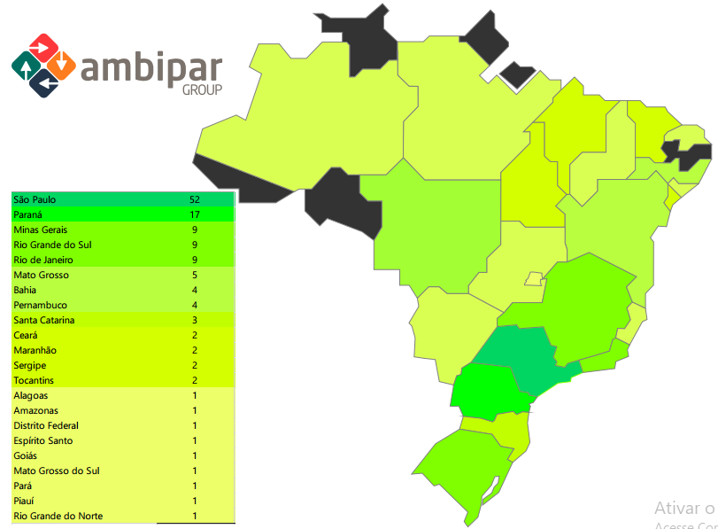

Figure 1 - Brazilian federation units where waste treatment facilities of the Ambipar is present and this project could develop new instances after project validation.

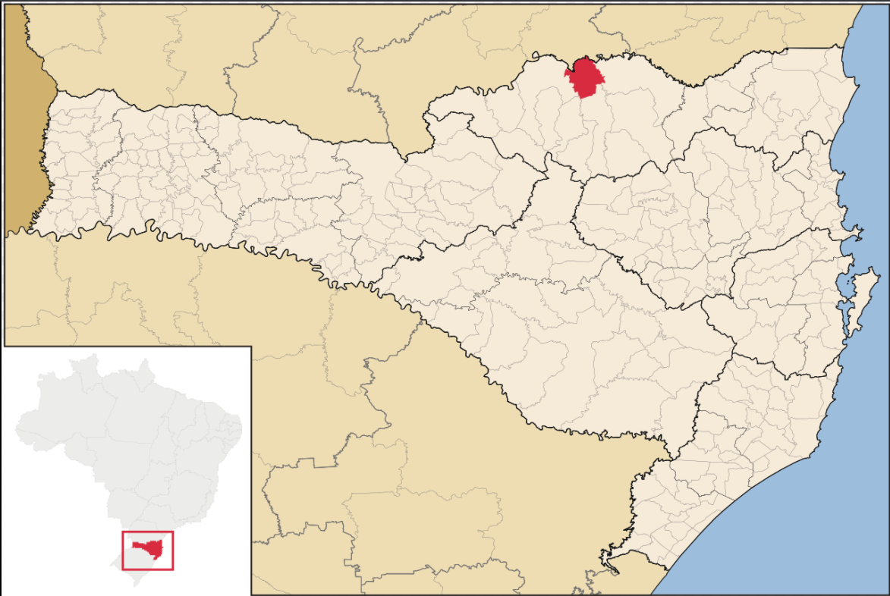

SC

Brazil

Três Barras

Figure 2 - Três Barras is located in Santa Catarina State, south region of Brazil.

The baseline scenario considering the designed geographic area at the implementation of the AMS-III.F methodology (Ambipar’s Composting Facilities) is the situation where, in the absence of the project activity, biomass and other organic matter are left to decay within the project boundary and methane is emitted to the atmosphere. The baseline emissions in this case are the amount of methane emitted from the decay of the degradable organic carbon in the biomass solid waste. And the baseline scenario considering the designed geographic areas at the implementation of the VM0021 methodology (rural producers’ areas) is the most likely sequence of events and actions which have caused the degradation of the croplands, grasslands or rangelands and expect to continue impacting the project rural area in the absence of the project. Examples of actions would be traditional agriculture without soil regeneration, i.e., lack of crop rotation, lack of coverage vegetation and practices of chemical control of plagues. With these actions the total carbon content of the soil organic and inorganic carbon pools within the project area is highly unlikely to increase under the baseline scenario.

The additionality considering the designed geographic area with the AMS-III.F methodology (Ambipar’s Composting Facilities) is evident at the implementation of controlled aerobic treatment by composting of biomass or organic residue with the objective to obtain a product that promote benefits on the land management areas. The additionality considering the designed geographic areas at the implementation of the VM0021 methodology outcomes from the enrollment of rural producers to improve agricultural practices and soil management including the compost application. Currently the rural producers apply synthetic chemicals to enhance the productivity and avoid susceptibility to plagues and diseases. However, these actions hardly affect the conservation, ecosystem restoration, management of soils, management of hydrology, fertility, and vegetation systems along the years, promoting changes in soils, like erosion, leaching and reduction of organic matter content.

The project activities at this first instance do not present factors relevant that require assessment across a given area, such as common practice; laws, statutes, regulatory frameworks, or policies relevant to demonstration of regulatory surplus; determination of regional grid emission factors; and historical deforestation and degradation rates.

The capacity limit in emission reductions of the small-scale AMS-III.F methodology is 60 kt CO2eannually. The average emission reduction from the implemented project activity instance was lower: 38.397kt CO2e/y.

There is no capacity limit outlined at the VM0021 methodology.

### Eligibility Criteria

The eligibility criteria of the methodology AMS-III.F for implementation of the Ambipar’s Composting Facilities must have the following characteristics to evidence the additionality:

* The composition of the waste must have organic fraction or biomass waste from agricultural or agro-industrial activities to allow controlled aerobic composting;
* Evaluate the feasibility for construction and/or expansion of treatment facilities as well as activities that improve capacity utilization at an existing facility;
* Whether the solid biomass waste or wastewater has been treated in an anaerobic treatment system without biogas recovery.
* The location and characteristics of the disposal site of the solid biomass waste in the baseline shall be known, in such a way as to allow the estimation of its methane emissions;
* Evaluate of the composting process efficiency and improvement, if necessary, with addition of blending materials to achieve desirable C/N ratio or free air space value. It is allowed under monitored quantity of solid waste or manure or wastewater diverted from the baseline treatment system. In the case of further project activities instances involve composting of animal manure, the activities shall meet the requirements under paragraph 3 and 4(c) of the latest version of AMS-III.D;
* At the beginning of each crediting period: (a) establish that identified landfill(s)/stockpile(s) could accommodate the waste to be used by further project activity instance during crediting period; (b) or establish that it is common practice in the region to dispose the waste in solid waste disposal site (landfill)/stockpile(s);
* Analyzing the geographical boundary of the further project activity instance to identify where is the source of the waste and stablish adequate distances to cover the composting project activity. In addition, it should also consider the distance to which the compost will be transported. In either case, the region should cover a reasonable radius around the project activity that can be justified with reference to the project circumstances but in no case, it shall be more than 200 km. Once defined, the region should not be changed during the crediting period(s);
* In case produced is treated thermally/mechanically will be conditioned to the provisions applied in AMS-III.E methodology;
* In case produced compost is stored under anaerobic conditions and/or delivered to a landfill, emissions from the residual organic content shall to be taken into account and calculated as per the latest version of the methodological tool “Emissions from solid waste disposal sites”;
* The composting process will be done with the principle and residue (raw material) quality control, as applied in the same manner by the initial instance;
* The compost handled aerobically to be submitted to soil application should be evaluated to identify if the conditions and procedures have been adequately followed, not resulting in methane emissions and ensuring additionality.

The eligibility criteria of the methodology VM0021 for the enrollment of rural producers’ areas aiming soil carbon quantification must have the following characteristics to evidence additionality:

* The project area shall not be cleared of native ecosystems within the 10-year period prior to the project start date;
* In case of ICM, increasing carbon stocks in soils and woody biomass and/or decreasing CO2, N2O and/or CH4 emissions from soils through practices that increase residue inputs to soils and/or reduce soil carbon mineralization rates. Such practices include, but are not limited to, the adoption of no-till, elimination of bare fallows, use of cover crops, creation of field buffers (e.g., windbreaks or riparian buffers), use of improved vegetated fallows, conversion from annual to perennial crops and introduction of agroforestry practices on cropland. Where perennial woody species are introduced as part of cropland management (e.g., field buffers and agroforestry), carbon sequestration in perennial woody biomass may be included as part of the ALM project;
* In case of IGM, increasing carbon stocks in soils by practices that increase belowground inputs or decrease the rate of decomposition. Such practices include increasing forage productivity (e.g., through improved fertility and water management), introducing species with deeper roots and/or more root growth and reducing degradation from overgrazing.
* The project area must not consist of forest, wetland, or peatlands, as such terms are defined under the VCS. It has to consist of grasslands or croplands. Crops may include woody species grown for food products, fuel products or timber, providing that the densities of these crops do not meet the requirements for definition of these lands as forest lands.
* The only baseline activities that can be displaced by the project activities are grazing and fodder production, crop production and timber production;
* Do not include changes in surface and shallow (< 1m) soil water regimes through flood irrigation, drainage or other significant anthropogenic changes in the ground water table;
* Do not cause a significant change in termite populations, as compared with the baseline scenario presented in each instance;
* Be located in a reasonable radius of 200 km around the project activity of composting;
* New project activity instances must be consistent with the same investment, technological and other parameters (such as the size/scale of the instances) as the initial instance.

New project activities instances shall meet the same baseline and additionality conditions validated by registration into this grouped project. Beyond to comply with the complete set of eligibility criteria described above for the AMS-III.F and VM0021 methodologies, each one shall:

- Occur within one of the designated geographic areas specified in the Figure 1;

- Be included in the monitoring report with sufficient technical, financial, geographic and other relevant information to demonstrate compliance with the applicable set of eligibility criteria and enable sampling by the validation/verification body;

- Be validated at the time of verification;

- Have a start date that is the same as or later than the grouped project start date;

- Be eligible for crediting from the start date of the instance through to the end of the project crediting period (only) and new instances are eligible for crediting from the start of the next verification period;

- Evidence of project ownership and where necessitates the addition of a new project proponent to the project, such instances shall be included in the grouped project within two years of the project activity instance start date or, where the project activity is an AFOLU activity, within five years of the project activity instance start date.Strictly to the AFOLU project activities, new instances shall:

- Analyse the AFOLU non-permanence risk, where required, for each geographic area specified in the project description. Where risks are relevant to only a portion of each geographic area, the geographic area shall be further divided such that a single total risk rating can be determined for each geographic area. Where a project is divided into more than one geographic area for the purpose of risk analysis, the project’s monitoring and verification reports shall list the total risk rating for each area and the corresponding net change in the project’s carbon stocks in the same area, and the risk rating for each area applies only to the GHG emissions reductions generated by project activity instances within the area;

- Assess if there is any activity-shifting, market leakage and ecological leakage.

## Project Proponent

|  |  |
| --- | --- |
| Organization name | AMBIPAR ENVIRONMENTAL SOLUTIONS |
| Contact person | Bianca Maíra Teixeira Ayres |
| Title | Carbon Initiatives Director |
| Address | 1088, Pacaembu Avenue, Pacaembu Neighborhood, São Paulo City, São Paulo State, Brazil, zip code 01234-000. |
| Telephone | +55 19 99173 5154 / +55 11 3429 5020 |
| Email | Bianca.Ayres@ambipar.com |

Ambipar was found in 1995 and currently is the national leader on waste management. It is worthily experienced in treating and managing high volumes of waste across the Brazilian territory. The organization has overall control and responsibility for the project activities: composting facilities operation, enrollment of rural producers to develop climate-smart sustainable ALM practices, implementing soil carbon quantification by monitoring and documenting changes in soil carbon.

## Other Entities Involved in the Project

None

## Ownership

Ambipar is a provider of environmental management services to industries, having legal responsibility to control and operate waste management its role in the services agreement (Figure 3). The contractual period within the first instance is every 5 years and renewal for the same period. A renewal agreement has been signed for the following five years (from February 2021). Thus, Ambipar has an operating license issued by the environmental agency of the State of Santa Catarina, Production Facility Registry at the MAPA (Ministry of Agriculture, Livestock and Supply), Operating Permit issued by the City Hall of Três Barras and a safety permit issued by the State Fire Departments. All documents are available for VVB.

The agreement between the parties defines Ambipar as the owner of the knowledge of the composting process and party responsible for the waste management, carried out with an operating license from the state environmental agency and a registration as a production facility at MAPA, guaranteeing Ambipar’s ownership in the process. For new project activity instances, the deed of conveyance about the waste property will be signed in an agreement through an exclusive clarification clause. In this first project activity instance, the industrial waste from the paper mill is assigned to Ambipar through invoices among the companies (documents available for VVB).



**Rural producers producer**

**Industry**

Agreement for environmental services

Agricultural partnership agreement

Figure 3 - Flowchart of Ambipar’s ownership of the composting implementation with industrial residues and agricultural applications. Evidence of the agreement between Ambipar and each party involved in the project: one agreement with industry and another with landowners.

The product resulting from the composting of the waste is registered under the control of Ambipar and the entire process is signed by Ambipar’s engineer as the technical overseer. The product registries held by Ambipar at the MAPA are classified as substrates for plants, organic fertilizers, and soil conditioner class “B”. The guaranteed parameters for classification of the agricultural product are met primarily as a soil conditioner according to normative guideline 35 issued by the national regulatory agency MAPA. The batches produced are analyzed physically, chemically, microbiologically and have the quantitative limits of heavy metals safely met. The compliance of the batch is tracked through an Ambipar tax invoice, in its role of owner of the product, issued to the farmer, for final disposal into a rural property.

The rural producers receive the compost in consensus with an agricultural partnership signed between Ambipar and each rural producer (Figure 3). The clauses of the agreement state that Ambipar control and operate the soil carbon quantification aiming raise carbon stock in soil. The agreement also highlights the importance of engagement to track ALM practices, follow advisory services on farm-specific sustainable ALM practices providing by Ambipar though a participatory planning. The agricultural partnership agreement clearly stablishes the sharing percentual of the predicted potential verified carbon units. In exchange, Ambipar subsidizes the soil carbon quantification, specialized technical advisory services for climate-smart sustainable ALM practices, as well as support the costs of structuring and certifying the project.

Ambipar technical skills about soil improvement is consolidated thoroughly on the results of studies including soil conditioner application associated to ALM in several crops, showing gains in productivity, reduced use of chemical fertilizers and water retention. The work was carried out within the field of the Federal Institute of São Paulo, Barretos campus, São Paulo State, Brazil, coordinated by a PhD in agronomic sciences involving 20 scholarship students (Figure 4) of technical courses reporting benefits for several cultivation (Figure 5).

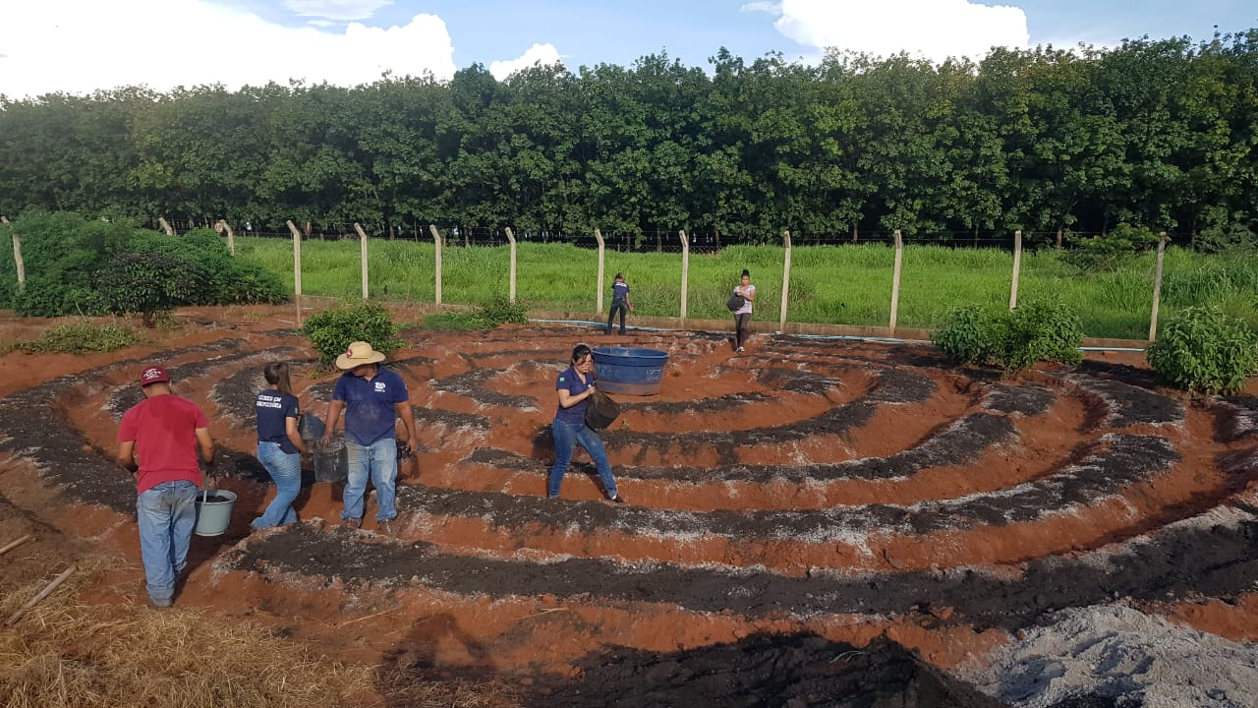

Figure 4 - Internships from technical agronomy courses.

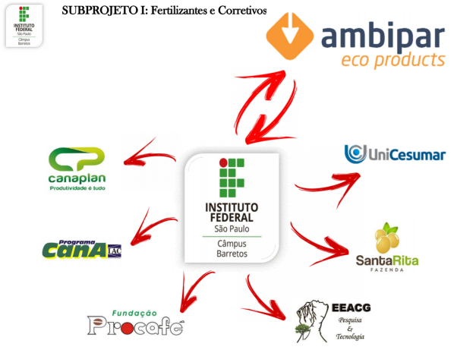

Figure 5 - Research developed by the Federal Institute of São Paulo, Barretos campus, São Paulo State, Brazil, providing a cooperation with other specialized agricultural programs about citrus, coffee, sugarcane and soil crops.

In addition, there were also technical cooperation studies with the Cana Program with the objective of managing genetic improvement research. In order to improve research management, the sugarcane program was divided into several projects including Genetic improvement, bioclimatology, soil sciences, economics, statistics, agricultural engineering, plant fertility and nutrition, phytotechnology and plant health. All these scientific investigations have been supported by Ambipar unilaterally and are presented in APPENDIX B.

## Project Start Date

The Project Start Date was stablished October 1st, 2020. This was the date when the composting cycle of the organic matter started to produce the compost delivered for the selected farmers within this first instance. Thus, the non-AFOLU project activity began generating GHG emission reductions and the AFOLU project activities began by selecting target farmers and areas.

## Project Crediting Period

Project start date October, 1st 2020

Project end date September, 30th 2040

Total number of years 20 years

## Project Scale and Estimated GHG Emission Reductions or Removals

|  |  |
| --- | --- |
| Project Scale | |
| Project | X |
| Large Project |  |

|  |  |
| --- | --- |
| Year | Estimated GHG emission reductions or removals (tCO2e) |
| 2021 | 2.461 |
| 2022 | 11.561 |
| 2023 | 18.474 |
| 2024 | 24.433 |
| 2025 | 29.523 |
| 2026 | 33.846 |
| 2027 | 37.509 |
| 2028 | 40.424 |
| 2029 | 43.053 |
| 2030 | 45.287 |
| 2031 | 47.000 |
| 2032 | 48.621 |
| 2033 | 50.005 |
| 2034 | 51.005 |
| 2035 | 51.963 |
| 2036 | 52.845 |
| 2037 | 53.419 |
| 2038 | 54.081 |
| 2039 | 54.659 |
| 2040 | 55.164 |
| Total estimated ERs | 805.331 |
| Total number of crediting years | 20 |
| Average annual ERs | 40267 |

## 

## Description of the Project Activity

The main project activities are controlled aerobic treatment of biomass or organic matter through composting and enrollment of farmers to develop sustainable ALM practices aiming quantification of changes in soil carbon accrual, which is calculated using statistical rigor.

The geographic area within which all project activities instances will expand in this grouped project is demonstrated on Figure 1. The sets of eligibility criteria for the inclusion of new project activity instances will be followed according to Section 1.4.

The net GHG emission comprises emission reduction and carbon removal. First comprises measures to avoid methane emissions to the atmosphere from biomass or other organic matter that would have otherwise been left to decay anaerobically in a SWDS instead of composting. Second, carbon removals are achieved from increasing changes in carbon stock in soil, which is possible from strategic planning, training and advisory services for farmers on farm-specific sustainable ALM practices.

### Non-AFOLU project activity: Composting (AMS.III.F. Methodology)

The composting process is characterized by an aerobic and thermophilic biological degradation of organic solid material that under control and management results in an organic compost, useful as an agricultural input (statute 481 from CONAMA described in section 1.14). Ambipar manages area license to implement aerobic composting technology, operates and sales the compost. Ambipar selects organic waste free of environmental contaminants for unique safe purpose of soil conditioner application, to promote improvements on the soil quality, fertility, productivity, water retention and proliferates the microbiota.

First of all, the biomass or other organic matter get entrance at the composting facility (Waste treatment center), Figure 6. Measurement of the wet basis amount is recorded. The emissions from the transportation of the raw material to the SWDS is replaced by the transport to the alternative treatment. The amount of solid waste type j in period x is gathered in a report with database of one weighbridge where loaded trucks pass through. This item-by-item net weight draws up the lots of windrows duly identified. In this report, there is information about the source of the organic matter.

Figura 1 -

Figure 6 - Composting technology as alternative treatment involving GHG emissions from fossil fuel consumed by machines in operation (loader and propeller) and from composting process.

Biomass or Organic matter ($W_{j,x}$)

generator sector

**Waste Treatment Center**

Composting Process

- Aerobic Decomposition

- Mineralization

Machines in operation

Aeration by propelling

Loader

**ECOSOLO**®

Compost ()

compost **Production**

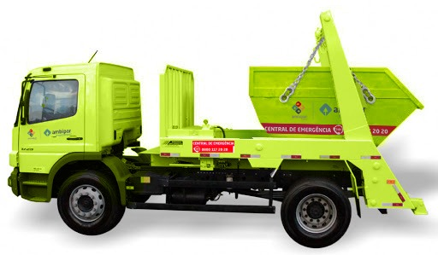

transportation

CO2eq

The aeration and the shaping of the windrows requires mechanical force (Figure 7), with electrical or combustion technologies employed.

* A compost turner or hydraulic excavator (this one is used at the first instance) are employed for aeration and shaping. Their maintenance schedule follows the manufacturer’s specifications to get the best in lifetime: predictive every 500 workhours.
* Wheel loaders are used to load trucks and can contribute to shape the windrows (included at this first instance). The same predictive maintenance schedule above.
* For quality improvement of the compost, an additional sieving process can be employed (absence within this first instance but predicted for the further instances). For this complementary operation unit, emissions from electrical energy have to be taken into account.
* The operation of composting facilities is documented in a quality control form, monitoring the conditions and procedures that ensure that each batch of the soil conditioner product derived from composting is in accordance with the parameters of the regulatory body MAPA. The registered product within MAPA requirements for the first instance calls ECOSOLO®. Once the composting stage reaches stability, the compost is labeled to be delivered for soil application.

Figure 7 - Compost turner on the windrow to accomplish the controlled aerobic treatment.

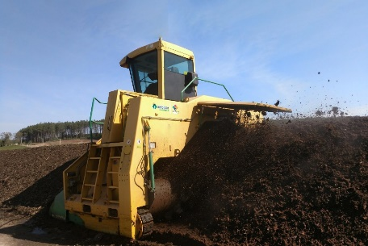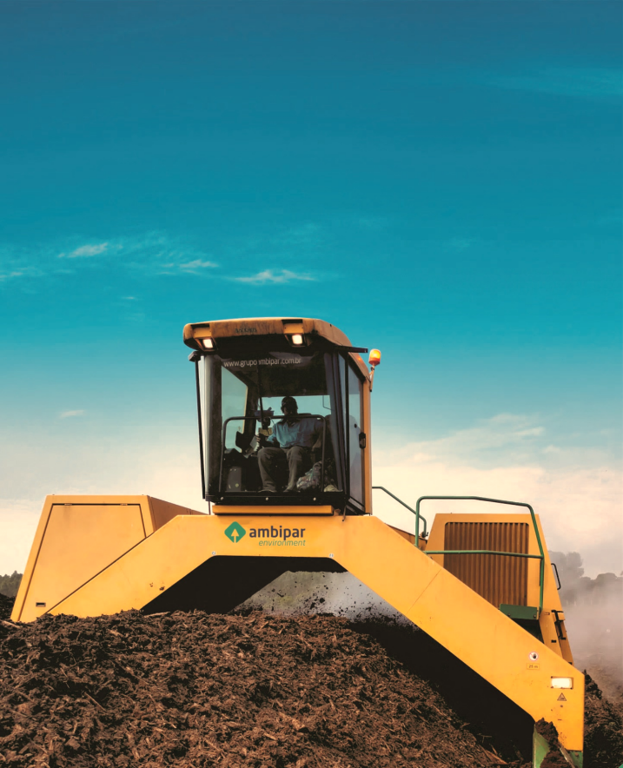

CH4

N2O

Figura 2 -

* Ambipar operates and supplies specialized know how about waste treatment management to industrial customers. This project addresses the quantification and stimulate worth evaluation of the waste into the carbon cycle. The first instance related to the project activity of composting process started with the organic waste generated by one paper mill and tends to expand to other sectors within future instances. Ambipar gets the amount of waste and is responsible throughout the waste treatment. It favors a clean and sustainable production and reduces environmental risks associated to SWDS. This system diverges significantly from the common practice within the project region.

Financially, waste disposal in SWDS is more attractive than biological treatment. Therefore, the services provided in the baseline scenario would be SWDS management. Based on the huge monthly volume of composting in industries, the waste manager has to search for continuous and proper rural areas to apply it (Figure 8) avoiding accumulation in the residues yard. Under the existing scenario, the soil conditioner product has been accumulated at composting facilities due to financial constraints to get the most noble application of the product by several rural producers. The main reason for this gap is the fossil fuel prices, necessary for transportation. The VCUs sales would fill out this gap among composting treatment center and raised planning of soil fertility.

Measurements (Composting facilities)

Volume of fossil fuel (in Liters) combusted by loader, turner or hydraulic excavator

Weight of organic waste at the entrance of the composting process

Quantity of waste composted

Calculation

CO2, NxO and CH4 emissions from fossil fuel combustion as CO2eq

NxO and CH4 emissions from composting cycle as CO2eq

NxO and CH4 emissions from composting process as CO2eq

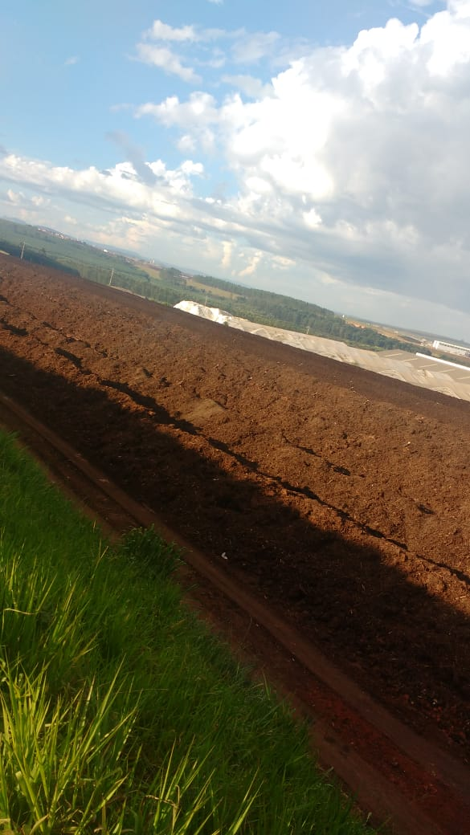

Composting facilities

Compost is delivered in the selected rural area where sustainable ALM will be implemented.



CO2

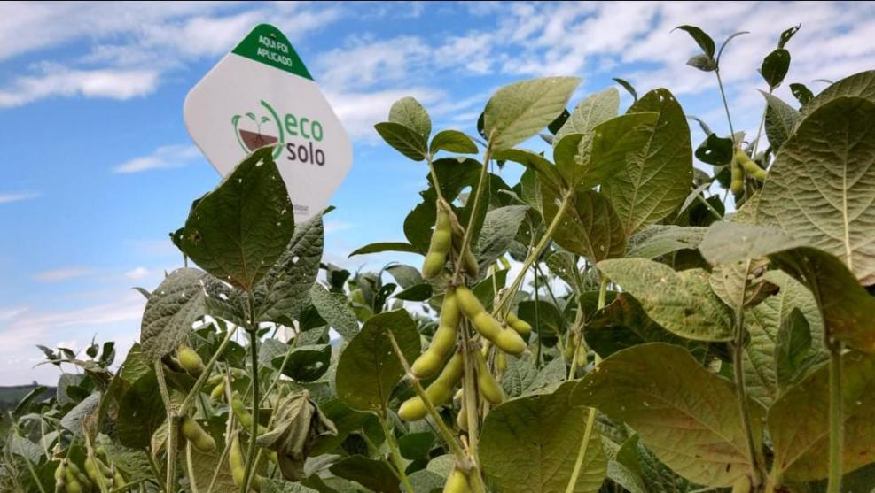

Measurements (Rural areas)

Soil organic carbon

Bulk density

Soil layers

Carbon concentration is calculated per area

Figure 8 – Waste composted with quality ensured for soil application and the rural area is monitored by measurements of soil organic carbon, bulk density into deep soil layers

### AFOLU project activity:Changes in carbon stock with sustainable ALM practices (VM0021 Methodology,v.1.0)

This innovative, and first of its kind project activity in Brazil aims to enroll and assist farmers to overcome barriers that prevent improve soils, grasslands and rangeland restoration, soil carbon protection and accrual. The project is designed to expand over time and cover a range of farmers and farming activities in Brazil to help drive the critical transition to a future dominated by resilient and sustainable agricultural systems. The enrollment of farmers to sustainable ALM practices encompasses training to land preparation, as choice of equipment that prevents soil erosion, preferring no-tillage, reduction, to the exclusion, whenever possible, of the use of pesticides harmful to the soil biome, crop rotation, on-farm diversification, structuring contour lines and compost application.

The enrollment starts with symposiums (Figure 9) and campaigns (Figure 10) to spread knowledge of beneficial productivity (Figure 11 and Figure 12) provided by sustainable ALM practices for farmers. In the baseline scenario, soil degradative agricultural practices keep be employed outcoming examples as the top images on Figure 11 and Figure 12, where low productivity and unhealthy soil is notable. Ambipar’s field adviser recruits a group of farmers including contract, sensitizing and trust building among them. Altogether, a participatory planning, monitoring and evaluation of the area led implementation project.

Ambipar has carefully selected land, farmers and setting boundaries within their rural properties. Targeted land meets specific requirements, preferably far from the water course, areas classified as mineral soil or intense practices of grassland and cropland and selecting open minded stakeholders to cooperate with the Agro Ambipar Survey. This Survey is based on the monitoring plan and has the function of sharing data from their land management and agricultural inputs data added to quantify the carbon removed from the atmosphere and associate it to the productivity.

Monitoring parameters include equipment activities, addition of inputs, agricultural productivity, macro, and micronutrient content in the soil, and mainly focus on the organic carbon content accumulated in the soil at one layer below rooting depths. The definition of carbon farmers is related to landowners that capture CO2 in the subsoil for fertility preservation.

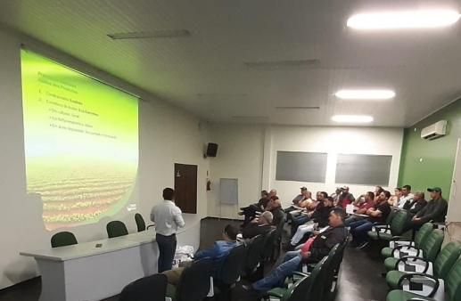

Figure 9 - Symposium about the benefits provided by ECOSOLO with regional landowners (2019).

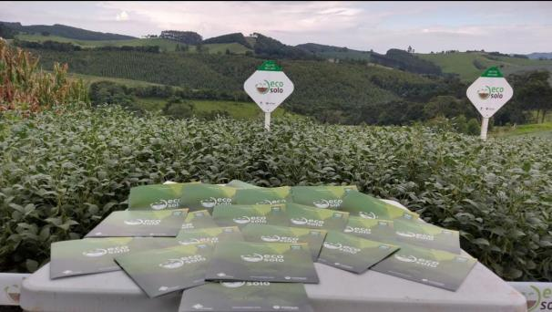 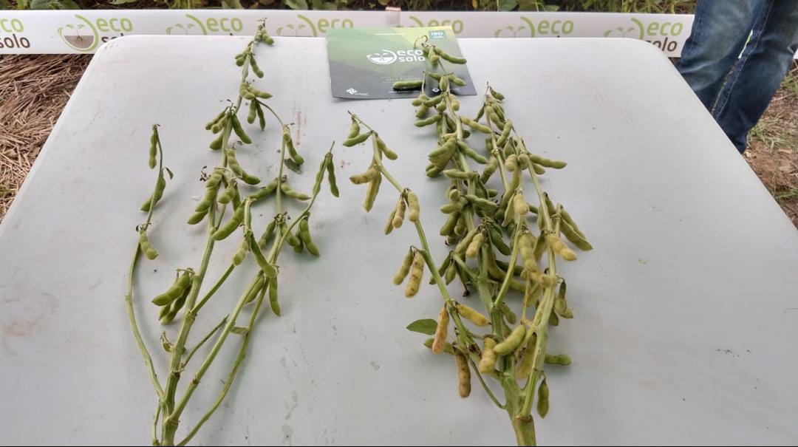

Figure 10 - ECOSOLO Campaign at a Sectorial Fair with benefits demonstrated in soybean cultivation (left) and Improvement in soybean productivity upon ECOSOLO application (right).

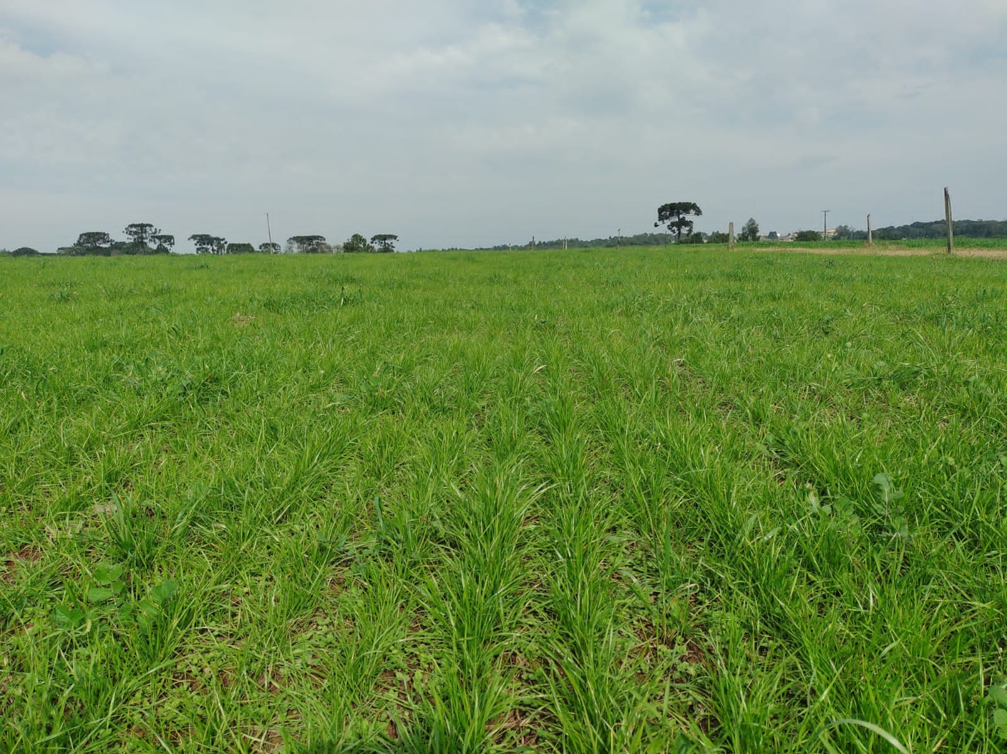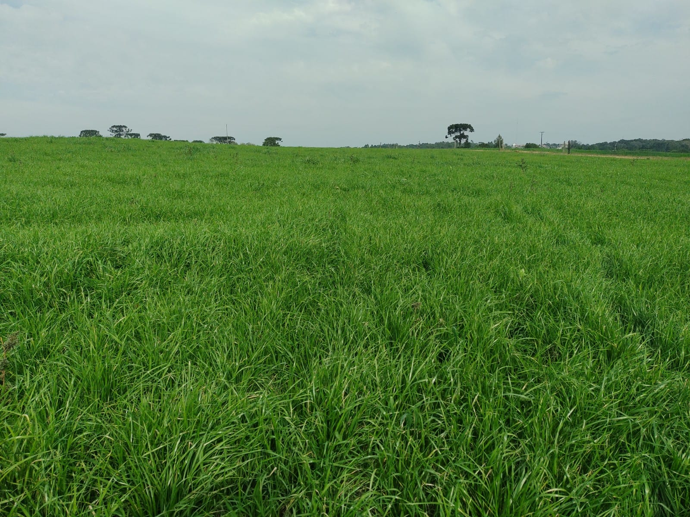

Figure 11 – Side-by-side comparison of vegetation density under no ECOSOLO application (at the top) and raised under ECOSOLO application (at the bottom).

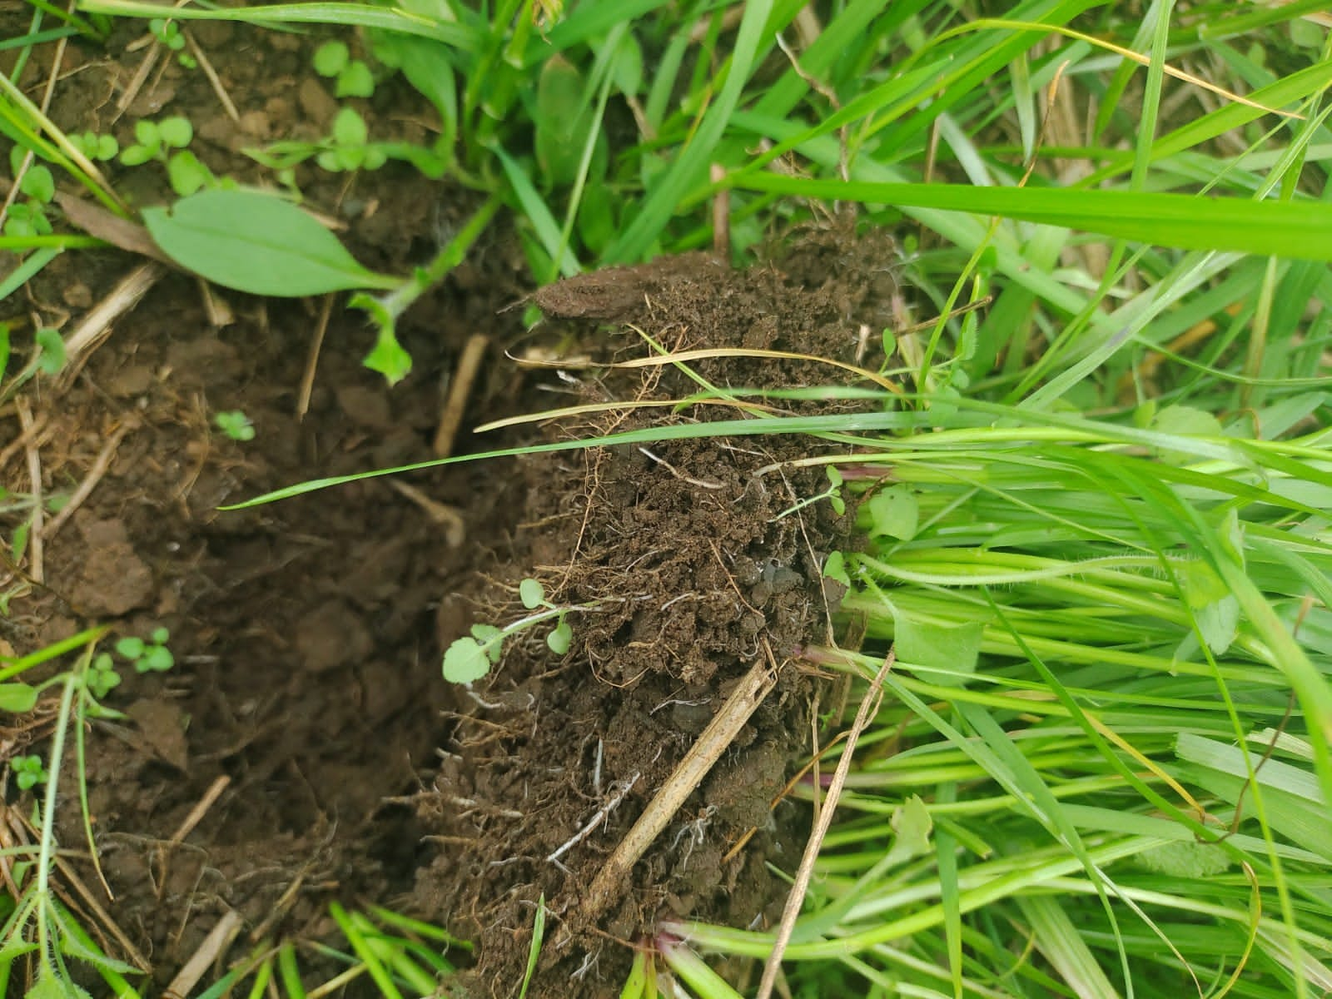

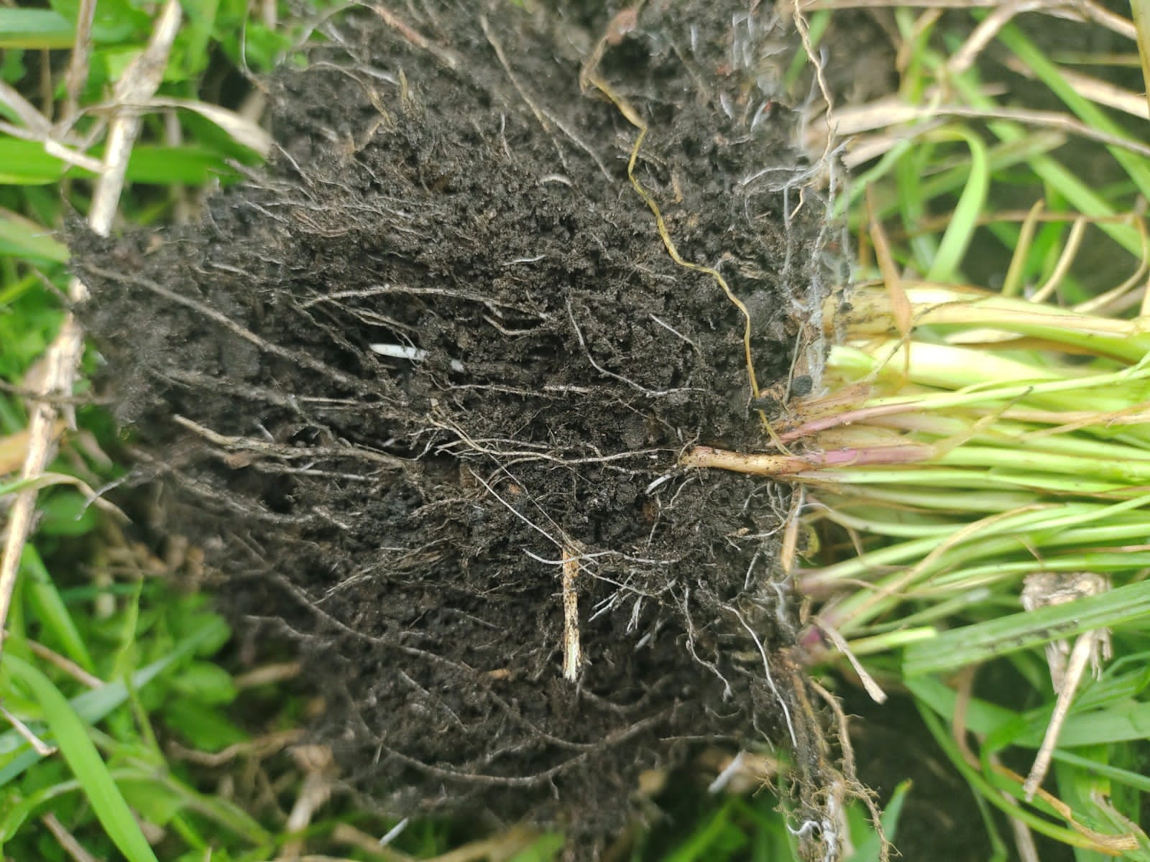

Figure 12 - Comparison of rooting in grassland area under no ECOSOLO application (at the top) and healthier under ECOSOLO application (at the bottom).

The delivery and application of ECOSOLO within the first instance will be scheduled according to the monthly production of the compost. The first sampling for the carbon stock estimation at the baseline scenario was previously to the ECOSOLO application. Annual soil sampling will be performed within this first instance for data analysis.

Specialized agricultural team of Ambipar will perform the stratification of the area, soil sampling, evaluation of the results of physical chemical analyzes, build the transition plan to the regenerative agriculture, and instruct landowners to register all the activities and inputs for scenario comparison during the monitoring plan.

The quantification of GHG emissions reduced and/or removed from the atmosphere is done by applying approved methodology (VM0021) and related modules, designed to monitor changes in soil organic carbon stocks and other parameters, relevant to agricultural processes and activities to mitigate climate change. Additionality of this AFOLU project activity is raise group of farmers to develop sustainable ALM practices, getting greater productivity and carbon accrual in their lands.

A summary of steps involved in the project is presented on Figure 13.

**Selection of organic matter or biomass to be composted nearby soil application**

**Campaigns about beneficial outcomes with regenerative agriculture practices**

**Evaluation of rural areas regarding the eligibility and set boundaries for stratification and sampling**

**Stakeholder awareness**

**Sensitization and trust building with farmers**

**Identification of potential additionality**

**Planning, training and advisory services on specific sustainable ALM practices**

**Re-sampling and data analysis**

**Monitoring Plan development**

**Estimative calculation**

**Third party audit**

**Annual Validation Report**

**VCU Sales for improvements and expansion**

**Implementation of aerobic biological treatment for organic matter be converted in compost**

Figure 13 - Sequency of steps involved in the project since selection of raw material to originate the compost until the carbon credit generation and management.

The first instance of the project is not located within a jurisdiction covered by a jurisdictional REDD+ program. Whilst further project activity instances of this grouped project will get updates regarding be included within a jurisdiction covered by a jurisdictional REDD+ program.

## Project Location

The project location for this grouped project encompasses the federation units of the Brazil where Ambipar has operation facilities for waste management (Figure 1), i.e., where the project owner has potential to demonstrate project’s conformance with regulatory compliance. The geographic boundaries of new project activities instances will be reported as soon the inclusion occurs across the national territory. Figure 14 illustrates the geodetic polygons of delineation of expected expansion of project activity instances. The blue circle refers to the first instance, whose characteristics is accurately described along this session.

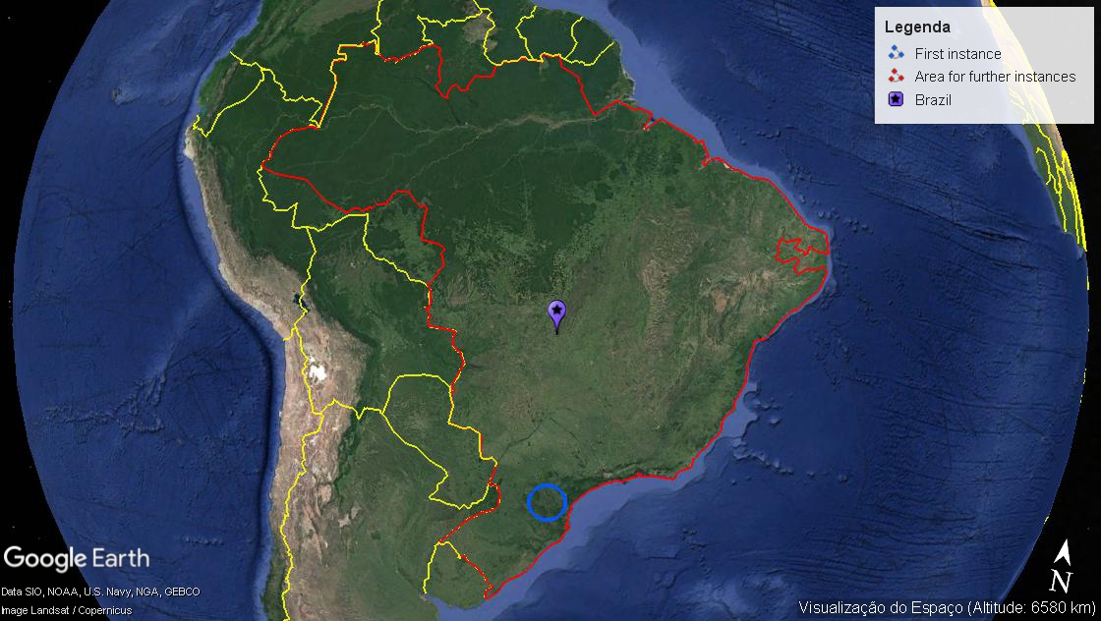

Figure 14 - Brazilian territory where there are operation units in regulatory compliance to implement new project activities instances. The blue circle in the south points out the project location of the first instance.

According to the applicability 12 of the AMS.III.F. Methodology, v.12.0, the distance of waste transportation to the project activity can take into account the radius traveled at the baseline scenario, i.e. the distance between the waste generation and predicted SWDS disposal. In addition, the distance to which the final product after composting will be applied shall not exceed a coverage radius of 200 km. The core of the project location within the first instance is the composting facilities, whose geodetic coordinates are 26°7'36.01"S , 50°19'0.36"O. It is where the non-AFOLU project activities occur under control and operation by Ambipar, project owner. Therefore, the potential of expansion for the project area with the AFOLU project activities is on Figure 15.

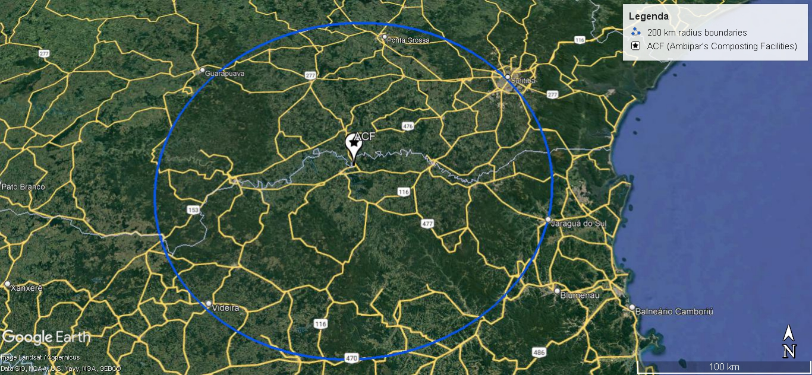

Figure 15 - Ambipar’s composting facilities (ACF) at the core of the project activity and the boundaries surrounding 200 km radius designing the project area where AFOLU activities can be implemented. The geodetic coordinates are 26° 7'36.01"S, 50°19'0.36"O (KML file separately available).

The Figure 16 assigns the location of the Ambipar’s composting facilities (ACF), the SWDS and some rural producer area with the respective ID number (xRPa) within the first instance in Três Barras city.

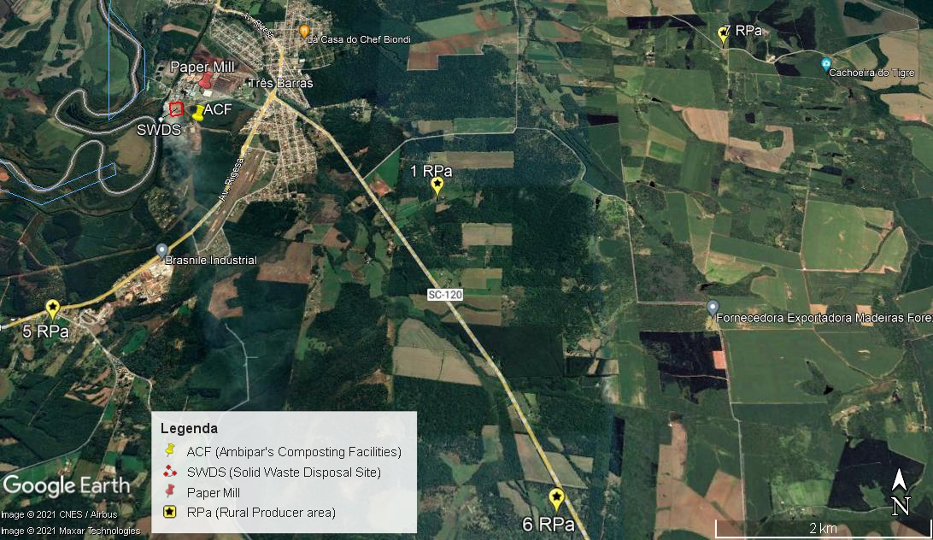

Figure 16 - Satellite image from surroundings of the city of Três Barras highlighting the location of the ACF and SWDS (KML file separately available).

The project location for the AFOLU project activities is in the Table 1 with geodetic coordinates and delineated on the Figure 18 up to the Figure 24 below within section 1.12. Selected land and rural producers adhered to the project through the agreement mentioned in the Section 1.7, which states the control and advisory services for sustainable ALM practices be received for estimative of carbon stock changes be operated by Ambipar.

The rural areas are legally documented in state and federal agencies (information available for consultancy at the folder “Registro da terra dos agricultores” during validation process).

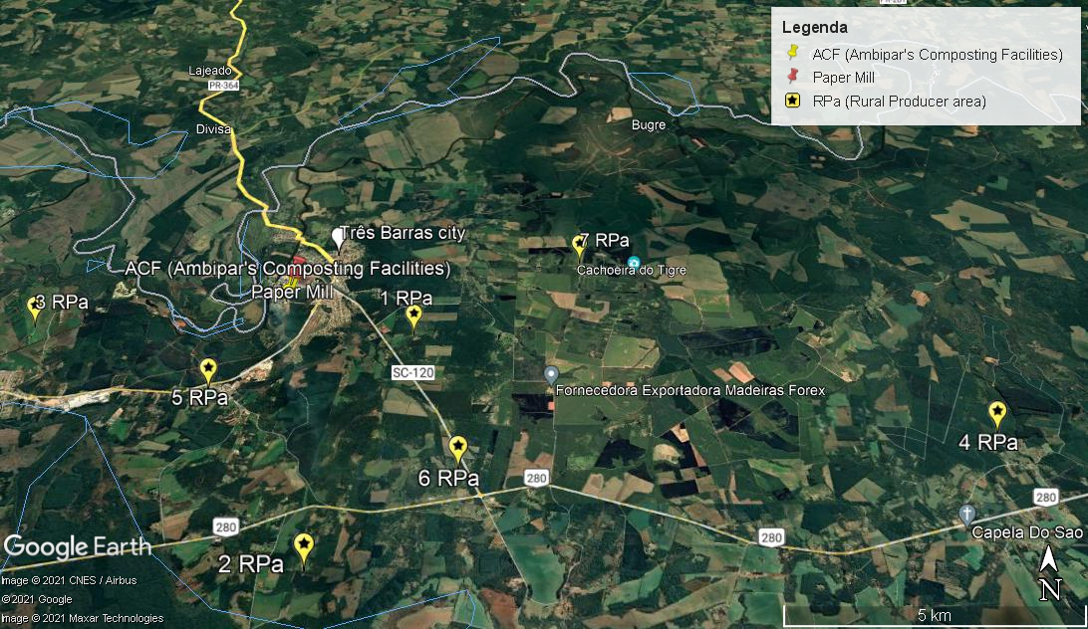

Figure 17 - Satellite image from surroundings of the city of Três Barras highlighting the location of the ACF and the seven rural producer areas within this first instance at the moment of the validation (KML file separately available)

Table 1. List of selected rural producers and area to implement sustainable ALM practices with compost application and soil carbon quantification.

|  |  |  |  |  |
| --- | --- | --- | --- | --- |
| Rural producer ID | Area (hectare) | Geodetic coordinate  SOUTH | Geodetic coordinate  WEST | Figure with area stratification |
| 1 | 8.20 | 26°8' 10.57" | 50°17' 15.38" | Figure 18 |
| 2 | 5.10 | 26°11' 10.78" | 50°18' 3.64" | Figure 19 |
| 3 | 3.40 | 26°8' 2.29" | 50°22' 9.45" | Figure 20 |
| 4 | 2.04 | 26°9' 36.42" | 50°10' 20.45" | Figure 21 |
| 5 | 4.80 | 26°6' 0.46" | 50°19' 39.06" | Figure 22 |
| 6 | 5.35 | 26°10' 3.75" | 50°16' 33.39" | Figure 23 |
| 7 | 14.40 | 26°6' 56.65" | 50°15' 6.31" | Figure 24 |
| Total area (ha) | 43.29 |  |  |  |

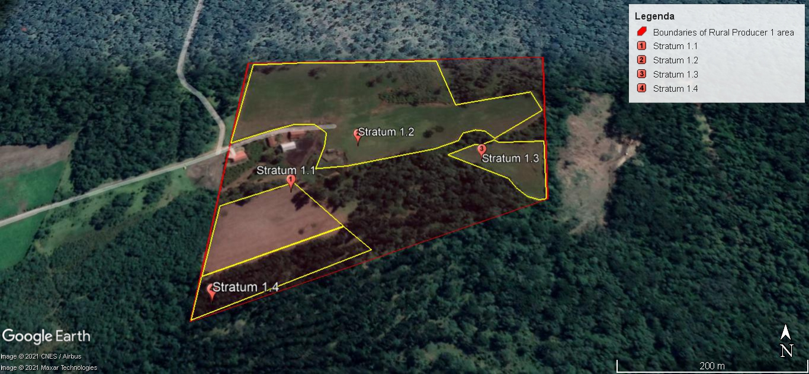

Figure 18 - Closer satellite image of the area of rural producer 1 in the first instance of the proposed project activities (KML file submitted separately). The red boundaries are for the rural producer area and the yellow outline the strata where the compost application occurs.

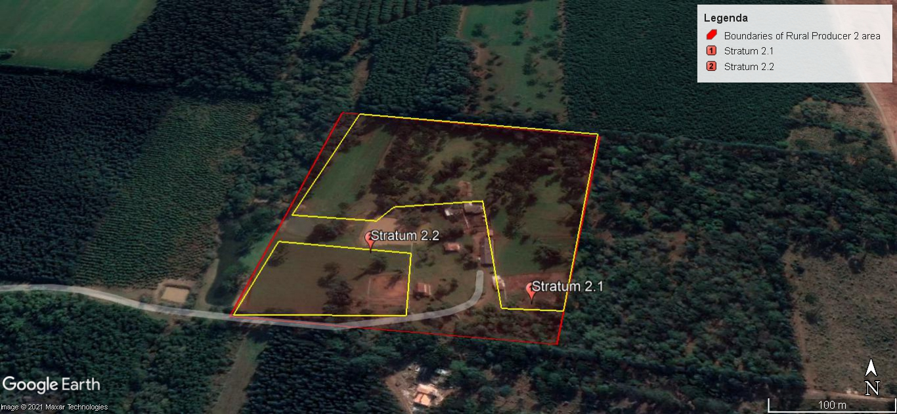

Figure 19 - Closer satellite image of the area of rural producer 2 in the first instance of the proposed project activities (KML file submitted separately). The red boundaries are for the rural producer area and the yellow outline the strata where the compost application occurs.

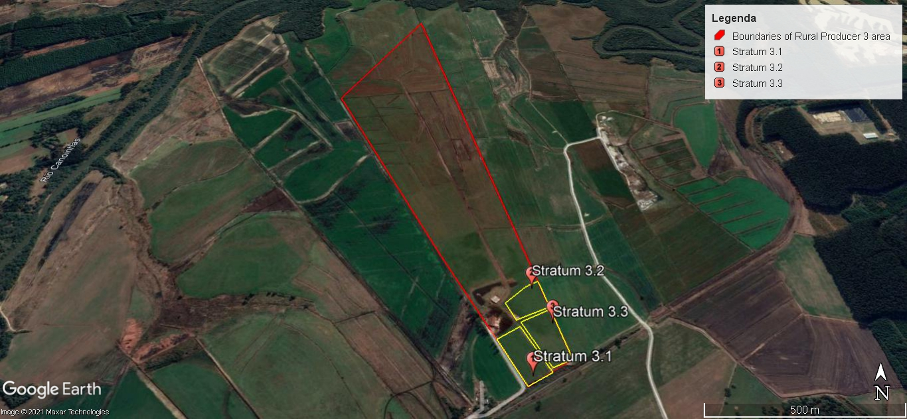

Figure 20 - Closer satellite image of the area of rural producer 3 in the first instance of the proposed project activities (KML file submitted separately). The red boundaries are for the rural producer area and the yellow outline the strata where the compost application occurs.

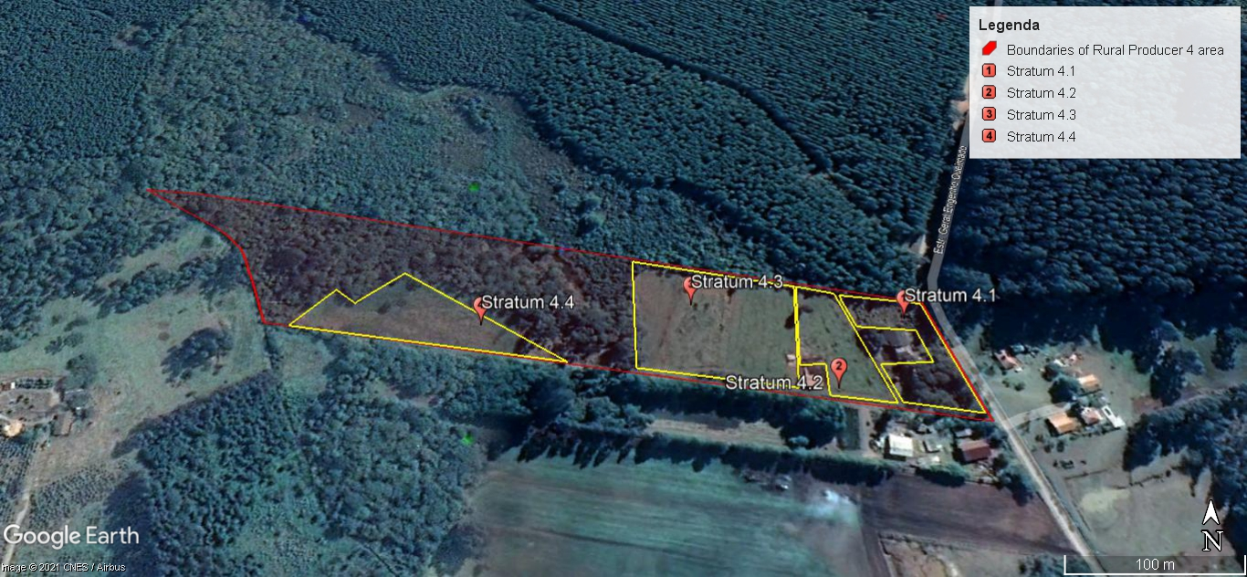

Figure 21 - Closer satellite image of the area of rural producer 4 in the first instance of the proposed project activities (KML file submitted separately). The red boundaries are for the rural producer area and the yellow outline the strata where the compost application occurs.

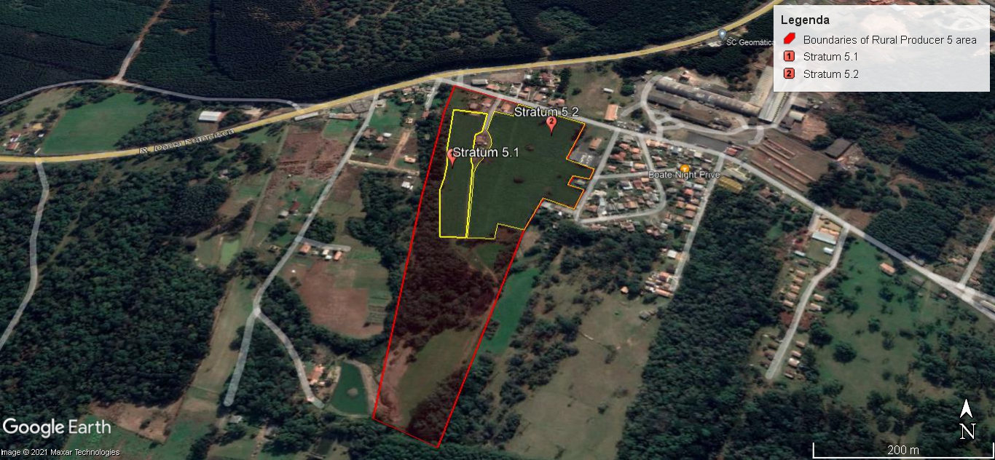

Figure 22 - Closer satellite image of the area of rural producer 5 in the first instance of the proposed project (KML file submitted separately). The red boundaries are for the rural producer area and the yellow outline the strata where the compost application occurs.

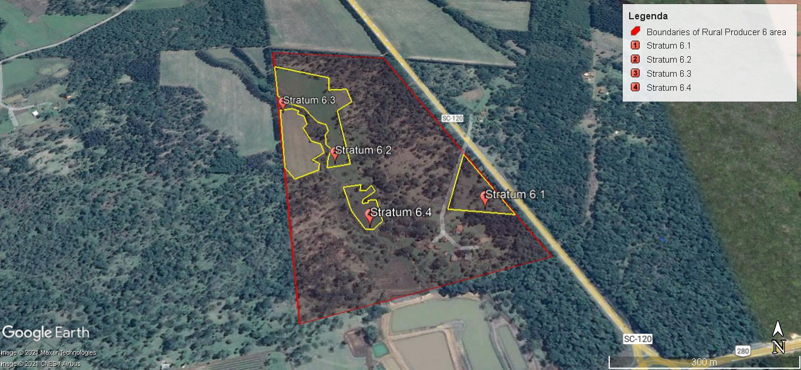

Figure 23 - Closer satellite image of the area of rural producer 6 in the first instance of the proposed project activities (KML file submitted separately). The red boundaries are for the rural producer area and the yellow outline the strata where the compost application occurs.

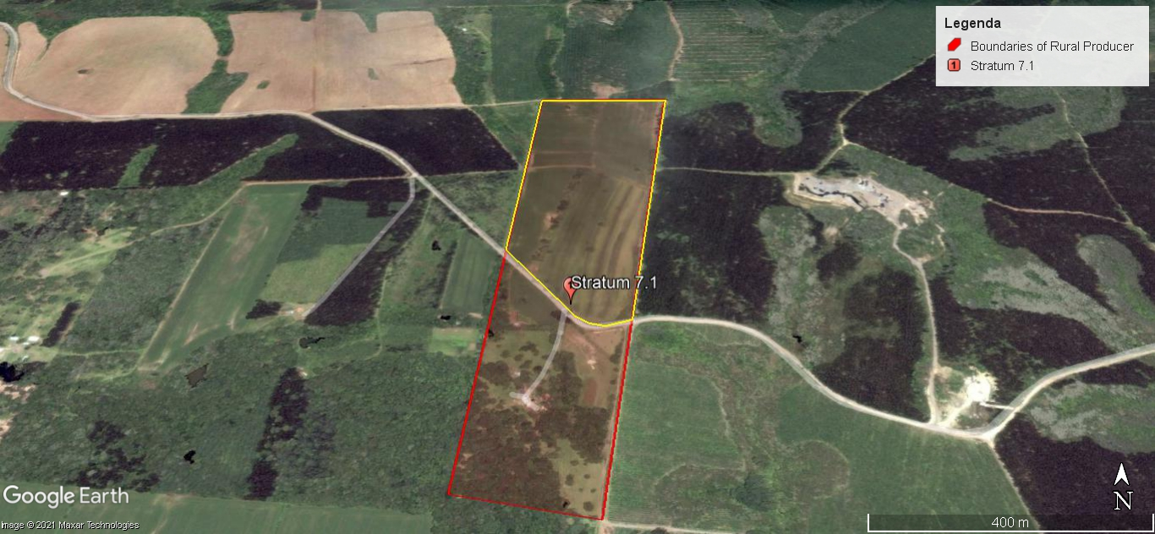

Figure 24 - Closer satellite image of the area of rural producer 7 in the first instance of the proposed project activities (KML file submitted separately). The red boundaries are for the rural producer area and the yellow outline the strata where the compost application occurs.

## Conditions Prior to Project Initiation

Prior to project initiation, the composting yard has accumulated huge volume of compost, because rural producers within the first instance were not follower for regenerative agriculture and had the prejudice about the compost quality based on industrial waste. With the implementation of Ambipar’s know how about conformance in biological treatment, and dissemination about improvements regarding sustainable ALM practices, the trust building was slow. In addition, the fuel prices oscillation diverts rural acquisition of the organic input. It is common practice in the region that factories do not hesitate to dispose waste into landfills.

Small rural properties usually carry out the so-called extensive agriculture, with the addition of agricultural inputs aligned to visual sensitivity and experience, that is, without quantitative analytical monitoring and without the guidance of a qualified professional for this purpose. Continuous land degrading, tillage and land exposure after harvest are common practice in the region. The condition prior to the project initiation is perceived by avoidance of organic inputs due to the slower response compared to the synthetic inputs. The project activities provide participatory planning, advisory services addressed by soil analysis, whose results are shared for soil and productivity improvements. Summing up to the fact that soil conditioner will be available within the first instance, being liable to food security, soil healthy and rentability.

The increase in profitability and less aggressive working conditions tends to reduce the prone rural exodus, which is raising in the country. Besides the rural population be elderly, climate changes (increased insensitivity of the rainfall regime and increased temperature) can affect food supply, market price and, consequently interference economically in society. The implementation of the project tends to offer better working conditions influencing younger generation interested and committed to organic and sustainable production. The project's implementation structure offers information and knowledge about regenerative agriculture, qualifying farmers, reducing the need for chemical fertilizers that vary directly with exchange rate fluctuations.

The project location was climate classified based on the methodology proposed by Wladimir Köppen, the most used classification in the World. According to this classification, the project activity area is Cfb climate type – Humid mesothermic climate, with rain well distributed, mild summers and rigorous winters (Figure 25). The mean annual temperature and relative humidity is about 17-18 °C and 80-82%, respectively, with warm summer, most humid than winter, and uniform precipitations during all months of the year. With this mean annual temperature below 20 °C and high humidity, it is considered a boreal/temperate wet climate. The mean annual pluviometric index for Três Barras region is ranged about 1500-1700 mm. In this classification there is no presence of dry seasons and occurrences of frosts during the colder periods.

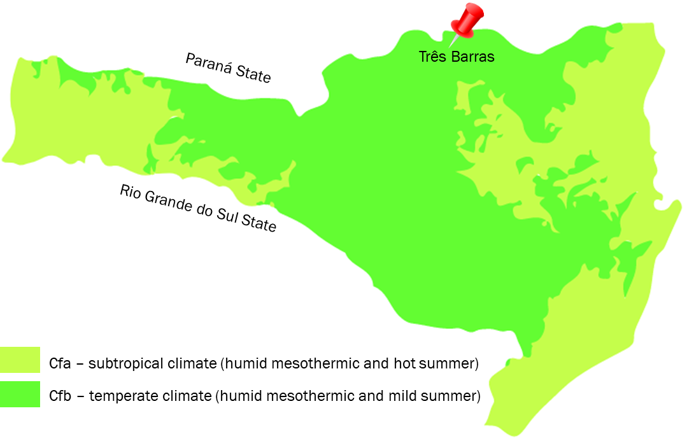

Figure 25 - Climatological classification of Santa Catarina State, Brazil, according to Köppen. Source: Elaborated from Atlas Climatológico de Santa Catarina, 20071.

The Santa Catarina State presents considerable watersheds spread in all regions. The project region is localized at number 10 on Figure 26.

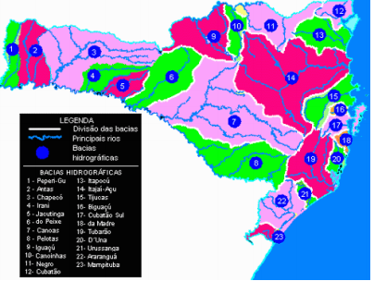

Figure 26. Map of watersheds region in Santa Catarina State, Brazil2.

The project activities within the first instance are localized at the Northern Santa Catarina Plateau, in the region of Três Barras city, Santa Catarina, Brazil. The region presents mean altitude3 of 802 m (Figure 27), area of 438,07 km2 and it is distant 349 km from Florianópolis (State’s capital). Três Barras is localized at 26°06’23’’ latitude south and 50°19’20’’ longitude west.

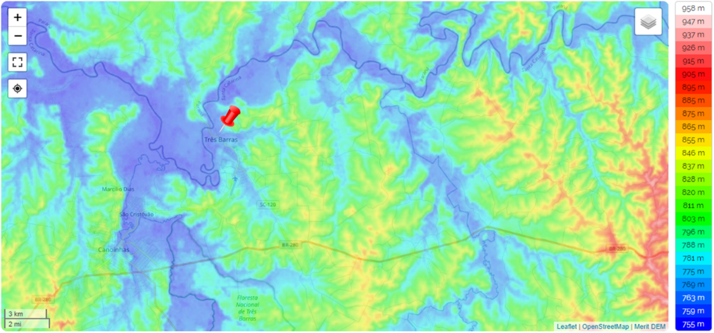

Figure 27. Topographic map of the project region at Três Barras, Santa Catarina, Brazil4.

The name of Três Barras was originated through of three rivers that surround it: Negro, São João and Canoinhas. Três Barras city was founded in January 23rd 1961 and present a population estimated in 19,046 inhabitant5. The immigration of Portuguese, Polonies, Ukrainians and Lebanese beside that caboclo people (Xocleng Indians), in 1909, started the colonization of the region. According to the Ministery of Labour related to 2015, Três Barras counted with 720 companies, which were responsible for the generation of 4,852 formal jobs. In 2015, the micro and small businesses represent 98,6 % of the companies present in the city and they are responsible by 31.3 % of the formal jobs. In Três Barras, 8.6 % of the establishment are connected to agricultural sector, 16.9 % to industry, 36.9 % to commerce and 37.5 % to services sector. The industrial sector is the one that the most employ in the city (58.7 %), followed by the services with 23.9 %.

The project activity instance is localized in a region practically contextualized by cambisols and latosols and in small proportion of gleysols, neosols and nitisols. The soil generation is intrinsically related to the rock mineralogical composition, climate, permeability, geomorphology and the time of action of the process that act on the rocks. The main characteristics of each type of soil found in the project region is presented below, using the Brazilian System of Soil Classification (SIBCS, 2018)6:

* Cambisols are characterized by slight or moderate weathering of parent material and by absence of appreciable quantities of illuviated clay, organic matter, aluminum and/or iron compounds. Environment: level to mountainous terrain in all climates and under a wide range of vegetation types.
* Latosols, also known as tropical red earth, are soils found under tropical rainforests which have a relatively high content of iron and aluminum oxides. They are typically classified as oxisols or ferralsols. It is largely correct to say that latosols are tropical soils, but the reverse is not true because there are many soils in the tropics that are not latosolic. Latosols are red or yellowish-red in color throughout and they do not have distinct horizons. They are deep soils, often 20-30 m deep. The soil generally contains a thin but very fertile layer of humus dropped from plants and animals in the forest above, followed by an infertile second layer due to rapid leaching in the high rainfall. The third level, weathered bedrock, is common to almost all soil types. The latosol is completely reliant on the rainforest to maintain fertility, as all nutrients leach away quickly when the forest is felled, and the layer of humus is no longer being replaced.

The vegetations type and ecosystems within Santa Catarina State is present on Figure 28, where is notable that the project location is characterized mainly by Araucarias Forests biome.

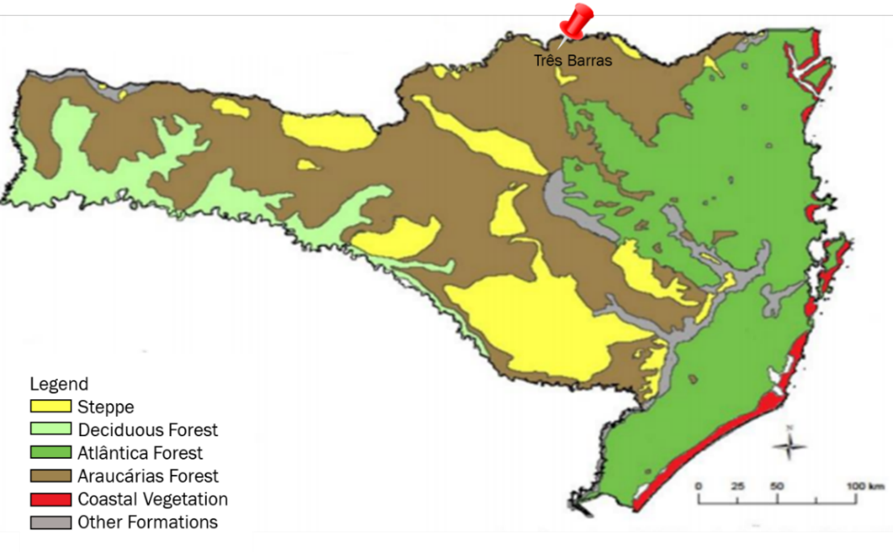

Figure 28. Vegetation type and ecosystems found in Santa Catarina State, Brazil.

The new project activities instances are still not stablished prior to the validation process, since a credible program with stakeholders, rural producers’ engagement is sensitive and makes part of a slow building. The validation of the first instance will be helpful as demonstration field for other instances.

In general, the data presented in the sub-section sustainable development of the section 1.17 dispel the necessity to increase de 1.26% of Brazilian organic farmers. For inclusion of information about the present and prior environmental conditions of the predicted expansion project area, some Brazilian data were gathered below based on the location where Ambipar has treatment facilities (Figure 1).

The Figure 29 presents high-level information for Brazil's climate zones and its seasonal cycle for mean temperature and precipitation for the latest climatology, 1991-2020. Climate zone classifications are derived from the Köppen-Geiger climate classification system, which divides climates into five main climate groups divided based on seasonal precipitation and temperature patterns. The five main groups are tropical, dry, temperate, continental and polar.

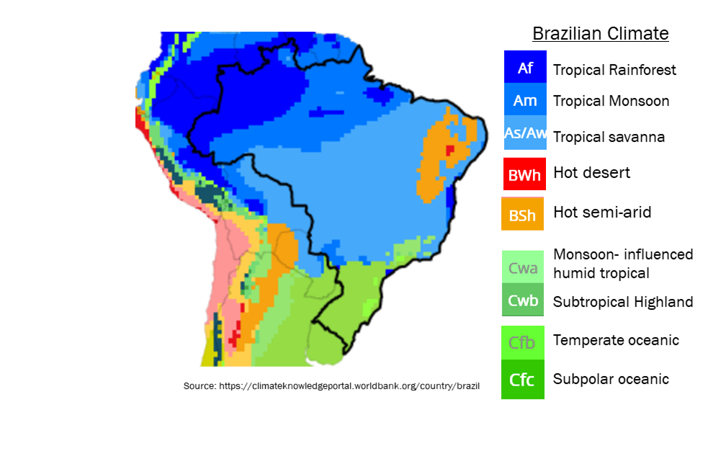

Figure 29 - Diversity of climate zone within the Brazilian territory. Source: https://climateknowledgeportal.worldbank.org/country/brazil.7

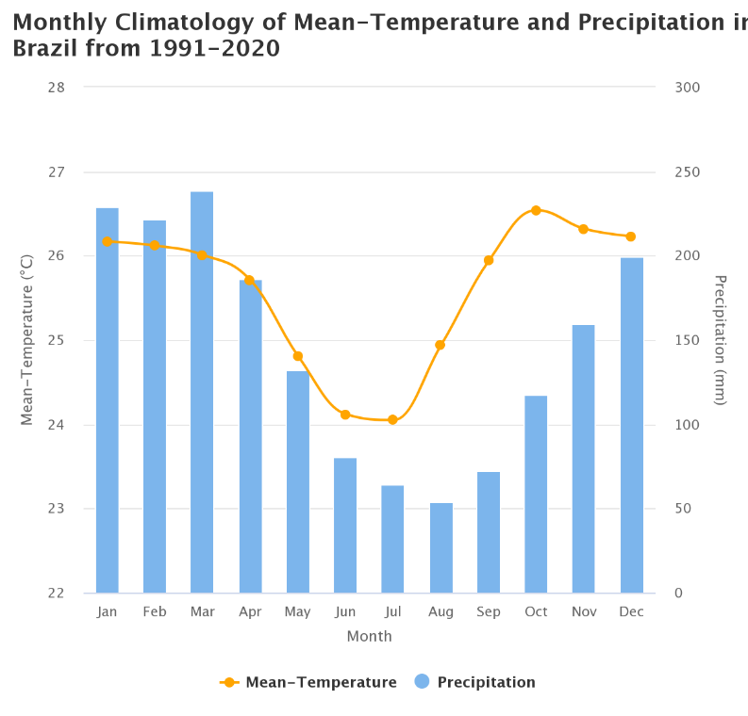

Figure 30 - mean temperature and precipitation for the latest climatology, 1991-2020. Source: <https://climateknowledgeportal.worldbank.org/country/brazil>7

The Brazilian land area of 8,510,295 km² corresponding to the fifth largest country in the world. Brazil is home to an extremely rich flora and fauna and a rich diversity of ecosystems including, but not limited to, the Amazon Forest, the Cerrado (central plateaus, covering 21% land area), the Atlantic Forest (forests which extend along the Atlantic coastline), the Caatinga (desert shrubland in the northeast) and the Pantanal wetlands (encompasses the world’s largest wetland area, located along the western border). Brazil’s diverse and abundant natural resources, ecosystems, and significant biodiversity are world renowned. The national territory comprises six unique biomes: Amazon, Caatinga, Cerrado, Atlantic Forest, Pampa, and Pantanal. The Amazon and Atlantic Forest are home to humid and seasonal forests and significant biodiversity. The Caatinga is characterized by semi-arid climate and arid plant life. Cerrado houses three major watersheds of South America, which makes it the richest savannah in biodiversity worldwide.

Brazil has a population of 214 million people (2021) with an annual population growth rate of 0.8% (2019). The population projected to reach 223.8 million people by 2030 and 228.9 million by 2050. An estimated 86% of the country’s population resides in urban areas, and this is expected to increase to 92% by 2050.

The Figure 31 demonstrates the daily waste generation per habitant within the 26 states (SNIS 2021)8. In 2017, organic waste was estimated to reach 800 million of tonnes. The estimative of organic waste into the solid waste composition is about 50%, that elucidate the amount of potential wasted because it has not been applied for fertility in agriculture.

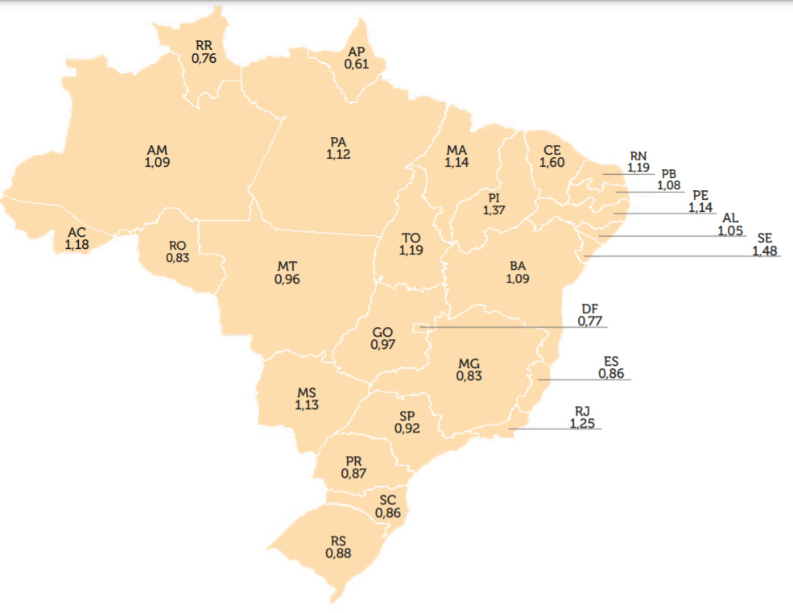

Figure 31 - Mass of solid waste daily generation per habitant in kilograms. Approximately, 50% is organic waste that has not been reused for soil fertility. Source: SNIS, 2021.

The types of destinations for the final disposal of solid waste in Brazil from 2010 to 2015 were (on weight basis): sanitary landfill, 57.6–58.7%; controlled landfill, 24.3–24.1%; and open dump, 18.1–17.2% (ABRELPE, 2016)9. The Figure 32 presents the waste mass disposed in these types of destination along the Brazilian states, demonstrating that open dump representation has been decreasing.

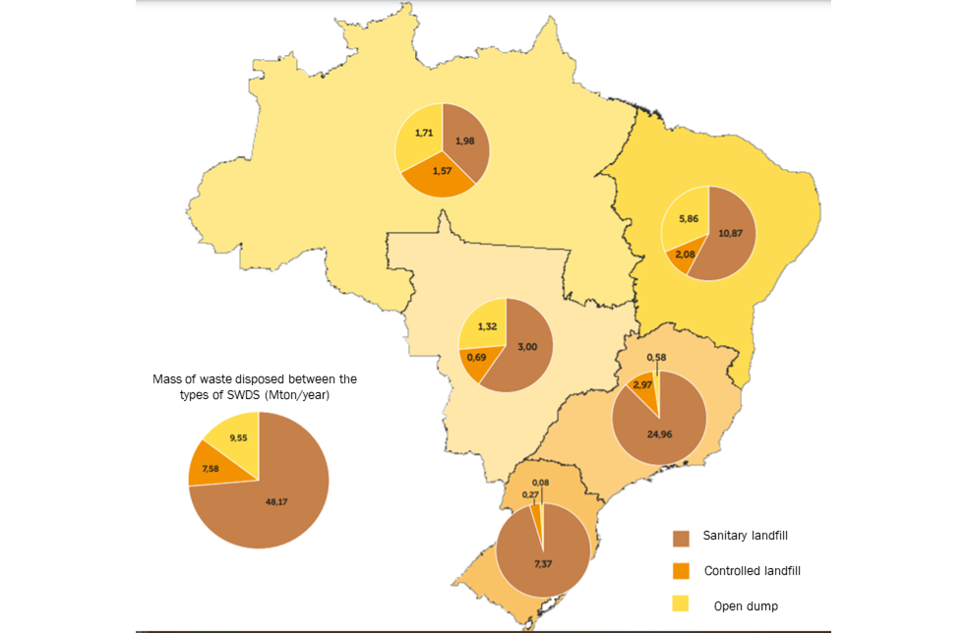

Figure 32 - Distribution of types of destinations for the final disposal of solid waste in Brazilian microregions with the value of solid waste in Mton/y in 2020. Open dump are representing 14.6%, sanitary landfill 73.8% and controlled landfill 11.6%.

Until 2020, there were only 74 registered composting facilities across the national territory processing 270 thousand tons of organic waste. This number is low among the predicted mass or organic waste produced by the population. The project area expansion tends to absorb some of this potential to avoid methane emissions by left to decay in SWDS and reintroduce for soil application. The primary expansion units will be surrounding the Ambipar’s facilities for capacity expansion or composting implementation. Current data about compost application associated to carbon sequestration and regenerative agriculture are still publicly unavailable to enrich the sectorial engagement.

The country’s economy is driven primarily by industry, its services sector and agriculture. Brazil is the largest net-exporter of agricultural commodities, with the agri-business sector contributing approximately 20% of the country’s GDP and over 30% of all domestic employment. Brazil is one of the world’s leading exporters of soybeans, beef, coffee, and automobiles.

There are 13 soil classification across the Brazilian territory due to the wide diversity of factors for formation of the soil. The wide peculiarity observed in the pedoenvironments also represents an important condition for the assessment of the potentials and limitations of each soil, conditioning its sustainability as a function of the uses and management practices applied.

Latosols, Argissolos and Neosols predominate, which together are distributed in approximately 70% of the national territory (Figure **33**). The Oxisols and Argissolos classes occupy approximately 58% of the area and are deep soils, highly weathered, acidic, of low natural fertility and, in certain cases, with high aluminum saturation. There are also medium to high fertility soils, which are generally shallow due to their low degree of weathering. These fall mainly into the classes of Neosols, Luvisols, Planosols, Nitosoils, Chernosols and Cambisols.

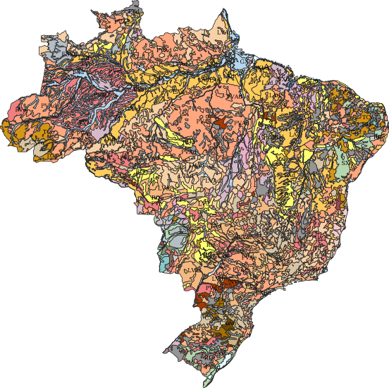

Figure 33 - Geographic distribution of soil classification in Brazil, based on the Brazilian system of Soil Classification (Sistema Brasileiro de Classificação de Solos -SiBCS, 200610 - http://geoinfo.cnps.embrapa.br/layers/geonode%3Abrasil_solos_5m_20201104).

In 2017, EMBRAPA11, a Brazilian public agricultural research corporation that works to have solutions that ensure sustainable development grow from the fields gathered their calculations of the sum of SOC stocks from horizons/layers within 0-30 cm. The environmental covariates values were extracted to the soil sampling points by spatial overlay and the results range were from 2.6 to 417.3 t ha-1, with a mean of 4.8, median of 4.1 and standard deviation of 3.3 t ha-1. Zinn et al (2018)12 compiled the literature on Brazilian soils encompassing all regions of the country and different ecosystems. They evaluated the percent changes in soil organic carbon (SOC) after conversion of native vegetation to different land use systems (pastures with/without nitrogen fertilization, annual crops (no-till or minimal tillage), annual crops (conventional tillage) and perennial crops) and found a mean loss in SOC ca. 75% (0–20 cm depth interval) and 14% (for a 20–40 cm depth interval). According to the same study, the SOC contents in pristine soils vary widely due to factors such as climate, forest and soil type, depth, percent of plant debris, and soil internal drainage. These factors widely variable in Brazil, makes it difficult to stablish an historical and actual conditions about the topography for further expansion activities of the proposed project. Then, an interpretation of the significance of soil organic carbon changes is complex and must be done on a case basis. For instance, many of the soils in the southern and southeastern parts of Brazil have long supported productive commercial production of human food. However, it has been only in recent years that commercial agricultural production has accessed the more extensive soils originally under Cerrado vegetation in the Central-West region of Brazil and some tropical forested areas of the Amazon basin, representing a new expansion of the agricultural areas in Brazil. Cerrado is the region of Brazil where most grain production development is taking place. In 1955 only 200,000 hectares in the Cerrado region were considered arable. In 2005 over 40,000,000 hectares were in cultivation. This phenomenal achievement over a span of less than 50 years is the world's single largest increase in farmland. The great expansion affects negatively the native vegetation impacting the soil condition, weather, rainfall and, consequently, the climate change.

Several studies have suggested that Brazil has an opportunity to significantly increase its agricultural production without new deforestation. This opportunity is rooted in the fact that Brazil has a very large pool of already cleared, underutilized land, as well as capable agricultural sector that is primed for innovation. The graphs on Figure 34 presents historical productivity increase in grassland and croplands (specific for soybeans). It means that some macroregions increased their yield in reduced expansion of area, but south and central for the croplands. In north is also alarming the area increasing for low increment in heads per hectare. Our project intends to expand for compost application and model sustainable ALM practices for several ecosystems within Brazil.

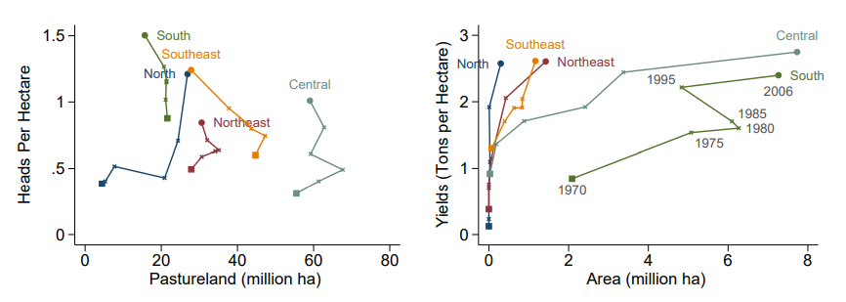

Figure 34 -Evolution of Cattle Grazing and Soybean Cultuvation: Area and Productivity, Brazil 1960-2006. Source: INPUT, 2016.13

Brazil’s vast territory is home to an extraordinary mosaic of ecosystems, which parallel its climatic and topographic diversity. Notably, northeast Brazil exhibits a semi-arid climate, receiving less than 700 mm per year of rain. Climate variability across the country is driven by the South American Monsoon System (SAMS), the El Niño Southern Oscillation (ENSO), and the Inter Tropical Convergence Zone (ITCZ). Typically, early October marks the beginning of monsoon season in tropical Brazil. For the country’s austral summer (December to February), the Amazon Basin receives a significant increase of precipitation. The country experiences a rainfall gradient from the northwest to the south and east. The Figure X presents the historical annual mean temperature of Brazil since 1901. There is a smooth increase concentrated later than the nineties.

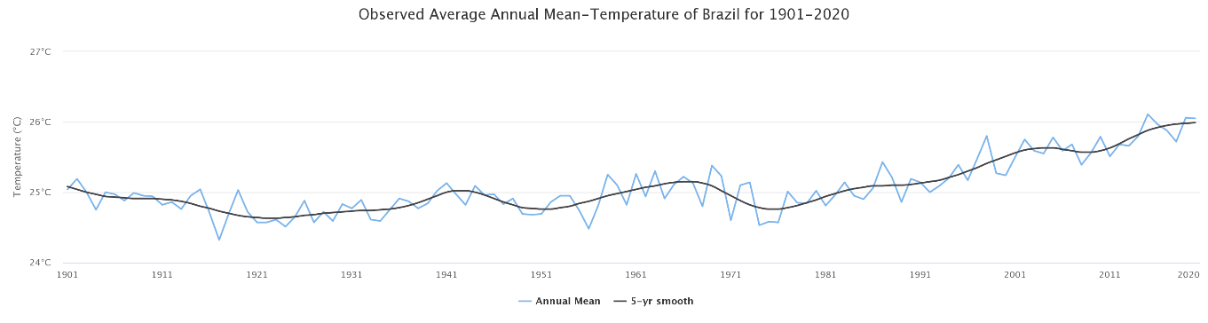

Figure 35 - Observed average annual mean temperature of Brazil for 1901-2020. Source: https://climateknowledgeportal.worldbank.org/country/brazil/climate-data-historical.7

## Compliance with Laws, Statutes and Other Regulatory Frameworks

According to the National Solid Waste Policy (highlighted below), Ambipar is legal service provider contributing to circular economy, recycling and reusing organic matter. Appendix A provides the composting facilities registration and product registry of the compost, classified as soil conditioner according to the CONAMA 481, IN 27, 35 and 53 highlighted in details below. The parameters for quality control of the organic waste involve physical chemical analysis such as raw material for the composting process, as well as conformity in composting batches of soil conditioner in compliance with the mentioned IN 27 and 35. The monitoring plan of the ECOSOLO application and additionality is driven by soil analysis results and batch analysis. Data will be shared with rural producers and additionality results will be reported.

1. **National Solid Waste Policy (PNRS)14 - Law No. 12,305**

The National Solid Waste Policy - Law No. 12,305, established on August 2nd, 2010, provides for the principles, objectives, and instruments, as well as guidelines for integrated management and solid waste management, the responsibilities of generators and the government and applicable economic instruments.

Individuals or legal entities, whether public or private, responsible directly or indirectly for the generation of solid waste and those who develop actions related to integrated management or solid waste management are subject to compliance of this Law. The project activity follows the principles of the PNRS, including Article 6 - The principles of the National Solid Waste Policy:

III - the systemic vision, in the management of solid waste, which considers the environmental, social, cultural, economic, technological, and public health variables.

IV - sustainable development.

VIII - the recognition of reusable and recyclable solid waste as an economic good with social value, a generator of work and income and a promoter of citizenship.

This project also has synergies with the objectives of the PNRS, including Article 7 - The objectives of the National Solid Waste Policy:

I - protection of public health and environmental quality.

II - non-generation, reduction, reuse, recycling, and treatment of solid waste, as well as environmentally appropriate final disposal of the waste.

III - encouraging the adoption of sustainable patterns of production and consumption of goods and services.

IV - adoption, development, and improvement of clean technologies as a way to minimize environmental impacts.

VII - integrated solid waste management.

IX - continued technical training in the field of solid waste.

XIV - encouraging the development of environmental and business management systems aimed at improving production processes and reusing solid waste, including energy recovery.

The PNRS instruments, which have synergies with this project:

VI - Technical and financial cooperation between the public and private sectors for the development of research on new products, methods, processes and technologies for management, recycling, reuse, waste treatment and environmentally appropriate final disposal of waste.

VII - scientific and technological research.

Section V of Chapter II provides guidelines for preparing the Solid Waste Management Plan. Industrial solid waste generators are subject to the preparation of a solid waste management plan based on Article 20.

Chapter III deals with the responsibilities of generators. According to Article 27: “The natural or legal persons referred to in art. 20 are responsible for the implementation and full operation of the solid waste management plan approved by the competent agency (...) § 1 Hiring services for the collection, storage, transportation, transshipment, treatment or destination of solid waste, or the final disposal of waste, does not exempt the individuals or legal entities referred to in art. 20 of the liability for damages that may be caused by the inadequate management of the waste or tailings”. According to it, Ambipar services are in compliance with the responsibilities to control and operate the waste management.

1. **Resolution No. 481 by CONAMA (National Council for the Environment)15**

CONAMA Resolution No. 481, issued on October 3rd, 2017, establishes the criteria and procedures to guarantee the control and environmental quality of the organic waste composting process, in order to protect the environment and reestablish the natural cycle of organic matter and its role of fertilizing the soil, in addition to other measures. The first instance attends to all these guidelines for composting operation.

Section II refers to the guidelines for the environmental quality of the composting process. According to Article 5, during the composting process, the thermophilic period is necessary to reduce pathogenic agents and must be guaranteed

Article 6 establishes in paragraph 2 that the carbon/nitrogen ratio of the compounds that are used for the manufacture of substrates for plants, soil conditioners and as raw material for the manufacture of organomineral fertilizers must be determined according to the analytical methodologies adopted by MAPA or other internationally accepted methods.

Section III - Article 10 establishes the guidelines for the environmental control of composting units:

I – taking the necessary environmental control measures to minimize leachate and odor emission and avoid the generation of leachate.

II - soil protection through base waterproofing and installation of collection, handling and treatment systems for the leachate liquids generated, as well as the management of rainwater.

III - implementation of a system for receiving and storing organic waste *in natura*, guaranteeing the control of odors, generation of liquids, vectors, and nuisances to the community.

IV - taking isolation and signaling measures in the area, with access to unauthorized persons and animals being prohibited.

V - control of the types and characteristics of the treated waste.

VI - control of the environmentally appropriate final disposal of solid and liquid waste generated by the composting unit.

1. **MAPA Normative Guidance No. 53 16**

Normative Guidance No. 53, issued on October 23rd, 2013, regulates the provisions and criteria for determining, the classification, registration and renewal of the facility’s registration, product registration and other measures.

Chapter I, Art. 2 defines the following in items IV, V and VI:

“IV - Secondary Material Generator: individual or legal entity, public or private, registered with MAPA, responsible for activities or undertakings that generate or sell authorized by-products, which can be safely applied to agricultural use, directly or indirectly, as a fertilizer, concealer, remineralizer and substrate for plants or as raw material for their manufacture;

V - Storage Service Provider: individual or legal entity, that has adequate facilities and equipment, to store the products covered by the Regulation of Law No. 6,894, of 1980, ensuring their integrity, identity and quality;

VI - Conditioning Service Provider: individual or legal entity, possessing adequate facilities and equipment and trained personnel to pack or fill the products covered by the Regulation in Law No. 6,894, issued in 1980, without harming their integrity, identity or quality; "

Section I of Article 3 determines which specifications that meet, commercialize, import and export fertilizers, correctives, inoculants, biofertilizers, remineralizers and plant substrates do not require agriculture and companies providing storage, packaging, laboratory analysis services, secondary material generators and ore suppliers which must be registered at MAPA, being classified according to the activities, categories and additional characteristics.

Based on this classification, Ambipar is a reliable service provider and agreed upon beforehand.

Section II, Article 8 establishes the registration of products and granting of authorizations for the commercialization or use of secondary materials; for importing products for research purposes or for quality analysis and for importing products by the final consumer for their own use, the interested party must submit to the MAPA state office where it is located or to be provided in the proper system, the electronic information required and the documents provided for the regulation of Law No. 6,894, issued in 1980, and based on complementary legislation. Paragraph 1 of this article provides for the granting of product registration by the SFA Inspection Service in the state where the applicant is located.

**D) MAPA Normative Guidance No. 3517**

Normative Guidance No. 35, effective on July 4th, 2006, until the present date by the Ministry of Agriculture, Livestock and Supply (MAPA) establishes standards on specifications and guarantees, tolerances, registration, packaging and labeling of lime, soil conditioners, intended for agriculture, as well as their validity terms.

In Chapter I of Article 1, item IV, it defines soil conditioners as: "a product that promotes the improvement of the physical, physicochemical or biological activity of the soil, capable of recovering degraded or nutritionally unbalanced soils".

In the section of the referred Section V Soil Conditioner - ECOSOLO is classified according to Art. 6º as Class “B”, defined as:

II - Class “B”: product that is manufactured with raw material from the processing of industrial activities or agribusiness where sodium (Na+), heavy metals, potentially toxic synthetic organic elements or compounds are used in the process, complying with minimum warranty specifications based on Article 7, § I - Water Retention Capacity (WRC) - minimum of 60% (sixty percent); and II - Cation Exchange Capacity (CEC) - minimum of 200 mmol C/ kg.

1. **MAPA Normative Guidance SDA No. 2718**

Normative Guidance SDA No. 27 issued on June 5th, 2006 (Amended by SDA No. 7 of April 12nd, 2016), in Article 1, provides for the maximum concentrations allowed for phytotoxic agents, pathogens to man, animals and plants, heavy metal toxins, pests and weeds for a product to be considered a fertilizer and soil conditioner. Article 2 establishes that facilities producing fertilizers must maintain regular control of products regarding the contaminants provided in this Normative Guidance and Article 3 establishes that the tolerance allowed for analytical results is 30 %.

Table 2 - Maximum limits of contaminants allowed in organic fertilizers and soil conditioners.

|  |  |  |
| --- | --- | --- |
| **Contaminant** | | **Maximum limit acceptable** |
| Arsenic (mg/Kg) | | 20.00 |
| Cadmium (mg/Kg) | | 3.00 |
| Lead (mg/Kg) | | 150.00 |
| Hexavalent Chrome (mg/Kg) | | 2.00 |
| Mercury (mg/Kg) | | 1.00 |
| Nickel (mg/Kg) | | 70.00 |
| Selenium (mg/Kg) | | 80.00 |
| Tolerant Coliforms - most probable number per gram of dry matter (MPN/g of DM) | | 1,000.00 |
| Viable eggs of helminths - number per 4g of total solids (nº in 4g TS) | | 1.00 |
| *Salmonella sp.* | | Absence in 10 g of dry matter |
| Inert materials | Glass, plastic, metals > 2 mm | 0.5 % in dry mass |
| Stones > 5 mm | 5 % in dry mass |

## Participation under Other GHG Programs

### Projects Registered (or seeking registration) under other GHG Program(s)

The Project is not registered in any other GHG Program, nor has it sought such registration.

### Projects Rejected by Other GHG Programs

It is the first time that Ambipar is applying to a GHG Program.

## Other Forms of Credit

### Emissions Trading Programs and Other Binding Limits

The Project is not registered in any other trading program or mechanism that includes GHG allowance trading.

### Other Forms of Environmental Credit

The Project has never sought or received any other form of GHG-related environmental credit, or certificate for the activity

## Additional Information Relevant to the Project

### Leakage Management

Not applicable

### Commercially Sensitive Information

The project there is no commercially sensitive information.

### Sustainable Development

The project contributes to the nationally declared sustainable development priorities regarding:

* Job creation;
* Management of solid waste, bypassing disposal in landfills;
* The circular economy with reduced extraction of natural resources;
* Returning the waste as raw material in the economy;
* Increase of food productivity due to populational growth;
* Stimulating the development of organic regenerative agriculture.

The greatest impact is related to participation in boosting the Brazilian agricultural economy, which represents 21 % of the Brazilian GDP (Gross Domestic Product). This qualified potential with regenerative organic soil production resulting from the application of ECOSOLO that returns circularly to the economy stimulates the class of organic producers that is only 1.26 % (64,000 organic rural producers among 5,073,324 rural producers registered), according to IBGE (2017)19. This circular return of residue as a product for the market, contributes to the environment, resulting in increased food productivity and maintenance of microbial life in the soil through soil fertility.

The prosperity of organic crops, which moves away synthetic fertilizers and excessive inputs in the soil, contributes to food security and potential well-being of society. Job creation through the composting process, requiring drivers for transportation and technical assistance is crucial for sustainable national development. Greater food supply for an increasing population is also included in the national targets of Sustainable Development Goals (SDG) plan20. The Brazilian targets of SDG presented below are associated to this project:

* SDG 2: End hunger, achieve food security and improved nutrition and promote sustainable agriculture
* SDG 3: Ensure healthy lives and promote well-being for all at all ages
* SDG 12: Ensure sustainable consumption and production patterns
* SDG 13: Take urgent action to combat climate change and its impacts
* SDG 15: Protect, restore and promote sustainable use of terrestrial ecosystems, sustainably manage forests, combat desertification, and halt and reverse land degradation and halt biodiversity loss
* SDG 16: Promote peaceful and inclusive societies for sustainable development, provide access to justice for all and build effective, accountable and inclusive institutions at all levels
* SDG 17: Strengthen the means of implementation and revitalize the global partnership for sustainable development

Brazil made volunteer commitments to reduce GHG emissions at the Conference of the Parties (COP), held in Denmark in 2009 and which were strengthened at COP-16, held in Mexico in 2010. For this purpose, the Brazilian government created the ABC Plan (Low Carbon Emission Agriculture) and, to make feasible this plan, MAPA launched an official rural credit line on August 17, 2010, called the ABC program.

Among the goals established by the ABC Plan, is the adoption of agricultural practices involving the biological accumulation of Nitrogen, with a commitment to increase the area by 5.5 million hectares and a mitigation potential of 10 million tons of CO2e. This document analyzes the contribution of biological nitrogen accumulation, from the perspective of the ABC Plan and Program, with the two most important grains for Brazilian agriculture, soybean and beans.21

The preferable aerobic biological treatment instead to decay left to SWDS also contributes to national sustainable development of mitigation climate change.

# sAFEGUARDS

## No Net Harm

There are no negative impacts about social, environmental, and economic issues within the project area of this first instance. Conservatively, less likely adverse scenarios were predicted. Upon evaluating this precautionary point of view, the following options were raised:

- In case there is a reduction in agricultural productivity, mitigation will be carried out by technical monitoring of the soil to identify possible nutrient imbalances.

- Carrying or leaching, high content of organic matter in soil is always beneficial, the only point of attention is to avoid leaching into rivers, in which excess organic matter causes eutrophication. The mitigation tools are the mapping of riverbeds close to rural properties and physical containment barriers.

## Local Stakeholder Consultation

Two dates of presential meetings with local rural producers were initially held, on 03rd and 04th February 2021. The presentation emphasized: the project design and implementation; the importance of get involved into the project purpose; the eligibility criteria; the potential of the long-term financial return; the low risk in to join the project mainly regarded to the transition phasis between traditional agricultural system to sustainable ALM practices; the scheduled costs from soil analysis, obtainment, and delivery of the soil conditioner, as well the no sharing of agricultural outcomes; the the laws and regulations as well as the agricultural partnership contract, evidencing the lack of labor ties between the parties since the rural producer will continue to carry out their autonomous activity; the role of the agriculture contribution to climate change mitigation; the collected information about other experienced benefits of Ecosolo® and challenges to expand, among others. It was also informed that the Ambipar offers the soil carbon quantifying, mapping service and assists in the technique skills. There was time scheduled for Q&A session when rural producers shared the notable greater productivity where they tried soil conditioner application and get clear the steps to reach more profits with regenerative agriculture. Their written feedback was recorded within individual form (documents available for VVB at the validation process).

An online public consultation was held on 28th July 2021 disclosed through social media, public ads on the streets, and personal invitation to stakeholders since 14th of July. The live session exposed the predicted practices to reach changes on soil carbon stock to increase the carbon pool to engage with the same content mentioned above. The local technical agricultural team consulted the government, educational institutes, rural syndicate, rural producers, environmental bodies representatives, and so on. from 28th July 2021 to 14th September 2021. They had access to an executive summary of the project design in Portuguese guided by Ambipar specialist. Their inputs were recorded and included to complement the monitoring plan regarding the socio-economic positive impacts of the project activities. For instance, environmental monitoring, enhance productivity, controlled waste management and shared results to local environmental-technical research.

Along all means of PD exposure, the mechanism of ongoing communication established was largely disclosed with phone number of the: local specialist Claudio, project responsible Bianca and the Ambipar’s main office.

The process of local stakeholder consultation was held prior the validation. In both, comparison of areas under Ecosolo® application to areas without application were exemplified to demonstrate the results that will be monitored and basis for futures action.

Everyone showed interest in collaborating. At this opportunity, the Ambipar explained that a notebook will be provided to the rural producers containing instructions and fields to record all activities in the area, called Ambipar Agro Survey. Furthermore, it was also highlighted the importance to keep it duly fulfilled with the activities record, collaborating to the monitoring of technical visits, providing database for results analysis and for validation/verification body’s site visit, which shall be received upon prior scheduling.

The feedbacks from the local stakeholder consultations are available for VVB. The subjects highlighted were: the economical and social benefits that the project implementation can implement as permanent habit transition; the perception of high potential to enhance soil composition and consequently greater productivity; syndicate highlighted the perspective to reduce heavy labile and low profit from agricultural activities, outline the interest to know how the deal with the barriers for the sustainable from traditional ALM, ranging from concept to economy, demonstrating the thirst to get improvement (which means one of the additionality of this project); the environmental body demonstrated the concern about the environmental control since the compost comes from a waste and is applied in soil and the scientific analysis of the results provided by this project will contribute to significant publications for the region. All these outcomes were worthily considered to emphasize into the periodic disclosure for the stakeholders along the crediting period. For example, as Ambipar’s core business is global environmental management, the company is used to include this kind of environmental management control within any action of waste treatment for reuse. Besides that, Ambipar team performed orientation for agricultural prioritizing regenerative agriculture. The feedbacks about the main doubts from the rural producers were very important to focus along the orientation.

## Environmental Impact

Ambipar analyzes the alternatives for the project in terms of environmental and social impacts. Anticipation, avoidance, minimization or offset any adverse biophysical, social and other relevant negative effects of the program, ensure that any significant environmental impact of the target group (stakeholders) is addressed in a satisfactory and adequate manner and ensure that the productivity and ecosystems are maintained by the methods used by project.

Based on the environmental assessment of the project scenario, the composting facilities installed is legally licensed and attend all requirements of controls. Furthermore, the project will achieve its objectives at the same time have additional beneficial impacts including carbon sequestration, improved soil condition, increase in biological diversity at the farm level, restoration of degraded areas, improvement to rural economy/micro economy, climate change adaptation into land management, increased food productivity, community capacity building and institutional development and community awareness on climate change.

The raised assessment is environmentally feasible due to the fact that it proposes measure to mitigate climate change among small rural areas while at the same time improving farm productivity using sustainable technologies that not only safeguard the environment but also have incremental benefits of carbon revenue generation.

Among the environmental impact assessments, the following positive influence could be pointed out:

- In greater influence, the environmental impact caused is an increase in organic fertility in the soil through carbon stock change occur at depths in the soil.

- Raising the awareness of rural professionals about the influence of soil preservation with simple techniques regarding regenerative agriculture practices in where they observe results with greater productivity and agricultural profitability.

- increased biodiversity in the terrestrial ecosystem.

- acceleration of vegetative growth, which causes an increase in the scale of photosynthesis

- reduction of CH4 emissions from anaerobic digestion processes that are common in landfills.

- reduction of emissions of reactive nitrogen derivatives as less nitrogen inputs are needed when supplying organic matter to plant crops.

- reduction of excessive emissions from the addition of inputs and provision of specialized technical assistance and results of soil analysis.

## Public Comments

Not applicable for this version since the 30-day public comment period start when the project is listed.

## AFOLU-Specific Safeguards

A thorough assessment of the local stakeholders that will be impacted positively by the project was conducted by identification of representative entities of the environment and agriculture. The list of stakeholders is classified according to the differentiated interactions of the stakeholders across the project area. The government, educational, associations, syndicates and environmental bodies (Figure 29) represent resources management, communities and territories owners within the project area.

Government: The environment and agriculture secretariat of the municipalities (Três Barras, Canoinhas and Major Vieira) altogether to the Câmara de Vereadores de Três Barras supported legally the project development evaluating the innovative promotion of technical skills across the region. They believe on changes in well-being and economic improvements identified as a concern.

Educational Institutes: CEDUP, UnC and IFSC are involved to the selected population interested in agriculture through their courses surrounding all the cities within the project location. They assess the enhanced soil composition, nutrient availability from microbiota proliferation reduces fertilizer inputs improving productivity and consequently raising notable positive impact to the economy and social aspects.

Rural syndicate: As class representative, their concern is about improvement in labile conditions. His approval regarding implementation of sustainable practices was stated by comparison to the traditional techniques, which heavy labile and low profit is common. He believes in the need of project expansion.

Rural producers: The selected farmers and others located within the project area have participated to the consultation. As of their experience in agriculture, they shared the challenges of implantation of regenerative agriculture once synthetic inputs offer quick response to the nutrient. Most of them recognize the benefits of the Ecosolo application for long-term benefits. Their comments were important to outline how to deal with the barriers, ranging from concept to economy, demonstrating the additionality of this project.

Environmental bodies: entities that regulate operation license (IMA), develop local research (EPAGRI) and regional development (CIDASC) were included within the stakeholder consultation to gather knowledge about the challenges for implementation of the regenerative agriculture, and show the concern about the environmental control regarding the waste reuse. Currently, they develop the Water and Soil Program and believe in the synergy between both projects. Besides that, they encouraged the scientific analysis of the results from Ecosolo project for significant publications for the region.

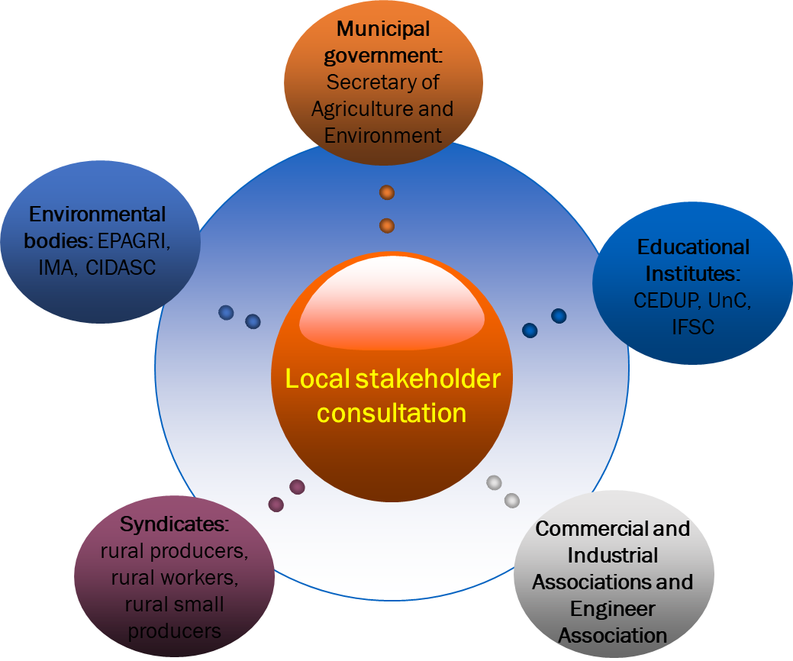

Figure 36 - Local stakeholder consultation from different sectors of the society.

The implementation of the project does not offer risks for the adhered parties since there is the criterion for selecting raw materials to approve the implementation of industrial composting. Thus, the project is restricted to industries that generate waste in the absence of contaminants impacting the land which also includes cumulative elements that may cause some damage to the land. The detection of these harmful compounds in organic residues excludes the introduction of the waste at the compost facilities.

The low risk identified and informed a priori for the rural producers is the temporary loss of yields due to the adaptation of techniques. It occurs during the transition phase from the decreasing quantity of the synthetic input to addition of the organic compost. This is naturally expected, up to the soil ecosystem seeks to reach the equilibrium. The productivity is gradually increased in a short term, however the outlined measures to mitigate this risk is implementation of the adaptation in growing phases. It means that the project area within one rural property begins with implantation in partial area and gradually expand. The VCUs sales shall provide financial return to mitigate these financial risks.

The adhesion of the project activities is subject to the low risk of not returning the same financial value of the commercialization of VCUs, as these units have a variable value with the global financial exchange variations and with the verification of the social, environmental impact and permanent positive balance in the capture of GHG. This risk is proportional to the result of the engagement and undertaking of the instructions for sustainable practices transferred by Ambipar to the interested parties. The risk in the rural sector investing in ECOSOLO transportation could be amortized by agricultural productivity, which returns financial values ​in the short term. While the expectation regarding returns for VCU sales varies with the international market.

The management team have prior experience orienting land management at the project scale. The contribution of the identified stakeholders influences the local community to improve the engagement.

The project proponent recognizes and respects the stakeholders’ property rights. The project activities do not damage the ecosystems.

During the project lifetime, the monitoring and orienting will happen continuously. Annually, the results of the project will be exposed to the stakeholders through a presentation with the quantity of waste composted and carbon stock per farmers’ areas.

The permanent link between the parties will be a communication channel available through two options of office phone numbers, the company headquarter address, regional unit address and phone number for exchanging instant messages with specialists. These communication channels will be available for any conflicts, contingencies, complaints, and doubts about the project in progress.

The grievance redress procedure to address disputes with local stakeholders include receiving, hearing, responding and attempting to solve grievances within three months documented publicly. Taken into account culturally-appropriate conflict resolution methods, amicable negotiations will be primarily preferred. Alternatively, mediation by a neutral third party or competent courts will be taken.

# APPLICATION OF METHODOLOGY

## Title and Reference of Methodology

CDM Small-scale methodology: AMS-III.F. “Avoidance of methane emissions through composting”, version 12.0, Sectoral Scope 13 and associated tools:

* CDM Tool 03 - “Tool to calculate project or leakage CO2 emissions from fossil fuel combustion”, version 03.0;
* CDM Tool 04 - “Emissions from solid waste disposal sites”, version 08.0;
* CDM Tool 13 - “Project and leakage emissions from composting”, version 02.0.
* CDM Tool 21 – “Demonstration of additionality of small-scale project activities”, version 13.1.

Approved VCS Methodology VM0021 “Soil Carbon Quantification Methodology”, version 1.0, Sectorial Scope 14 and associated modules:

* VMD0018 “Methods to Determine Stratification”, version 1.0;
* VMD0019 “Methods to Project Future Conditions”, version 1.0;
* VMD0020 “Methods to Determine the Project Boundary”, version 1.0;
* VMD0021 “Estimation of Stocks in the Soil Carbon Pool”, version 1.0;
* VMD0027 “Estimation of Domesticated Animal Populations”, version 1.0;
* VMD0028 “Estimation of Emissions from Domesticated Animals”, version 1.0;
* VMD0029 “Estimation of Emissions of NON-CO2 GHGs from Soils”, version 1.1;
* VMD0034 “Methods for Developing a Monitoring Plan”, version 1.0;
* VMD0035 “Methods to Determine the Net Change in Atmospheric GHG Resulting from Project Activities”, version 1.0;
* CDM Executive Board EB 35 Report Annex 19, “Combined tool to identify the baseline scenario and demonstrate Additionality in A/R CDM project activities”, version 01;
* VT0001 “Tool for the Demonstration and Assessment of Additionality in VCS Agriculture, Forestry and Other Land Use (AFOLU) Project Activities, version 3.0;

## Applicability of Methodology

3.2.1. AMS-III.F. “Avoidance of methane emissions through composting”, Version 12.0, Sectoral scope 13

This methodology enables to quantify methane emissions avoided by diverting organic fraction to decay anaerobically in a SWDS. This methodology can be applied because the project activity comprises organic fraction composting, increases the capacity utilization at existing facilities and all operation licenses are duly met and available. In addition, the following applicability conditions were met:

* The location and characteristics of the disposal site of the organic fraction in the baseline condition is known, in such a way as to allow the estimation of its methane emissions associating CDM tool04;
* Blending materials is added in the project scenario to increase the efficiency of the composting process by achievement of a desirable C/N ratio.
* The landfill considered in the baseline scenario can accommodate the waste at the beginning of each crediting period and the common practice for mills in the region is to dispose waste in solid waste disposal site stockpile.
* The geographical boundary of the region referred in the previous paragraph take into account that the waste is transported near to the composting facility because the industrial landfill and the waste management center are inside the same gates. In addition, the distance to which the final product after composting is transported will not be more than 200 km. The predicted region covers this reasonable radius around the project activity because the project additionality comes from the most plausible application of the compost produced be expanded under orientation of sustainable ALM practices.
* The compost is handled aerobically and submitted to soil application under proper conditions and procedures (not resulting in methane emissions) through quality control ensured.
* There is no co-composting, no thermal/mechanical treatment and no storage under anaerobic conditions and/or delivered to a landfill.

*3.2.1.1. Tool 03. “Tool to calculate project or leakage CO2 emissions from fossil fuel combustion”, Version 3.0*

This tool outlined the procedures to calculate project CO2 emissions from the combustion of fossil fuels based on the quantity of fuel combusted and its properties. The combustion process in the project activity occurs from machines employed at the composting operation for windrows aeration, shaping and trucks carrying.

*3.2.1.2. Tool 04. “Emissions from solid waste disposal sites”, Version 08.0*

The project activity of composting meets the applicability condition of this tool within the classification of the application type B. It means that the alternative treatment, composting, has been preventing waste from being disposed of in a SWDS. The tool was applied for both ex ante and ex post estimation of emissions from avoided methane during the crediting period. The simplified approach detailed in the Appendix of this tool was applied to calculate baseline emissions. For determining parameters within this tool, this type B application was considered.

The residual waste composted within this first instance was only one type: sludge from paper mill. And the default values provided in the tool was applied

This project aims to minimize the waste disposal in landfills, encouraging the use of an alternative composting method capable of avoiding methane emissions in the environment during the crediting period. Ambipar’s provides environmental management expertise for companies that avoids SWDS, reducing emissions.

*3.2.1.3. Tool 13. “Project and leakage emissions from composting”, Version 02.0*

The project activity of composting meets the applicability condition of this tool because

* CH4 and N2O emission from composting could be estimated and,
* Transport emissions in the project scenario were assumed similar to transportation activities in the baseline scenario. As exemplified in the footpage of this tool, the waste transported to the composting installation in the project activity would in the baseline scenario be transported to an alternative treatment location (e.g., a SWDS). Similarly, the compost that is transported to its place of application in the project activity, would replace the need to transport fertilizer to the same place of application.

*3.2.1.4. CDM Tool 21. “Demonstration of additionality of small-scale project activities”, version 13.1.*

Since this methodological tool provides a general framework for demonstrating and assessing additionality and is applicable to a wide range of project types in small-scale, the project activity of composting meets the applicability to demonstrate additionality.

3.2.2.VM0021. “Soil Carbon Quantification Methodology”, Approved VCS Methodology, Version 1.0, Sectorial Scope 14

This methodology was chosen due to the fact that the ECOSOLO product has been a successful supplier of organic matter to agriculture over the years. After noting the qualitative benefits generated for the soil, Ambipar has been developing soil carbon quantification to reach measurements with statistical rigor. For this purpose, the project activities characterized by Ecosolo application associated to technical orientation for sustainable ALM and proper carbon quantification, depend on the calculation of CO2 equivalence, allowable by following the steps described in this methodology.

As mandatory conditions:

* The project meets the most recent VCS requirements for the Agricultural Land Management activities involving Improved Cropland Management (ICM) and Improved Grassland Management (IGM);
* At the project start date, the project area consists of grasslands or croplands. The project area does not consist of forest, wetlands, or peatlands, as such terms are defined under the VCS;
* The only baseline activities improved by the project activities are grazing and crop production;
* The project activities ensure that does not change surface and shallow (<1m) soil water regimes through flood irrigation, drainage or other significant anthropogenic changes in the ground water table;
* The project activity does not change termite populations, as compared with the baseline scenario.

As optional conditions, i.e. the following conditions do not need to be met to apply this methodology:

* The activities and agents, typical from baseline scenario, which have caused the degradation of the croplands, grasslands or rangelands are expected to continue to impact the area in the absence of the project activity. On that basis, it can be demonstrated that the total carbon content of the soil organic and inorganic carbon pools within the project area is highly unlikely to increase under the baseline scenario during the project crediting period. The project activity of soil carbon quantification associated to the implementation of sustainable ALM practices will be demonstrated additional under comparison of scenarios applying this methodology and its approved modules.

Therefore, the project proponent, conservatively, assume that soil carbon content for all future dates under the baseline scenario shall be accounted as equal to the current soil carbon content, subject to re-assessment at year 10, as required under the VCS rules.

* The GHG emissions from populations of domesticated animals are expected to remain the same or decline under the project scenario as compared with the baseline scenario. The population and manure management will be monitored applying this methodology and its respective approves module.
* The amounts of any of the following conditions or activities between the baseline scenario and the project scenario will be compared applying this methodology’s tasks:
  + Amount or location of application of organic or inorganic fertilizers.
  + Amount or location of domesticated animal grazing and deposition of manure or urine.
  + Amount or location of areas subject to flooding, and duration of flooding.
  + Amount or location of nitrogen fixing species.

The list below presents the approved modules associated to the VM0021 methodology, useful for calculations applied to estimate removals, emissions and reductions from the project activities of soil carbon quantification.

*3.2.2.3. VMD0018. “Methods to Determine Stratification”, Version 1.0, Sectoral Scope 14*

The approved VCS module is applicable in this project to reference stratification for monitoring variable X, in which in this project consists of the spatial coordinated carbon content accumulated in the soil that could vary throughout the project area, reference region or other relevant land base. Stratification techniques were applied properly according to observed homogeneity of the grouped areas. Re-stratification will be necessarily applied if the minimum confidence level of 90 % is reached.

*3.2.2.4 VMD0019. “Methods to Project Future Conditions”, Version 1.0, Sectoral Scope 14”*

The steps described within this VCS module enable data to be organized into a monitoring plan that can be used to model an equation over time for project prediction. Since the SOC accumulation rate is unknown for the project area, the module foresees constant communication enabling the continuous improvement of the variable until its behavior becomes clear in different regions. There is no applicability condition restriction.

*3.2.2.5 VMD0020. “Methods to Determine the Project Boundary”, Version 1.0, Sectoral Scope 14*

The project activities of sustainable ALM practices with soil carbon quantification applied this module to set out the temporal and spatial boundaries of the project. At the project start date, the spatial boundaries within the first instance were defined with few farmers, duly documented. The selected carbon pools and GHG emissions will be monitored in the temporal and spatial boundaries for further expansion within the project area surrounding the composting facilities. There is no applicability condition restriction.

*3.2.2.6. VMD0021. “Estimation of Stocks in the Soil Carbon Pool”, Version 1.0, Sectoral Scope 14*

The project activity meets the applicability conditions of this module because the sampling and estimation of soil carbon content does not occur in organic soils. This module provides the methods to be used to estimate the required number of soil plots in each stratum, design and establish the plots, determine the carbon stock in the soil carbon pool, and check the statistical rigor of the results.

*3.2.2.7. VMD0027. “Estimation of Domesticated Animal Populations”, Version 1.0, Sectoral Scope 14”*

The project activities involving sustainable ALM apply this module because it provides methods for estimating domesticated animal populations on an average annual basis, broken down by type of animal, as well as the manure management systems associated with each population.

Although the baseline and project scenarios tend to be similar because there is no prediction to increase the population of domesticated animals, this module was applied to allow comparison of any variations under the monitoring parameters. All landowners’ changes about their husbandry practices will be monitored. There is no applicability condition restriction.

*3.2.2.8. VMD0028. “Estimation of Emissions from Domesticated Animals”, Version 1.0, Sectoral Scope 14*

The module provides methods for estimating the emissions of CH4 and N2O both from domesticated animals directly, and from emissions due to the decomposition of manure. Estimates for domesticated animal populations and associated manure management systems are determined using VMD0027 Estimation of Domesticated Animal Populations, above described.

This methodology was applied to estimate the emissions from domesticated animals population. In the current scenario, landowners have kept the population and the regime similar, however, this methodology will be applied under any perception of raising of domesticated animals and accounts for additional organic material from manure. The emissions from enteric or manure has been estimated to aim opportunities of emission reduction with sustainable ALM practices making the project in a holistic process. There is no applicability condition restriction.

*3.2.2.9. VMD0029. “Estimation of Emissions of non-CO2 GHGs from Soils”, Version 1.1, Sectoral Scope 14*

The project activities involving compost application and general changes in ALM practices need non-CO2 GHGs emissions monitoring. The approved module provides equations to estimate emissions of N2O or CH4 from the soils within the project area as a result of complex processes governed by both organic and inorganic variables. Although the applicability conditions of this module suggested where significant increases in the emissions of non-CO2 GHGs are expected under the project scenario as compared with the baseline scenario, the procedures were applied due to the unknown changing rate.

The synthetic inputs replacement by organic will follow the monitoring plan during the crediting period, allowing to compare the crop and grass cultivation on which the ECOSOLO will be applied.

*3.2.2.10. Module VMD0034. “Methods for Developing a Monitoring Plan”, Version 1.0, Sectoral Scope* 14

This module sets out the methods and requirements for creating a monitoring plan for the project. It has been applied in this project to foresee an implementation plan, to predict disturbances and how to deal with them, as well as to elaborate monitoring tasks that will render a clear technical description of the GHG flux, and project benefits and risks. There is no applicability condition restriction.

*3.2.2.11. VMD0035. “Methods to Determine the Net Change in Atmospheric GHG Resulting from Project Activities”, Version 1.0, Sectoral Scope 14*

The module provides the methods required to sum up the estimated atmospheric GHG flux associated with the project area under either the baseline or project scenario for a given time period, and to estimate the uncertainty of project and baseline scenario carbon stock and emission calculations. This methodology was applied to elucidate benefits from the project activities in comparison to the baseline scenario and quantify project additionality and uncertainties. There is no applicability condition restriction.

*3.2.2.12 CDM Executive Board EB 35 Report Annex 19, “Combined tool to identify the baseline scenario and demonstrate Additionality in A/R CDM project activities”, Version 01*

The tool was applied to determine the most plausible baseline scenario for the VM0021 Methodology, which clarifies, in its Section 6, that the CDM tool is applicable for all VCS ALM project types, since it complies with the VCS eligibility rules set out by the Appendix 1”Eligible AFOLU Project Categories” of the VCS Standard, v 4.1 (latest version of the AFOLU Requirements v3.2, section 4.2.2.

The project does not lead to violation of any applicable or enforced law, attending the applicability condition of this tool.

*3.2.2.13 VT0001. “Tool for the Demonstration and Assessment of Additionality in VCS Agriculture, Forestry and Other Land Use (AFOLU) Project Activities”, Version 3.0*

The tool was applied to demonstrate and assess additionality because the project activities, as waste treatment as compost application for soil carbon stock change, performed on the land within the proposed project boundary do not lead to any violation of any applicable law.

The applicability condition of this tool for the project activities requires a stepwise approach (detailed on section 3.5) justifying the determination of the most plausible baseline scenario, according to the VCS document AFOLU Requirements.

This tool was used to define additionality and requires the justification of a plausible baseline scenario and consistency for the proposed project. Initially, scenarios and alternatives were identified so that the lower emissive could be chosen, and to justify the need and value of the stimulated carbon cycle. Analysis of barriers and Common Practices were performed to highlight additionality and to propose a feasible plan.

## Project Boundary

The project boundary encompasses the physical and geographical site where:

* the solid waste would have been disposed and the methane emissions occurs in absence of the proposed project activity. It is located nearby the composting facilities and waste generator site, the pulp and paper mill identified on Figure 16 above;
* the product from composting (compost) is handled, disposed, submitted to soil application. The Figure 16 provides reference of where the compost is applied within rural properties of the selected and engaged farmers;
* The itineraries between the alternative waste treatment and compost applications are included into the project boundaries to identify the relevant GHG sources, sinks and reservoirs for the project and baseline scenarios.

The Figure 30 illustrates the project boundaries of the baseline and project scenarios. On the right side of this figure the additionality from Project Activities is highlighted in green: waste treatment from the composting process of organic waste that produces an agricultural product, trademarked as ECOSOLO® and its application for improvement of grassland and cropland management.

Table 3 presents the different sources of gas emission identified or absence in the project activities and furthermore, the inclusion or not of the gas emission is justified/explained.

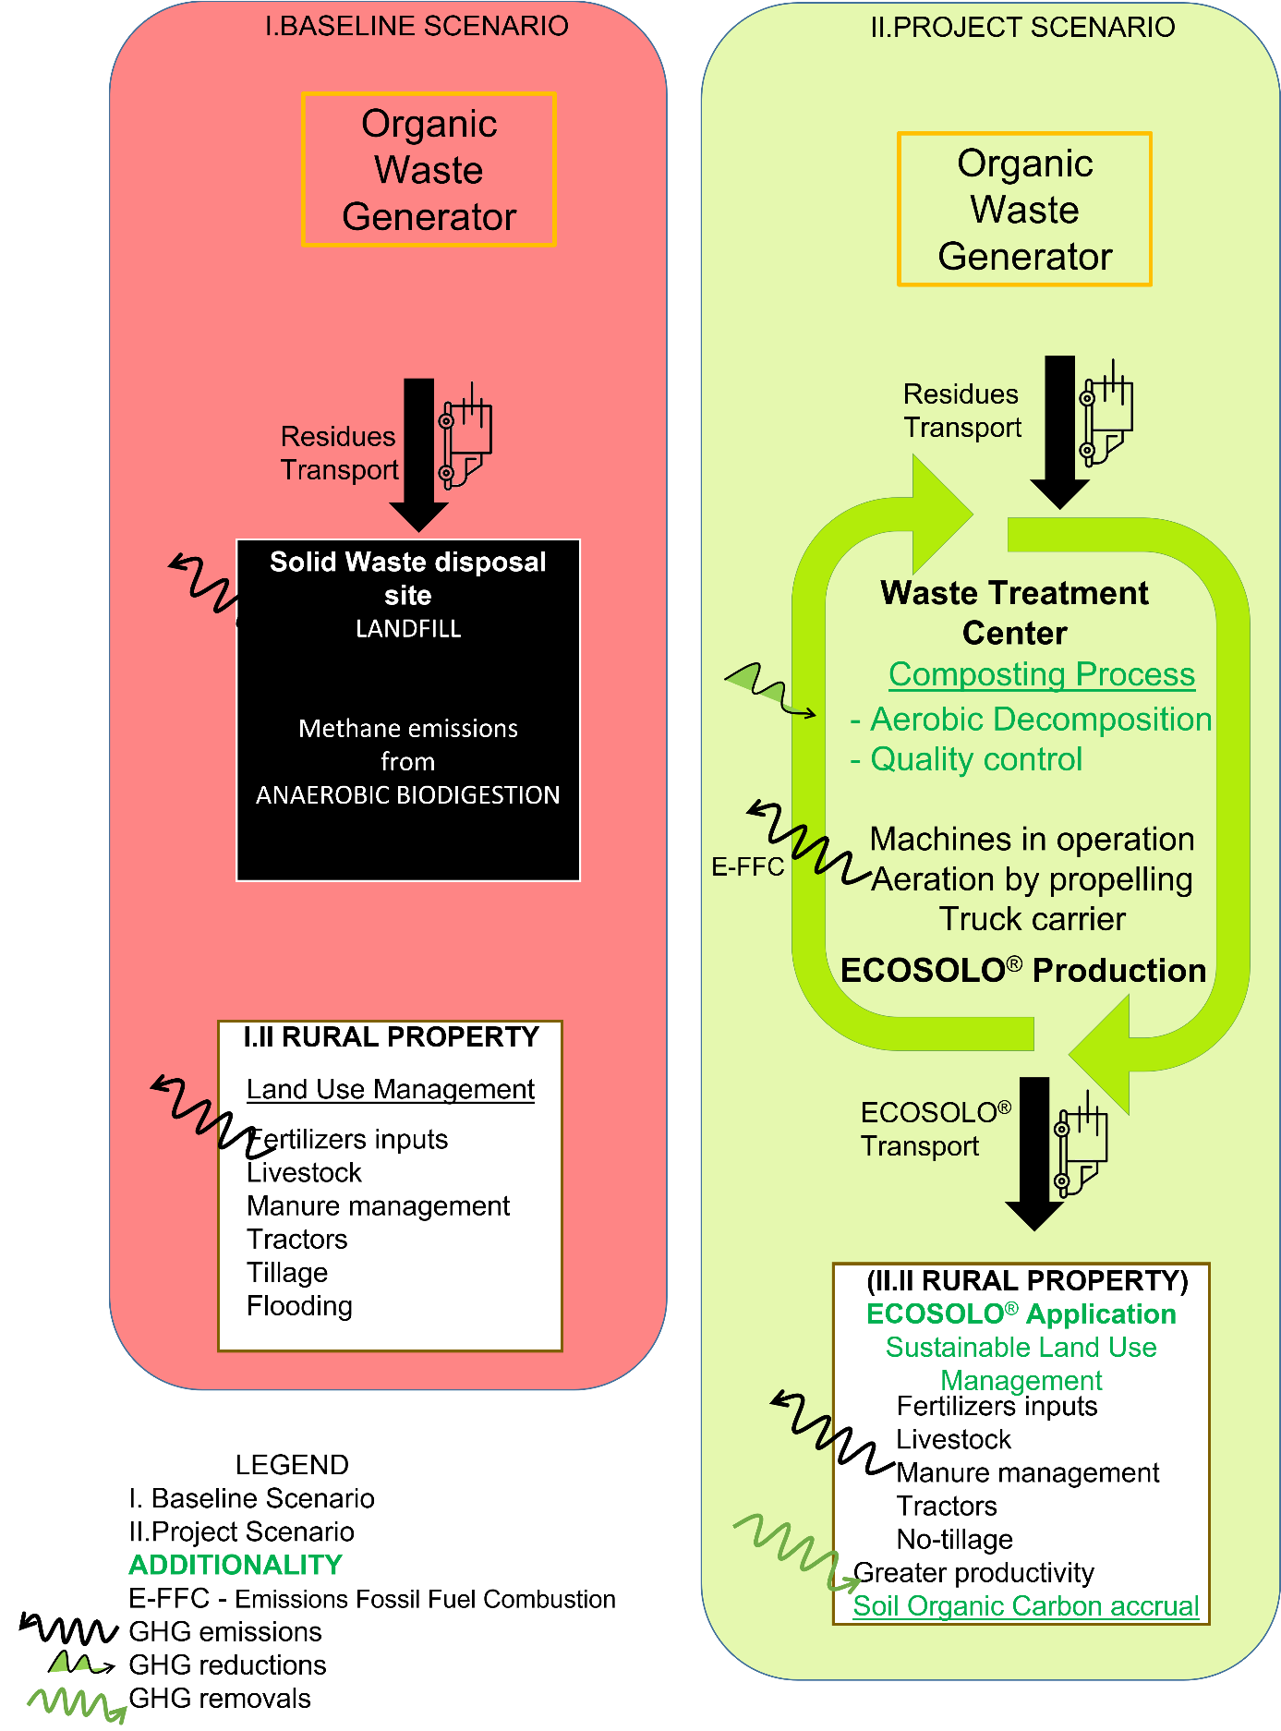

Figure 37 – Illustration of the project boundaries differentiating the baseline and project scenarios. GHG emissions, reductions and removals are illustrated trough the narrows.

Table 3. GHG sources, sinks and reservoirs within the project boundaries for the project and baseline scenarios.

| Source | | Gas | Included? | Justification/Explanation |
| --- | --- | --- | --- | --- |
| BASELINE | Source 1. Solid Waste Disposal Site | CO2 | no | Fossil fuel combustion were not included since the waste that is transported to the composting installation in the project activity would in the baseline scenario be transported to the SWDS (Tool 13). |
| CH4 | yes | Emissions of methane to the atmosphere from organic matter left to decay anaerobically in a SWDS. |
| N2O | no | Anaerobic biodigestion produces negligible amount of nitrogenous compounds compared to CH4. They are not significant. |
| Other | no | N/A |
| Source 2. Agricultural land management | CO2 | yes | CO2 removal will be estimated based on the chemical equivalence to the soil carbon (VMD0035). Initial soil carbon stock was estimated following the VMD0021 module “Estimation of stocks in the soil carbon pool”, v. 1.0. |
| CH4 | yes | 1. Emissions from enteric fermentation domesticated animals directly, decomposition of manure (VMD0028), manure management systems and population (VMD0027), were estimated from the population ex-ante.  2. Methane emissions from soil resulting from soil processes (VMD0029). |
| N2O | yes | 1.Direct and Indirect emissions from manure management associated to the domesticated animals population, per livestock head (VMD0028) estimated from the population ex-ante.  2.Direct emissions as a result of common practice of nitrogen application, synthetic or organic fertilizer, adjusted for volatilization as NH3 and NOx (VMD0029). |
| Other | no | N/A |
| PROJECT | Source 1. Alternative Waste Treatment: Composting | CO2 | yes | Emission estimated from fossil fuel combustion consumed by composting machines. |
| CH4 | yes | 1.Emissions from the aerobic composting treatment were estimated according to the Equation (5) of Tool 13 “Project and leakage emissions from composting”, V. 12.0. These emissions occur at the beginning of the composting, when waste were about to reach homogeneity. |
| N2O | yes | Emissions from the aerobic composting treatment were estimated according to Equation (7) of Tool 13 “Project and leakage emissions from composting”, V. 12.0. |
| Other | no | N/A |
| Source 2. AFOLU activities: sustainable agricultural land Management | CO2 | yes | CO2 removal will be estimated based on the chemical equivalence to the soil carbon content (VMD0035). The carbon stock changes are expected be resultant of the implantation of sustainable ALM practices. Soil carbon stock will be estimated during the crediting period following the VMD0021 module “Estimation of stocks in the soil carbon pool”, V. 1.0. |
| CH4 | yes | 1.Emissions from enteric fermentation of the domesticated animals population, decomposition of manure (VMD0028), manure management systems and livestock group population (VMD0027) will be monitored.  2.Emissions from soil resulting from soil processes, which will be monitored regarding to saturation and flooding days (VMD0029). |
| N2O | yes | 1.Direct and Indirect emissions from manure management associated to the domesticated animals population, per livestock head (VMD0028) whose population will be monitored during the crediting period.  2. Direct emissions as a result of nitrogen application, synthetic or organic fertilizer, adjusted for volatilization as NH3 and NOx (VMD0029) during the crediting period supported by the amounts provided by the monitoring plan. |
| Other | no | N/A |

The geographic boundaries of the rural producers involved in the project activities are presented in the Section 1.12 (Project Location). These areas were mapped following standards required in the mapping of the project area. The importance in to perform an adequate mapping is to allow the appropriate projection of future values for the variable soil organic carbon fixation, indicating assertively probable changes. The Figure 18 to 24 to 24 highlight the boundaries of each eligible rural producer in red. Each numbered stratum within each rural producer project area where the compost will be applied, and the measures are taking place is outlined in yellow. The remaining between yellow and red are administrative, housing and forest belts.

## Baseline Scenario

According to the AMS-III.F methodology, version 12.0 (Avoidance of methane emissions through composting), the baseline scenario for our project is the situation where, in the absence of the project activity, organic matter or biomass are left to decay within the project boundary and methane is emitted to the atmosphere (Figure 31) . The baseline emissions for this methodology are presented at the section 4.1.



Biomass or Organic Matter

SWDS

CO2

CH4

CO2

Figure 38 - Baseline scenario for the AMS.III.F methodology: organic matter or biomass left to decay anaerobically in a SWDS.

The recommendation provided at VM0021 methodology is that the determination of the baseline scenario for the project area shall be performed using the EB 35 Report Annex 19, version 01 “Combined tool to identify the baseline scenario and demonstrate additionality in ALM project activities, which latest version is the 01. Assuming the specific guidance provided in the section 6 of the VM0021 for interpreting the terms “A/R”, “forestation”, “forest”, “CDM”, and ‘tCERS” where they occur in the CDM A/R tool so that proper application to the VCS ALM context is clarified. Beyond the methodology clarifies that the CDM tool is applicable for all VCS ALM project types, since it complies with the VCS eligibility rules set out by the Appendix 1 ”Eligible AFOLU Project Categories” of the VCS Standard, v 4.1 (latest version of the AFOLU Requirements v3.2, section 4.2.2).The Steps 0, 1, 2 and its sub-steps of the EB35 A/R Methodological tool is a step-wise approach to identify the baseline scenario in ALM activities.

*Step 0: Preliminary screening based on the starting date of the ALM project activity.*

The starting date of the ALM project activity was later than 2000 as specified in the section 1.8 of this PD. Previously, farmers had applied ECOSOLO in their cultivation not allowing enough organic matter reposition in the rhythm of intensive tillage. They had not received technical orientation to improve ALM aiming increasing in carbon stock. The incentive from the planned sale of VCUs was strongly taken into consideration during the decision on how to frame the project activity and monitoring plan of carbon soil quantification.

*Step 1: Identification of alternative land use scenarios to the proposed ALM project activity*

This step serves to identify alternative land use scenarios to the proposed VCS project activity that could be the baseline scenario, through the following sub-steps:

*Sub-step 1a. Identify credible alternative land use scenarios to the proposed VCS project activity:*

Alternative 1: the cropland or grasslands managed by landowners or farmers whose practices have caused degradation and are expected to continue to impact the area in the absence of the project activities. The characteristics of these rural properties are infertile soil, poor organic carbon, lower productivity than local ruler, with progressive land use with chemical replacement of nutrients and tillage resulting in organic matter volatilization, poor soil life and soil compaction.

Alternative 2: Adoption of composting process of the organic waste, production of soil conditioner under quality control and its application without the technical orientation for sustainable ALM practices; and

Alternative 3: Adoption of the composting process of the organic waste and application of the soil conditioner product by rural producers assisted by technical skills for sustainable ALM practices under a monitoring plan to quantify the soil carbon.

*Sub-step 1b: Consistency of credible alternative land use scenarios with enforced mandatory applicable laws and regulations to the proposed ALM project activity*

All alternatives’ scenarios are in compliance with current laws and regulations. All laws and regulations enforced in Brazil related to the project activities were previously mentioned and explained in detail at the Section 1.14 (Compliance with Laws, Statutes and Other Regulatory Framework). Considering that information, all identified scenarios listed above follow the mandatory applicable legal and regulatory requirements. In Brazil, there are no laws that oblige the emission reduction of GHG from the land use practices up to the date of the current project validation. However, the federal22, state23 and municipal governments have stimulated the society considering: the adoption of public policies able to mitigate the impact on climate change; the environmental education aiming to capacity the society from the early years at the school to build adequate attitudes for the common good, encourage the study, research and implementation of technologies oriented for the rational and protection of environmental resources; the sustainable development aiming to ensure life quality for all citizens in the present and for future generations; the incentive for rational use of soil, water and air through State monitoring.

*STEP 2. Barrier analysis*

This step serves to identify barriers and to assess which of the land use scenarios identified in the sub-step 1b are not prevented by these barriers.

*Sub-step 2a. Identification of barriers that would prevent the implementation of at least one alternative land use scenarios*

Table 4. Displays the barrier analysis for the three identified alternative scenarios. The identified barriers are discussed in Sub-step 2a.

|  |  |  |  |
| --- | --- | --- | --- |
| **Alternative scenarios** | 1. Degradation of the croplands or grasslands by tillage practices (pre-project) | 2. Adoption of composting process of the organic waste, production of soil conditioner under quality control and its application without the technical orientation for sustainable ALM practices | 3. Adoption of the composting process of the organic waste and application of the soil conditioner product by rural producers assisted by technical skills for sustainable ALM practices under a monitoring plan to quantify the soil carbon |
| Investment |  | X | X |
| Institutional |  |  |  |
| Technological |  | X | X |
| Local tradition |  |  |  |
| Prevailing practice |  |  | X |
| Local ecological conditions |  |  |  |
| Social conditions |  |  | X |

*Sub-step 2b. Elimination of land use scenarios that are prevented by the identified barriers*

Tillage practices including intense application of synthetic nutrition and chemical pest control to the soil, use of invasive equipment, soil exposure after harvest, monoculture are typical causes of erosive processes, organic matter volatilization and degradation of the croplands or grasslands. Farmers raise their livestock and increase productivity with chemical nutrition, increasing soil compaction, un equilibrating soil life and becoming the soil poor in nutrients. The alternative scenario 1 is not prevented by the financial or technological barriers, so it is widespread within the region.

*Sub-step 2c. Determination of baseline scenario (if allowed by the barrier analysis)*

Applying the decision tree to the alternative scenario 1, the sustainable ALM practices and soil carbon quantification without being registered as an ALM VCS project activity included in the list of land use scenarios are not prevented by any barrier. Therefore, this only one remaining land use scenario is the baseline scenario, and it was allowed to identify by the barrier analysis. The suggested following step 4, common practice test, will be performed in the Section 3.5 below.

## Additionality

The AMS.III.F methodology recommends project participants to apply the Methodological Tool 21 “Demonstration additionality of small-scale project activities”, whose latest version is the 13.1. The general framework to demonstrate the additionality of small-scale project activity and component project activity follows the explanation about the project activity would not have occurred anyway due to at least one of the following barriers: investment, technological, prevailing practice or any other.

The financially more attractive alternative of sending waste to landfills without composting process results in higher emissions. The activity to send the organic waste to landfill and land use using traditional agriculture are by far the most dominant activities throughout the region. Considering the above information, this scenario is assessed as the baseline scenario.

The project activity of composting process with a quality control of the produced compost would not occur if Ambipar would not manage the waste treatment in a narrow process to ensure the compost quality for soil application. The additionality of this project activity is highlighted by the methane emissions avoidance from the organic matter that would decay left to the SWDS. For engagement of this value chain of the compost production, a robust system of benefits by using the compost has to be advertised with the VCS program. Besides the financial restraint for composting process implementation, the compost sale is not continuous without engagement campaigns. In general, industries prefer disposing their organic waste in landfills due to the higher costs of implementing composting processes.

Furthermore, sustainable ALM practices are not farmers’ preferred choice because of transportation costs and longer period necessary for soil to gain fertility when induced from organic compost compared to synthetic fertilizers. Thus, in the absence of the ECOSOLO® application, farmers raise their livestock and produce their agriculture with intense application of synthetic nutrition to the soil, resulting in erosion from the use of invasive equipment in other to obtain better results and higher profits for their activities. Soil productivity would progressively decrease, and farmers would have to spend large amounts on synthetic inputs to eventually reach volatile fertility. Without attractivity for compost application, the compost could accumulate in the composting yard.

To evaluate the existence of additionality from the project activities involved in the VM0021, the following steps described in the approved VCS tool VT0001, version 3.0, were performed:

* STEP 1 Identification of alternative scenarios for the AFOLU project activity
* STEP 2 Investment analysis (if applicable)
* STEP 3 Barrier analysis
* STEP 4 Common practice analysis

**STEP 1 Identification of alternative land use scenarios to the proposed VCS AFOLU project activity**

*Sub-step 1.a. Identify credible alternative land use scenarios to the proposed VCS AFOLU project activity*

The following alternatives for the project activity were evaluated:

Alternative 1: Continuation of the pre-project land use, degrading cropland and grassland under tillage management, described in the alternative scenario 1 of the Sub-step 1a in the section 3.4.

Alternative 2: Adoption of sustainable ALM, organic matter restoration and soil carbon quantification without the incentives from the carbon market (project activity); and

Alternative 3: Adoption of organic agriculture where the symbiotic ecosystem contributes to restore equilibrium, use only biological control of plagues and organic fertilizers with slow or none addition of soil conditioner.

Sub-step 1.b. Consistency of credible scenarios with mandatory applicable laws and regulations in force.

All alternative scenarios are consistent with current laws and regulations. All laws and regulations in force in Brazil related to the project activities were previously mentioned and explained in detail at the Section 1.14 (Compliance with Laws, Statutes and Other Regulatory Framework). Considering that information, all identified scenarios listed above follow the mandatory applicable legal and regulatory requirements. Currently in Brazil, there are no laws that oblige the emission reduction of GHG from the land use practices. However, the federal22, state23 and municipal governments have stimulated the society considering: the adoption of public policies able to mitigate the impact on climate change; the environmental education aiming to capacity the society from the early years at the school to build adequate attitudes for the common good, encourage the study, research and implementation of technologies oriented for the rational and protection of environmental resources; the sustainable development aiming to ensure life quality for all citizens in the present and for future generations; the incentive for rational use of soil, water and air through State monitoring.

Sub-step 1.c. Selection of the baseline scenario (allowed by the barrier analysis)

As demonstrated in the Sub-Step 2c of the Section 3.4, the alternative scenario 1 is the baseline scenario. The scenario encompasses degrading practices of ALM on croplands or grasslands. The characteristics of these rural properties are infertile soil, poor organic carbon, lower productivity than local ruler, with progressive land use with chemical replacement of nutrients and tillage resulting in organic matter volatilization, poor soil life and soil compaction. The alternative scenario 3 was excluded since the percentage of implementation, within the national and local areas, is lower than 2% along 2006 and 2017, according to Mattei and Michellon’s data analysis in 20210.

**STEP 2. Investment analysis**

The Investment analysis was not performed in this project. According to the item 2.3 of the Methodological Tool VT0001, version 03.0, the additionality may be determined using the Barrier analysis (Step 3).

As the project activity generates no financial or economic benefits to the project proponent other than VCS related income through the project activity, a simple cost analysis is justified.

The project activity produces no revenue, as in the project area will be managed by rural producers to collaborate for climate change mitigation through CO2 removals from atmosphere. Costs associated with implementing project activities, project development, and VCS project validation are significant. Additionally, while the project will incur ongoing costs (related to management and implementation of project activities including soil analysis, technical visits, skilled labor as agronomist, meetings with stakeholders, social engagement, payments for the certification of our soil conditioner product and environmental services), it will not generate future financial benefits other than VCU related income. The project proponent thus generates no financial benefits, and therefore the outcome of a simple cost comparison shows significant project expenditure with no financial return in the absence of VCS-related income. Therefore, making our project activity impractical in the absence of carbon finance.

**STEP 3. Barrier analysis**

The stepwise approach illustrates that the project activity would face barriers without the revenue from the sale of GHG credits and how the revenue will surpass them.

*Sub-step 3a. Identify barriers that would prevent the implementation of the type of proposed project activity*

As already indicated in section 1.13 and 1.14, Brazil’s agricultural sector is dominated by intensive production methods which does not include the sustainable ALM practices referenced earlier. In addition, there is no regulatory framework, systematically enforced law, statute, or other framework in place that prescribes growers and farmers of Brazil to adopt sustainable ALM. In addition, as what was mentioned in the earlier section, the technical skills for soil carbon measurement assuring contribution for climate change mitigation, adaptation and benefits from soil conservation is unknown, which constitutes barrier preventing acknowledgement.

Adoption of sustainable ALM by the application of soil conditioner and implementation of composting process of industrial organic waste without incentives from the carbon market faces two main barriers: investment and technological barriers; particularly the technological barrier is of fundamental importance. The project requires a written commitment from involved stakeholders to participate in the project, and a robust rural producer monitoring system engaging the producers to monitor their performances. This project presents innovation in a voluntary carbon market in Brazil. Rural producers face financial difficulties to implement organic practices in their tillage because the results take longer than synthetic additives. The cost required to reach food productivity is very close from either source (organic or synthetic additives), therefore through participating in the project, they would equally associate organic nutrition to the soil.

The Table 5 lists the barriers that would prevent the implementation of the type of proposed project activity from being carried out if the project activity was not registered as a VCS AFOLU project.

Table 5. Barriers that would prevent the implementation of the type of proposed project activity from being carried out if the project activity was not registered as a VCS AFOLU project.

|  |  |  |
| --- | --- | --- |
| **Barrier identification** | Sub-step3a. Technical orientation for sustainable ALM practices in croplands and grasslands followed by soil carbon quantification **without the revenue** from the sale of GHG credits | Reason |
| Investment | Applicable | Debt funding is not available to start this type of project activity.  Not even grants or other non-commercial finance terms exist locally because this knowledge is out of performance in local tradition. |
| Institutional | Applicable | Lack of enforcement of land-use-related legislation |
| Technological | Applicable | Lack of access to technical skills to implement sustainable ALM, soil carbon quantification and data analysis |
| Local tradition | Applicable | The traditional management with equipment and synthetic inputs are usually degrading practices. |
| Prevailing practice | Applicable | The project is the “first of its kind” |
| Social conditions | Applicable | Lack of skilled and/or properly trained labor force |

Sub-step 3b. Show that the identified barriers would not prevent the implementation of at least one of the alternative land use scenarios (except the proposed project activity)

The alternative scenario 1 would face the technological barrier because the technical knowledge about soil carbon measurement and practice management to avoid organic matter volatilization is not spread for reaching high productivity.

The alternative scenario 3 is affected by the technological barrier because the technical knowledge about soil carbon measurement and practice management to avoid organic matter volatilization is not spread. Barriers related to local tradition due to lack of market conditions and practices are also faced by organic farmers. In addition, the low representativity of organic farmers within regional farmers0 is reflection of the absence of add value to organic production, it means that is not financially attractive. The lack of attractiveness comes from the challenge to control plagues and avoid synthetic inputs, which increase quickly the productivity.

The barriers for the alternative scenario 3 are weaker effect than for the proposed VCS AFOLU project activity because the ALM practices implementation, addition of compost on accurate dosage, mapping with intense sampling for soil carbon quantification are not included and viable without revenue from VCU sales.

Attending to the Sub-Steps 3a-3b, the additionality assessment proceed directly to Step 4 (Common practice analysis)

**STEP 4. Common practice analysis**

Our project is the first sustainable ALM project at the region of Três Barras city, Santa Catarina State, Brazil. At this moment, there is no information about similar project activity in Brazil, using the same methodologies, restoring soil with avoidance of organic matter volatilization, soil conditioner addition and deep root soil carbon quantification (stable soil organic carbon) after consultancy at the voluntary market websites. Since the project started to involve rural producers to spread about the benefits of this project, its monitoring and the importance of sustainable land use, the concern about climate mitigation raised. Previously, farmers received ECOSOLO® in their cultivation but had not applied neither a monitoring plan nor receiving technical orientation to improve land management and reduce organic matter volatilization. Consequently, tillage practices had kept degrading soil and limiting productivity.

In general, industries prefer disposing their organic waste in landfills due to the higher costs of implementing composting processes. Furthermore, sustainable ALM practices are not farmers’ preferred choice because of transportation costs and longer period necessary for soil to gain fertility when induced from organic compost compared to synthetic fertilizers. In the absence of an ECOSOLO® application, farmers raise their livestock and produce their agriculture with intense application of synthetic nutrition to the soil, resulting in erosion from the use of invasive equipment in other to obtain better results and higher profits for their activities. Soil productivity progressively decrease, and farmers have to spend large amounts on synthetic inputs to eventually reach volatile fertility.

Research already developed using our soil conditioner (ECOSOLO®) have demonstrated an improvement on the productivity of the rural producers (Appendix B), impacting positively the economy of the region and consequently the environment. In the baseline scenario, investments on sustainable ALM practices, composting process from industrial organic waste and rural producer support to evidence the implementation of regenerative agriculture and link stakeholders with the carbon market are lacking in the project region. Stakeholder adhesion is a key factor to overcome local tradition which is not based on developing sustainable techniques. If it were to begin without financial attractiveness, it would be a very slow process. The project activity will succeed through sharing specific technical skills in order to demonstrate to farmers the positive results from using sustainable ALM. Engagement from both parties is essential for the success of the project.

Organic compost has been a challenging task to be applied in rural properties. It has been very slowly due to the high transportation costs for farmers and slow response for productivity. Consequently, resulting in the tonnes accumulation of ECOSOLO® in the composting yard. The VCS program emerged to make soil fertility more feasible for more farmers through a planned distribution project, limited to the applicability conditions. As we have reported in this project, when results from organic and synthetic inputs are compared, the organic input is less preferable owing to the effects on the productivity and fertility take longer to be perceived. Thus, subsidies to boost the sustainable ALM practices forward depend on the contribution from the sale of VCUs.

Organic waste treatment has been implemented across the country in less than 20% of the national capacity. The composting process has been implemented into industrial areas, but there is no correspondence to sustainable ALM applications with a monitoring plan. Ambipar is creating this opportunity to cycle organic waste in the entire national territory, and to support sustainable ALM adhesion as well.

The consolidation of this Project can create connects for partnerships that operate composting process in accordance with laws, regulations, policy and technologies. It is aligned to the Sustainable development goal 17 from united nations.

Similar aerobic composting operational units exist with the other company’s industrial clients. Currently, from more than 50 companies attended by Ambipar’s environmental services, three paper mills have composting processes in operation, and they are inside the prospective plan for project expansion. Other clients produce organic waste in a range of small scale, and in each one of these operations, currently none include re-use, chipping or composting within their boundaries. Ambipar believes that this project will potentially boost composting units across Brazil and will furthermore encourage sustainable ALM abroad.

**Conclusion: the proposed project activity is not the baseline scenario and, hence, it is additional.**

## Methodology Deviations

Not applicable.

# QUANTIFICATION OF GHG EMISSION, REDUCTIONS AND REMOVALS

## Baseline Emissions

### Quantification of baseline emissions in the absence of the waste treatment

According to the AMS-III.F methodology the baseline emissions is calculated using the following equation:

|  |  |
| --- | --- |
| $${BE}_{y}= {BE}_{CH4,SWDS,y}+{BE}_{ww,y}+ {BE}_{CH4,manure,y}- {MD}_{y,reg} × {GWP}_{CH4}$$ | Equation 1 |

Where:

${BE}_{y}$ = Baseline emissions in the year y (t CO2e).

${BE}_{CH4,SWDS,y}$ = Yearly methane generation potential of the solid waste composted by the project activity during the years x from the beginning of the project activity (x=1) up to the year y estimated as per the latest version of the methodological tool 04 “Emissions from solid waste disposal sites” (tCO2eq). The tool may be used with the factor “f=0.1” taking into account the methane oxidation effect by the upper layer of the landfill. With the definition of year x as ‘the year since the project activity started diverting wastes from landfill disposal, x runs from the first year of crediting period (x=1) to the year for which emissions are calculated (x=y)'.

${MD}_{y,reg}$ = Amount of methane that would have to be captured and combusted in the year y to comply with the prevailing regulations (tonne).

${BE}_{CH4,manure,y}$ = Where applicable, baseline emissions from manure composted by the project activities, as per the procedures in AMS-III.D (t CO2e).

${BE}_{ww,y}$ = Where applicable, baseline emissions from the wastewater cocomposted, calculated as per the procedures in AMS-III.H (t CO2e).

${GWP}_{CH4}$ = Global Warming Potential for CH4 applicable to the crediting period (t CO2e/t CH4).

At the instance of Santa Catarina, there is neither methane capture system at the SWDS referred as baseline scenario, nor wastewater co-composted and manure composted. Therefore, ${BE}_{ww,y}$, ${BE}_{CH4,manure,y}$ and ${MD}_{y,reg}$ are null at the Equation 1, summarizing it to:

$${BE}_{y}= {BE}_{CH4,SWDS,y}$$

The quantification of baseline emissions for methane avoided from disposal sites ${(BE}_{CH4,SWDS,y})$ applied the simplified approach to the first order decay (FOD) model, presented on the Appendix of the Tool 04. The project proponent employed the equation 15 of the Tool 04, v.8.0 (the calculations were outlined in the spreadsheet named as "BECH4,SWDS,y_Tool 04”):

|  |  |
| --- | --- |
| $${BE}_{CH4,SWDS,y}=φ_{y}×\left(1-f_{y}\right)×{GWP}_{CH4}×\sum_{x=1}^{y}{{Default}_{org,x}×W_{org,x}}$$ | Equation 2 |

Where:

|  |  |  |
| --- | --- | --- |
| $${BE}_{CH4,SWDS,y}$$ | = | Baseline methane emissions occurring in year y generated from waste disposal at a SWDS during a time period ending in year y (t CO2e/yr). |
| x | = | Years in the time period in which waste is disposed at the SWDS, extending from the first year in the time period (x = 1) to year y (x = y). |
| y | = | Year of the crediting period for which methane emissions are calculated (y is a consecutive period of 12 months). |
| $$φ_{y}$$ | = | Model correction factor to account for model uncertainties for year y. |
| $$f_{y}$$ | = | Fraction of methane captured at the SWDS and flared, combusted, or used in another manner that prevents the emissions of methane to the atmosphere in year y. $f_{y}$ =0 |
| $${GWP}_{CH4}$$ | = | Global Warming Potential of methane = 28 (according to IPCC 2012). |
| $${Default}_{org,x}$$ | = | Conservativeness factor of the resulting baseline emissions which varies according to the climate zone and time period x (values from Appendix (Simplified approaches), Table 2, Boreal/temperate wet, Tool 04, v.8.0). |
| $$W_{org,x}$$ | = | Total amount of organic waste disposed or prevented from disposal in the SWDS in year x. |

#### Determining the parameters required to apply the FOD model

For the instance of Santa Catarina, the model correction factor $φ_{y}$ was calculated based on specific situation of the project activity. The overall uncertainty of the determination of methane generation in year y ($V_{y}$) is calculated according to the Equation 3 (the calculations were performed in the spreadsheet named as "BECH4,SWDS,y_Tool 04”, in the tab $φ_{y}$).

|  |  |
| --- | --- |
| $$V_{y}=\sqrt{a^{2}+b^{2}+c^{2}+d^{2}+e^{2}+g^{2}}$$ | Equation 3 |

The factors a, b, c, d, e, and g quantify the effect of the uncertainty of different parameters, used in the FOD model, on the overall uncertainty of the methane generation in year y. All these parameters are presented below following the justification of their value selection.

$a$ = 2%. The solid waste is weighted using accurate weighbridges.

$b$ = 5%. ${DOC}_{j}$ is measured.

$c$ = 5%. More than 50 per cent of the waste is rapidly degradable organic material.

$d$ = 0%. More than 50 per cent of the waste is rapidly degradable organic material.

$e$ = 0%. The SWDS is managed.

$g$ = 5%. The uncertainty values provided express the uncertainty for the exponential term as a whole. According to Table 3 (Instructions for the selection of values for the factors a, b, c, d, e and g) of the module Tool04, version 08.0, it should be used the value of 5% for project following the case of Application B, considering that the residual waste is disposed at the SWDS and the value of *k* is larger than 0.2 y-1. In the section 6.4 of the module Tool04, version 08.0, subitem Data/Parameter table 7, the value of $k_{j}$ is 0.03 (wood, wood products and straw, considering boreal and temperate climate, wet).

Then, $φ_{y}$ is calculated as:

|  |  |
| --- | --- |
| $$φ_{y}=\frac{1}{(1+V_{y})}$$ | Equation 4 |

Following the Equation 3 and Equation 4, the value of $φ_{y}=0.91837$ (the calculations were performed in the spreadsheet named as "BECH4,SWDS,y_Tool 04”, in the tab $φ_{y}$).

The alternative landfill is located at the CTRRS within the industrial area. The operational plan encompasses material compaction and coverage and there is no occurrence of neither a gas capture system nor turner. Therefore $f_{y}=0$ because there is no gas capture.

According to the invoices of organic waste purchasing and cross checked with the report of each truck delivering waste to the composting installation, $W_{org,1}=72,936.75$ ton of waste. This mean annual value was adopted for emissions estimation within the crediting period.

According to the section 1.13, the instance of Santa Catarina is located at the climate zone Boreal/temperate wet, therefore the data from the respective climate zone column of the Table 2 from Appendix of the Tool 04, v.8.0 was assumed.

Therefore the annual baseline emissions according to the Equation **2** follows

${BE}_{CH4, SWDS,y }= 25.71×\sum_{x=1}^{y}{\left({Default}_{org,x}\right)×(W_{org,x})}$ and fulfills the Table 6

Table 6 - Yearly methane generation potential of the solid state waste composted by the project activity during the years x from the beginning of the project activity (x=1) up to the year y. With the definition of year x as ‘the year since the project activity started diverting wastes from landfill disposal, x runs from the first year of crediting period (x=1) to the year for which emissions are calculated (x=y)’

|  |  |  |
| --- | --- | --- |
| Years in the time period (x) | $${Default}_{org,x}$$ | BECH4,SWDS,x (t CO2e/yr) |
| 1 | 0.004905 | 9,199.47 |
| 2 | 0.004254 | 17,177.96 |
| 3 | 0.003686 | 24,091.16 |
| 4 | 0.003177 | 30,049.72 |
| 5 | 0.002714 | 35,139.90 |
| 6 | 0.002305 | 39,462.99 |
| 7 | 0.001953 | 43,125.90 |
| 8 | 0.001654 | 46,228.02 |
| 9 | 0.001402 | 48,857.51 |
| 10 | 0.001191 | 51,091.27 |
| 11 | 0.001013 | 52,991.18 |
| 12 | 0.000864 | 54,611.64 |
| 13 | 0.000738 | 55,995.78 |
| 14 | 0.000633 | 57,182.99 |
| 15 | 0.000511 | 58,141.38 |
| 16 | 0.00047 | 59,022.88 |
| 17 | 0.000406 | 59,784.34 |
| 18 | 0.000353 | 60,446.40 |
| 19 | 0.000308 | 61,024.07 |
| 20 | 0.000269 | 61,528.58 |
| Total | | 925,153.14 |

### Quantification of baseline emissions at the project area with land use

### Estimation of the carbon content of current pools, and projection of carbon pools and emission under the baseline scenario is undertaken using the Task 2 “Ex-ante estimation and projection of carbon pools and emissions under the baseline scenario“ and, its sub-tasks of the VM0021 Methodology, version 1.0.

#### Task 2.1 Project area stratification for soil carbon

The first stratification, named as pre-stratification in the VCS Module VMD0018 (Methods to determine stratification), version 1.0, was started considering the steps of stratification described in the referred module, as follows, for each farmer at this first instance:

* Step 1: the variable soil organic carbon (SOC) density was identified and classified as type 3 (variable for which the distribution of the variable across the area is not known).

* Step 2: the time span of the stratification is type 3 (future process, where the stratification is aimed at enhancing the feasibility or accuracy of projections of future conditions, and thus considers current conditions, and projected changes in the dynamics of the process influencing SOC).
* Step 3: the selection of the stratification method was based on the classification performed at both previous steps. In this case, it has been completed the sequence of steps 4 to 7.
* Step 4: identification of key factors that may cause change in the SOC contents at a given location such as land use/cover and soil management. the subdivisions were undertaken according to the crop species cultivated and associated crop rotation practices as key factor that tend to cause change in the variable;

- Step 5: pre-stratification was performed by splitting the area into relatively homogenous and low intensity sampling, which potentially allow to stratify in a cost-effective manner. The information mentioned in Section 1.13 (local site classification maps and soil type) as well land use/cover and historical records of management) from the farmers’ spoken reports were parameters for the area stratification; Step 5.b preliminary stratification conducted with distributed intensity sampling in each farmers’ area; Step 5.c supplementary sampling survey for qualitative analysis correlating the practices, observations and behavior of the rural producer; Step 5.d. strata homogeneity check allow to identify where the area will need more efforts for soil regeneration with the project activity; Step 5.e Pre-stratification map documented the SOC measurements based on spatial coordinate approach distributed in the stratum (Figure 32, Figure 33, Figure 34, Figure 35, Figure 36, Figure 37 and Figure 38). Each stratum was differentiated by historic of cultivated crop species and tillage practices, aiming to identify how to get stable SOC accumulation, with the association of the aboveground practices onto the belowground. Based on these key factors, the monitoring plan was sketched to check the stratification map during the crediting period.

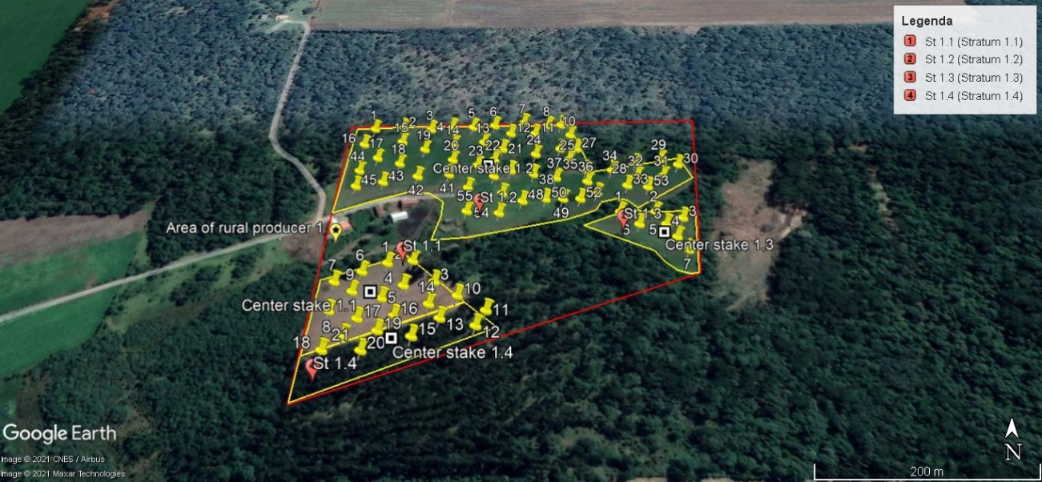

Figure 39 – Spatial coordinate of plots in each stratum of the area of rural producer 1.

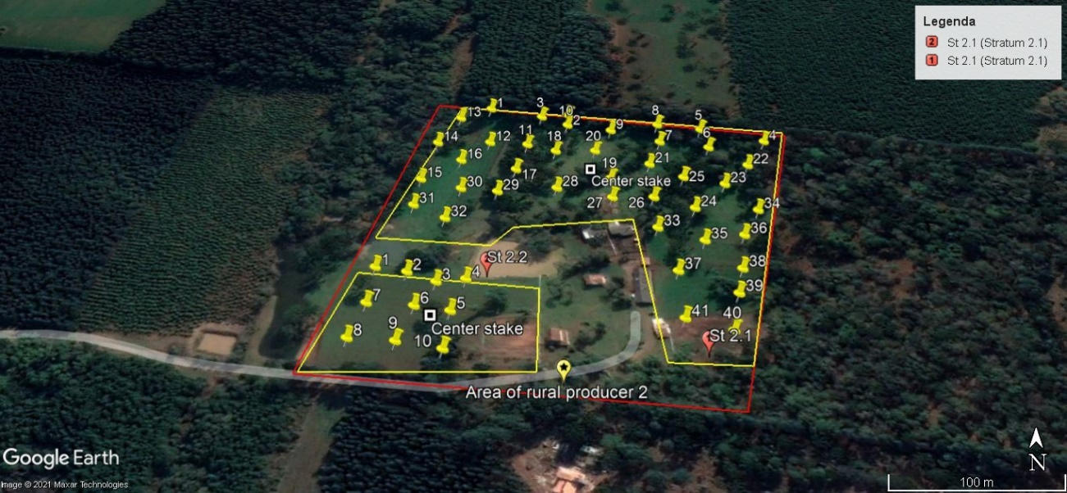

Figure 40 - Spatial coordinate of plots in each stratum of the area of rural producer 2.

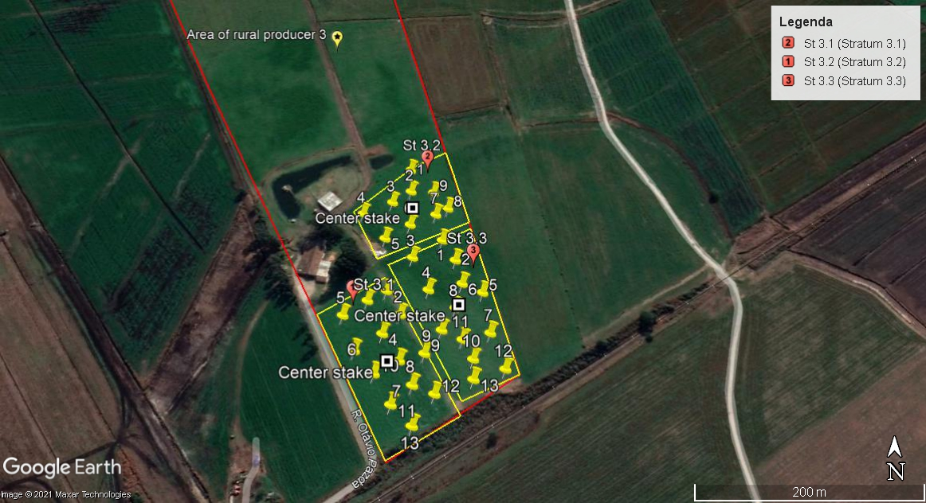

Figure 41 – Spatial coordinate of plots in each stratum of the area of rural producer 3.

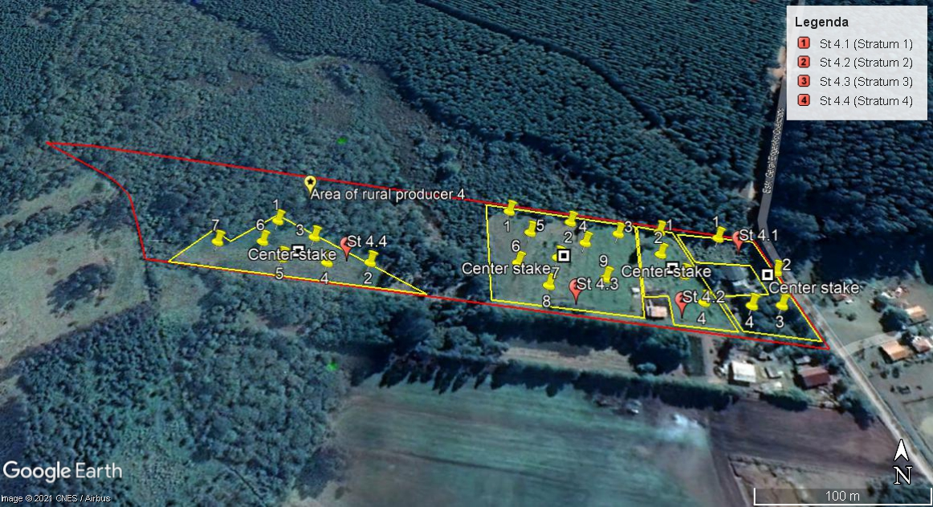

Figure 42 - Spatial coordinate of plots in each stratum of the area of rural producer 4.

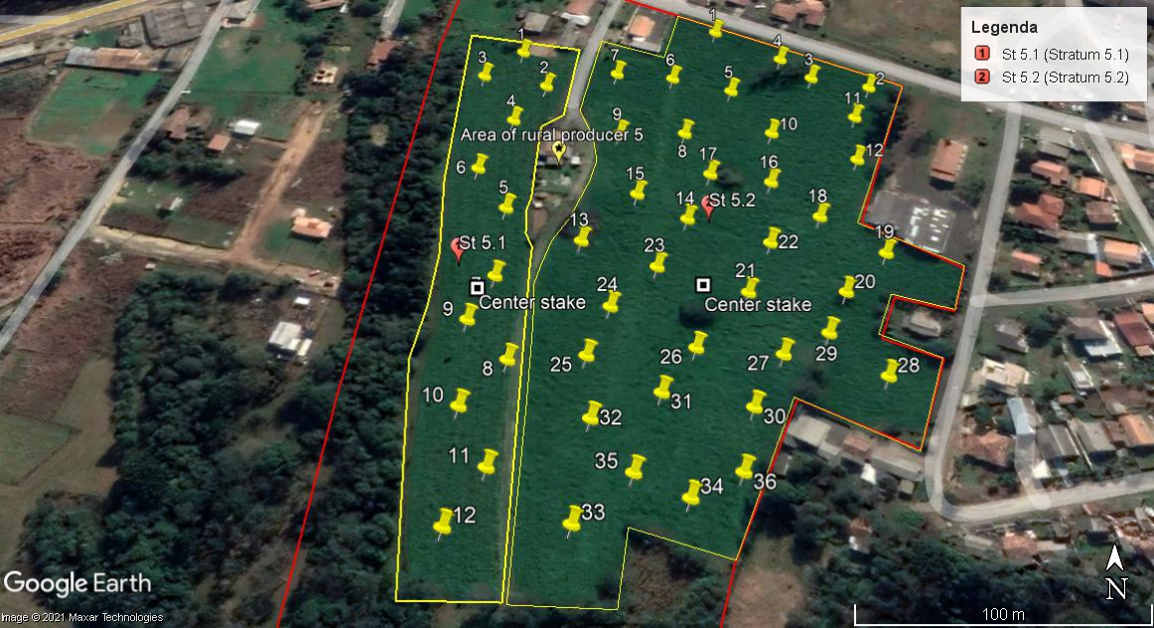

Figure 43 - Spatial coordinate of plots in each stratum of the area of rural producer 5.

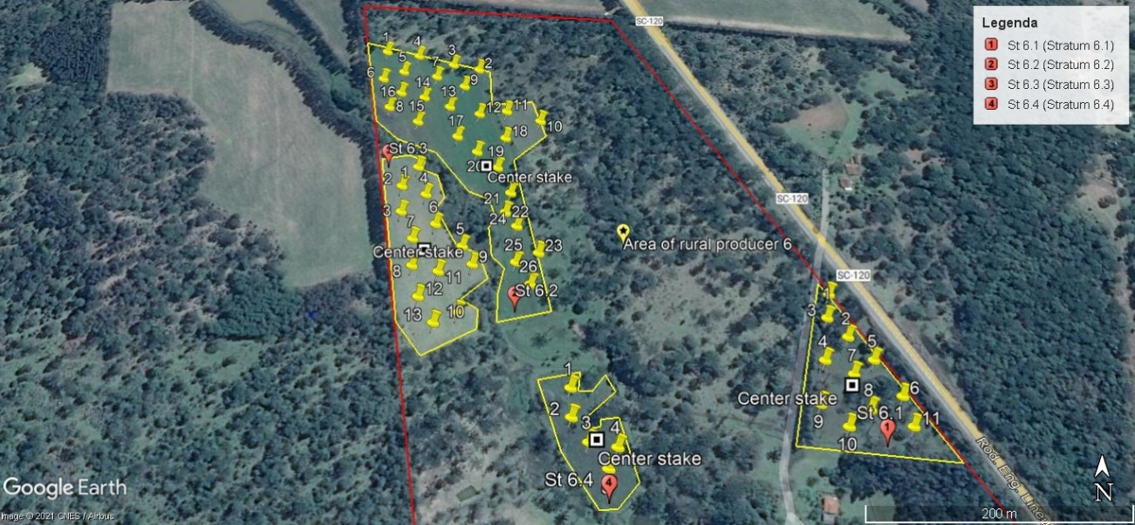

Figure 44 – Spatial coordinate of plots in each stratum of the area of rural producer 6.

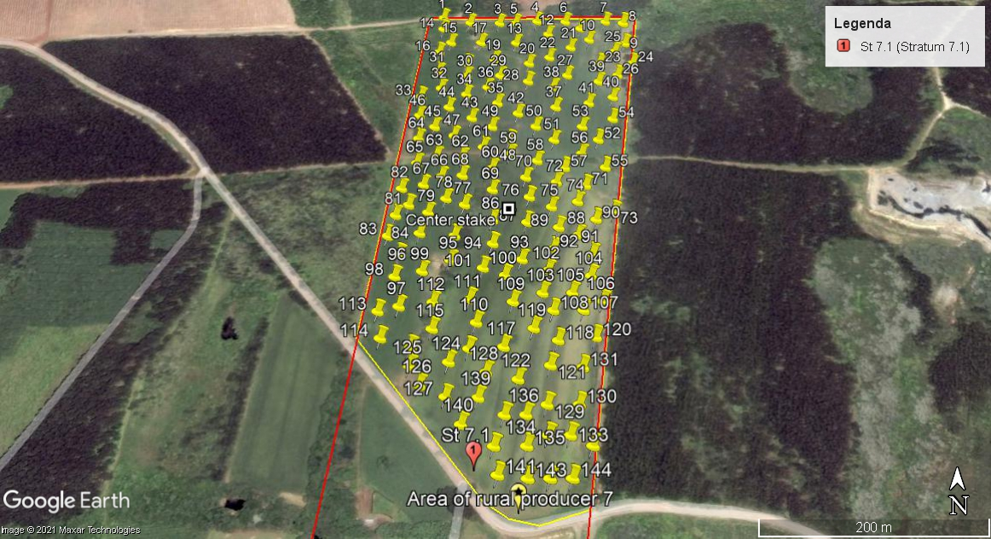

Figure 45 - Spatial coordinate of plots in each stratum of the area of rural producer 7.

* Step 6: Qualitative Truthing of Stratification during Sampling. The soil sampling was performed using a software which planned the design plot symmetrically distributed for the stratification process. A specific spatial coordinate approach was used in the project area. It was important to track the sampling by whom planned the pre-stratification to highlight any observable difference. Ex-ante stratification noticed some differences among the plots regarding to soil carbon content. The region where the project activities is implemented with of woody companies, which could justify some outliers (within %oscl) as harvested Pinus tree These observations allowed an evaluation more precise, identifying and justifying the noticed divergences on the results. Therefore, the stratification was based to some degree on qualitative and subjective judgements. For example, within the area of the rural producer’s 1, pre-stratification planned 3 strata and, after the SOC measurements, they were splitted in 4 strata using the steps above for reaching confidence of 90%.
* Step 7: The post-stratification used statistical techniques to refine stratification based on the quantitative and qualitative data collected of the variable SOC, as well key factors that influence reaching sufficient degree of homogeneity.

#### Task 2.2 Estimation of the current carbon content of the soil carbon pool per unit of area, for each stratum

The soil organic carbon per unit of area, for each stratum was estimated considering the pre-stratification sampling performed at the baseline scenario and described above (Task 2.1). For this, the steps of the VCS Module VMD0021, version 1.0, were followed.

**Step 1: Land reconnaissance and pre-sampling.** The sampling plot has been designed to ensure satisfactory investigation considering existing soil classifications and mapping, soil texture, mineralogy and apparent material, as well geomorphic position including surface shape (concavity/convexity) and slope position. There are specifics geographics coordinates for the location of the plots at the pre-stratification sampling. The sampling design was shaped in rectangular form, symmetrically distributed.

The pre-stratification was evaluated considering the following parameters: soil texture, clay content and organic carbon present in the soil before the implementation of the project activities, considering four horizons (0-20 cm, 20-40 cm, 40-60 cm, and 60-80 cm). These parameters tend to directly influence the accumulation of the organic carbon in a stratum. In the methodology VM0021 (Soil Carbon Quantification Methodology), version 1.0 it is recommended to evaluate different soil horizons due to the sequester capacity in each region. According to Lal et al. (2018)17 the concentrations of soil organic carbon (SOC) is higher in the top soil (up to 20 cm) than in deep depth, indicating that in the superficial region may occur an instable carbon sequester. The areas of the first instance are classified as non-organic soil according to the organic soil definition of the VMD0021 module. Thus, it attends the methodology applicability.

Soil sampling was undertaken using a permanent sample plot technique, and a plot design which supports repeated sampling tasks without any bias resulting from disturbances caused by previous sampling. Sampling will be undertaken using the following 6 steps:

This pre-sampling can be used to identify areas containing organic soils, which is not eligible for application of the VMD0021 module, v.1.0.

Step 2: Selection of sampling parameters. The sampling intensity and sampling depth calculations were complementary to the decision of the stratification and address the re-stratification to reach the goal of the project activity: stable SOC accumulation. The technical team accompanied and reported features such as active rooting, tillage disturbance, soil color changes indicating active carbon accumulation or leaching, textural changes resulting from mobilization of fine fractions, etc. in the project report.

- The determination of the sampling intensity at the baseline scenario was plotted as much as each stratum presented different parameters (soil texture, crop species, practices, slope position, surface shape). The subsequential sampling will be driven by the initial results analysis regarding the homogeneity, tillage management and statistical calculations.

- Determining calculated depth and sampling depth: The calculated depth was set to a depth that is deep enough to capture at least 90% of the expected change in soil carbon resulting from the project activity compared with the projected soil carbon change under the baseline scenario within the project crediting period. The first monitored application will generate knowledge on changes in soil carbon under the predicted ecological and treatment conditions. A range of layers will be sampled in order to observe changes in depth resulting from the management of activities and may result in the increase of soil carbon in some soil layers and the decrease of soil carbon in others. The topsoil (upper 20 cm) will not be considered in the calculations since the carbon content is considered unstable because of the sharing nutrients with the root dense presence, typical from the association of planting and soil dynamic. Bedrock or cement were not observed at this instance, that means no disturbance in sampling depth.

- Sampling depth for the first instance was 80cm attending to the recommendation of 10-20% greater than the calculated depth to allow the detection of changes caused by the project in deeper layers over time. Since tillage has been practiced, the sampling depth was assumed one layer below the maximum depth of the crop rooting depth, to capture effects of downward migration of soil carbon from the tillage and rooting layer.

Step 3 is appropriate for project scenario quantification and is included at the monitoring plan.

**Step 4: Sampling.**

**Step 4.1 Location plots**

According to MAPA’s national method, a randomized definition of plot locations was adopted. The procedure includes the systematized allocation of plots after a randomized initial plot is defined. In this case, the plots are located using a systematic method – usually on a grid, with the location of the first points on the grid determined randomly. This will be carried out prior to field work, with the plot locations specified on a map or on aerial photos, specified based on their distance from a defined point or as a GPS coordinate.

**Timing of Sampling**

The plot sampling will be undertaken annually under, to the greatest degree possible, the same ecological and treatment conditions with each repeated sampling. Thus, the day and month were recorded for each permanent sample plot and, subsequent samples at these plots will be undertaken within 15 days of the day, month in the following years, unless they have suffered significant changes in their ecological or treatment conditions (for instance a very late spring, late tillage, etc.).

**Step 4.2.Soil Sampling Plot Design**

A soil sampling plot design in each stratum was symmetrically distributed. Each sampling was taken under each plot location, and progressive relocation plot will occur with each registry. Re-sampling the same location plot will be avoided. The sample plot location did not fall in an area of exposed bedrock or impermeable parent material (for instance very compacted till) or an impermeable man-made material (for instance a road surface), therefore the applied technique allowed determination of representative results.

**Step 4.3 Initial Plot Establishment and Subsequent Relocation Steps**

Using a handheld GPS, the plot center was accurately determined and recorded with a center stake to use as reference to the subsequent sampling relocation. The plot layout was laid in the field collecting a separate soil sample from each soil layer placed in a plastic bag which was labeled with sample point and layer identification code, ensuring identification for later processing and analysis.

To determine the bulk density of each layer of soil, a known volume of undisturbed soil from each sampled soil layer within the plot was collected separately.

About ten sample plots per sub-division of 1 hectare were collected at the pre-stratification and labeled according to the layer depth of 20-40cm, 40-60cm and 60-80cm.

Table 7 – Summary of amount of strata, sampling plots and samples collected within the project area of the first instance

|  |  |  |  |  |
| --- | --- | --- | --- | --- |
| **Rural producer ID** | **Amount of Strata** | **Area (ha)** | **Sampling plots** | **Samples amount** |
| 1 | 4 | 8.20 | 83 | 280 |
| 2 | 2 | 5.10 | 51 | 174 |
| 3 | 3 | 3.40 | 35 | 129 |
| 4 | 4 | 2.04 | 24 | 96 |
| 5 | 2 | 4.80 | 48 | 162 |
| 6 | 4 | 5.35 | 55 | 201 |
| 7 | 1 | 14.4 | 144 | 457 |
| Total | 20 | 43.29 | 440 | 1,499 |

Soil analysis was primarily conducted to determine inorganic and organic carbon (Table 8 and Table 9), soil texture, classification, bulk density and coarse fragments. None large (greater tan 10mm in diameter) or small coarse fragments (between 2 to 10 mm in diameter) was identified within the soil sampling.

**Step 5: Soil Sample Preparation and Laboratory procedures.** All samples were inventoried with label to ensure that they are accurately recorded and prepared for laboratory analyses and archival preservation. The Kellogg Soil Survey Laboratory Methods Manual, Soil Survey Investigations Report No. 42, Version 5.0 by the USDA Natural Resources Conservation Service, issued 2014 (latest version) was used as standard of the laboratory´s procedures.

**Step 6: Analytical Laboratory Data Checking and Calculation**

**Step 6.1 Data checking**

All reported values were evaluated regarding to the attendance of be within the 10% variance with a 90% confidence interval. These tests were undertaken for soils collected from the same soil type, slope, vegetation cover typing, based on the stratification described above.

One point was concluded appear to be outlier data points with what appear to be significantly skewed or divergent reported data outside the range of similarity to other data point results: ID 17 of the stratum 1 of the rural producer 1 (as mentioned on the task 2.1). The reason for the variance is the historical harvesting eucalyptus trees within the stratum 1. The significant and highly anomalous difference found was at the average %osc of 5.23% among others below 2%. This plot was deleted. For subsequent sampling, this anomalous characteristics will be avoided by shifting the plot location within the stratum.

None request retesting by the laboratory of archived samples was necessary since any aberrant was unexplained.

**Step 6.4 Data Calculation: Total soil carbon**

The following equation was used to calculate soil carbon per unit area shown in the Table 8 and Table 9.

|  |  |
| --- | --- |
| $${SC}_{Y}= \sum_{l}^{x}{({sd}_{l}×(1-LCF\%_{l})×{sdens}_{l}×{\%osc}_{l}×{10}^{1})+\sum_{l}^{x}{({sd}_{l}×(1-LCF\%_{l})×{sdens}_{l}×{iscg}_{l}×{m_{iscl}^{-1}×({12}/{44})×10}^{1})}}$$ | Equation 5 |

Where:

${SC}_{Y}$ = Total measured soil carbon per square meter at plot y, kg/m2

= The number of soil layers measured

$l$ = Soil layers

${sd}_{l}$ = The average depth (thickness) of soil layer x found in the sampling points within the plot, cm

$LCF\%$ = The % of soil volume composed of large coarse fragments, %

${sdens}_{l}$ = The average oven dry bulk density of soil layer x after removal of coarse fragments, found in the sampling points within the plot, g/cm3

= The average mass of organic soil carbon in layer x, as a percentage of the total mass of the samples, as measured in the laboratory, %

${iscg}_{l}$ = The average mass of CO2 emitted from the soil samples during acid testing, g

$m_{iscl}$ = The average mass of the samples tested using acid testing, g.

$12/44$ = Conversion from CO2 to C

Notes: The depth ${sd}_{x}$ of the bottom-most measured soil layer is the thickness of that layer from the top of the layer to the calculated depth, 20cm for any soil layer within the first instance.

${\%osc}_{l}$ is the average value of organic carbon determined from the samples submitted to the laboratory for each plot.

In accordance with the introduction of the VMD0021, v.1.0, changes in inorganic carbon are not expected to be significant. The inorganic carbon content (Table 8) was determined by laboratorial analyses in all strata of the first instance of the proposed project to make sure about the negligible amount. Therefore only organic carbon was accounted. The information about the inorganic carbon content measured by laboratorial analysis is available at the folder “Resultados carbono inorgânico” (for the validation process).

Table 8 - Inorganic carbon content measured for each rural producer’s area.

|  |  |
| --- | --- |
| **Rural producer** | ${iscg}_{l}×{m_{iscl}}^{-1}$**(%)** |
| 1 | 0.14 |
| 2 | 0.11 |
| 3 | 0.28 |
| 4 | 0.14 |
| 5 | 0.18 |
| 6 | 0.17 |
| 7 | 0.17 |

**Step 6.5 Statistical Calculations**

The standard deviation and the confidence interval for total carbon were calculated for each stratum. Where the confidence interval exceeds +/- 10% with 90% confidence, the number of plots was calculated (N) with the Equation 5.3 of the VMD0021, v.1.0 using standard deviation and t-student. The comparison of it to the sampled number of plots in stratum s (#ys) concluded that three among eight had not installed enough plots. The alternative action (c) about recalculate SoilC to determine the baseline using the Equation 5.4 and 5.6 (Equation 6) of the same version of the VMD0021 module was adopted.

**Step 6.6 Calculating the total accounted soil carbon for the stratum**

The total accounted soil carbon for the stratum was calculated using the following equation:

|  |  |
| --- | --- |
| $$SoilC_{S}=(\sum_{y_{s}}{(}SC_{y})×{\#y}_{s}^{-1}×A_{s}×{10}^{-3}) - {AC}_{s,t}$$ | Equation 6 |

Where:

$y_{s}$ = The plots in stratum s

${\#y}_{s}$ = The number of plots in stratum s, dimensionless

${SC}_{y}$ = The average soil C per m2 in plot y, kg/m2

= The area of stratum s, m2

10-3 = Conversion from kg to t

${AC}_{s,t}$ = Carbon added to the soil as accounted amendments in stratum s to time t, t

Table 9 – Average total carbon concentration (SCy), standard deviation (s), confidence level, sampling (#Ys) and calculated (N) plot number and total soil carbon (SoilCs) for each stratum at the baseline scenario

|  |  |  |  |  |  |  |  |  |  |
| --- | --- | --- | --- | --- | --- | --- | --- | --- | --- |
| **Rural producer** | **STRATUM** | **SCy average (kg/m²)** | **Std deviation (s)** | **Confidence level** | **#Ys** | **N calculated** | **SoilCs (tC)** | **Re-calculated SoilCs (tC)** | |
| 1 | 1 | 9.17 | 1.18 | 91.62 | 10 |  | 100.87 |  | |
| 2 | 12.74 | 4.87 | 86.43 | 55 | 25 | 688.04 |  | |
| 3 | 5.05 | 1.16 | 80.23 | 7 | 11 |  | 26.68 | |
| 4 | 23.77 | 7.14 | 91.47 | 10 |  | 213.97 |  | |
| 2 | 1 | 21.13 | 7.48 | 97.56 | 41 |  | 866.15 |  | |
| 2 | 13.66 | 1.92 | 86.65 | 10 | 4 | 136.62 |  | |
| 3 | 1 | 15.43 | 2.18 | 85.99 | 13 | 4 | 192.84 |  | |
| 2 | 12.48 | 2.46 | 93.70 | 9 |  | 112.30 |  | |
| 4 | 15.78 | 2.90 | 92.36 | 13 |  | 197.21 |  | |
| 4 | 1 | 14.30 | 2.88 | 99.96 | 4 |  | 45.77 |  | |
| 2 | 10.36 | 2.24 | 99.59 | 4 |  | 33.14 |  | |
| 3 | 7.56 | 1.90 | 88.10 | 9 | 12 |  | 73.55 | |
| 4 | 14.10 | 2.61 | 97.26 | 7 |  | 70.51 |  | |
| 5 | 1 | 5.91 | 2.09 | 99.40 | 10 |  | 70.93 |  | |
| 2 | 5.85 | 3.20 | 81.59 | 36 | 51 |  | 168.75 | |
| 6 | 1 | 19.79 | 5.47 | 99.86 | 11 |  | 197.92 |  | |
| 2 | 14.21 | 7.17 | 99.18 | 26 |  | 369.48 |  | |
| 3 | 12.97 | 2.54 | 89.62 | 13 | 7 | 162.09 |  | |
| 4 | 15.88 | 3.49 | 99.96 | 5 |  | 79.40 |  | |
| 7 | 1 | 10.67 | 3.34 | 89.97 | 144 | 16 | 1536.19 |  | |
| Total |  |  |  |  |  |  | 5,342.39 | |

Task 2.3 Projection of the future carbon content of the soil carbon pool per unit of area, for each stratum

The projection of the future carbon content of the soil carbon pool at the first instance of this project in absence of the proposed project activity is the same that already published by several authors: degraded soil with low soil carbon pool (Rumpel and Chabbi, 202125; Sanderman et al., 201726; Sacks et al., 201427). The intensification of the agricultural production improved the combat against famine. However, it resulted in many negative effects mainly related to deforestation process with consequent conversion of native areas for agricultural production. It is believed that agricultural soils have impoverished in SOC by 116 Gt of SOC since agriculture began16. According to Sanderman et al. (2017), lower SOC content has important consequences for soil properties and provision of ecosystem services derived from soil: SOC-depleted soils are characterized by their low available nutrient contents and high erosion rates due to poor aggregation and structure, leading to compaction. Moreover, they contain few soil organisms and have low water infiltration and storage abilities. With low quantity of organisms such as bacteria and fungi that works in synergy with insects and animals, lower organic carbon can be sequestered in soils which may have contrasting effects on climate change and global warming4. Therefore, the expansion of tillage practices (intensive agriculture) impacted negatively the environment resulting in GHG emissions, declining biodiversity, loss soil fertility and elemental imbalance, acidification, salinization, and the pollution of waterways and water table28,29.

The identification of the land use baseline scenario is needed for the future projection of the variable soil organic carbon fixation. Regarding the available information in the VCS module VMD0019, version 1.0, it was identified that the referred variable is classified as location specific, and its category is planned. It is location specific due to the variable changes across the landscape and predicts different values of the variable in different places. It is a planned because the value of the variable is under the control of rural producers, who are independent of the project proponent (Ambipar). Still in accordance with the VCS module VMD0019: step 4 (Temporal character of the variable), the variable soil organic carbon fixation is classified as “intended” which means that variable is a characteristic which will arise as a result of the project activities under the project scenario; step 10 (Analysis of constraints to future values of the variable soil organic carbon fixation), where it is presented the constraints, we identify economic and physical constraints. The economic constraint occurs due to the application of our soil conditioner to be gradual for obtaining a regenerative agriculture, which could impact the productivity at the beginning, when compared to the continuous use of chemical additives employed in the traditional agriculture that presents fast response regarding the improvement of productivity. The physical constraints would be related to the soil composition (mainly related to clay and sand) that can limit the organic carbon fixation in the soil; and step 12 (Projection of planned variables), when specific agents not under the control of the proponent (Ambipar) have stated plans for the values of the variable soil organic carbon fixation.

In summary of the literacy above and steps of the VMD0019, the projection of the future carbon content within the project crediting period under the baseline scenario is in accordance with the optional condition (a) of the VM0021 Methodology, v.1.0, that recognize that current activities and agents have caused the degradation of the croplands, grasslands or rangelands. The SOC content per area would be lower than estimated at the baseline scenario. Therefore, being conservative, carbon pools within the project area is highly unlikely to increase under the baseline scenario during the project crediting period, subject to re-assess at year 10.

Task 2.4 Project area stratification for biomass

A follow-up was not monitored in conjunction with the rural producers’ areas at the baseline scenario.

This instance, a priori, does not notice any practice that would change biomass pools, aboveground woody, non-woody biomass, wood harvest outputs, long lived wood products and dead wood pools to be reported and accounted. Therefore, the optional tasks 2.5 to 2.11 were not applied.

The voluntary initiative 4 per thousand launched in 2015 from the Paris Climate Agreement emerged to engage the transition of intensive agriculture towards sustainable soil use, aiming to climate change mitigation, climate change adaptation and food security. The adoption of sustainable ALM practices and technological development can make land usage feasible as contribution for carbon capture, allowing more agricultural production from less land use.

Task 2.12 Estimation of current average domesticated animal populations within the project area

Although emissions from manure application are not expected to change with the project, the emissions calculations were estimated based on the current population of domesticated animals of the 7 rural producers for the final accounted carbon flux. The project activity expects that CO2 capture in soil will neutralize livestock husbandry. Among these selected rural producers, activities of manure trading or spread on the soil will be registered for comparison to the baseline scenario. The Table 10 presents the current population in the project starting date.

Table 10 - Population of livestock per farmer

|  |  |  |  |  |  |  |
| --- | --- | --- | --- | --- | --- | --- |
| **Farmer** | **Domesticated Animals Population *l*** | | | | | |
| **Dairy** | **Bovine** | **Poultry** | **Sheep** | **Swine** | **Goat** |
| 1 | 0 | 6 | 0 | 0 | 0 | 0 |
| 2 | 0 | 3 | 0 | 58 | 0 | 12 |
| 3 | 0 | 50 | 0 | 0 | 0 | 0 |
| 4 | 0 | 4 | 0 | 15 | 0 | 0 |
| 5 | 4 | 11 | 17 | 0 | 16 | 0 |
| 6 | 20 | 0 | 0 | 23 | 0 | 0 |
| 7 | 6 | 21 | 0 | 0 | 0 | 0 |

Task 2.13. Projection of future domesticated animal populations under the baseline scenario

There is not projection to animal population change and, conservatively, resulting emissions are equal to the current baseline scenario.

Task 2.14 Estimation of emissions of GHGs from domesticated animals within the project area under the baseline scenario

The VCS Module VMD0028, Estimation of emissions from domesticated animals, version 1.0 gives the methods to estimate emissions of non-CO2 GHGs through the Steps 1 to 4.

**Step 1: Estimation of CH4 emissions from enteric fermentation (El,CH4,ferm)**

Domesticated animals have a ruminant digestive system through which gases are often released into the atmosphere, classified as enteric CH4 emissions, Equation 7, Equation 8 and Equation 9 (Equations 12.1, 12.2 and 12.3 from the module VMD0028, version 1.0) notices how to perform the quantification of CH4 emissions from enteric fermentation and related to the manure management per rural producer per year.

|  |  |
| --- | --- |
| $$E_{l,{CH}_{4},ferm}=\sum_{l}{\left({EF}_{1}∙{Population}_{l}\right)∙{10}^{-3}∙{GWP}_{{CH}_{4}}}$$ | Equation 7 |

Where:

= CH4 emissions from enteric fermentation; tonnes CO2eq y-1

= Types of livestock

= Enteric CH4 emission factor for the livestock type *l*; kg CH4 head-1 y-1

= Number of livestock for livestock type *l*; heads

${GWP}_{{CH}_{4}}$ = Global warming potential for CH4 (with a value of 21 for the first commitment period); dimensionless

${10}^{-3}$ = Conversion factor of kilograms into tonnes; dimensionless

Assumptions:

1. Default values of Emission Factors per livestock are available on Tables 10.10 and 10.11 of the IPCC 2006 Guidelines for AFOLU, Chapter 10, volume 4.

Table 11 - Enteric (EF1) and Manure Management (EF2) Emission Factors per livestock (Table 10.10 and 10.11, Ch. 10, 2006 IPCC).

|  |  |  |  |  |  |  |
| --- | --- | --- | --- | --- | --- | --- |
| **Parameters** | **Dairy** | **Bovine** | **Poultry** | **Sheep** | **Swine** | **Goat** |
| EF1 | 72.00 | 56.00 | 0.00 | 5.00 | 1.00 | 5.00 |
| EF2 | 1.00 | 1.00 | 0.02 | 0.15 | 1.00 | 0.17 |

Considering the population of livestock presented in the Table 10 and the assumption of Table 11, it is possible to estimate the CH4 emissions from enteric fermentation. All involved calculation for this determination is presented at the file named “Emissions from domesticated animals” in the tab “ECH4,ferm” available for the validation process. The results are presented at the Table 15.

**Step 2. Estimation of CH4 emissions from manure management (El,CH4,manure)**

Considering the population of livestock presented in the Table 10 and the assumption of Table 11, it is possible to estimate the CH4 emissions from manure management. Specific manure management for each rural produced was reported and the calculation for this determination is presented at the file named “Emission from domesticated animals” in the tab “ECH4,manure” available for the validation process. The results are presented at the Table 15 and used default emissions factors presented in Table 10.14-10.16 of IPCC 2006 Guidelines for AFOLU.

|  |  |
| --- | --- |
| $$E_{{CH}_{4},manure}=\sum_{l}{\sum_{m}{\left({EF}_{2lm}∙{Population}_{l}\right)∙{10}^{-3}∙{GWP}_{{CH}_{4}}}}$$ | Equation 8 |

Where:

= CH4 emissions from manure management; tonnes CO2eq y-1

= Livestock type

$m$ = Manure management system

${EF}_{2lm}$ = Manure management CH4 emission factor for the livestock type l using the manure management system m; kg CH4 head-1 y-1

= Number of livestock per livestock type; heads

${GWP}_{{CH}_{4}}$ = Global warming potential for CH4 (with a value of 21 for the first commitment period); dimensionless

${10}^{-3}$ = Conversion factor of kilograms into tonnes; dimensionless

**Step 3. Estimation of N2O emissions from manure management (El,N2O,manure)**

Nitrous oxide emissions from manure management were estimated undertaken the type of management system used (direct emissions), and other forms of nitrogen loss from the system (indirect emissions).

|  |  |  |  |
| --- | --- | --- | --- |
|  | Equation 9 | | |
|  | | | Equation 10 | | |
| $$E_{Indirect_N_{2}O,manure}=\sum_{l}{\sum_{m}{\left({Population}_{l}∙Nex∙{Frac}_{gas}∙{EF}_{4}\right)∙{10}^{-3}∙(44/28)∙{GWP}_{N_{2}O}}}$$ | | | | | Equation 11 | | |

Where:

$E_{l,N_{2}O,manure}$ = emissions from manure management; tonnes CO2e y-1

= Direct N2O emissions from manure management; tonnes CO2e y-1

= Indirect N2O emissions from manure management; tonnes CO2e y-1

= Livestock type

$m$ = Manure management system

${Population}_{l}$ = Population of livestock; heads

$Nex$ = Annual average N excretion per livestock head; kg N head-1 y-1

= Emission factor for N2O emissions from manure management for the livestock group; kg N2O-N (kg N-1) head-1 y-1

= Emission factor for N2O emissions from atmospheric deposition of forage-sourced nitrogen on soils and water surfaces; kg N2O-N (kg NH3- N and NOx-N emitted) -1 head-1 y-1

Note: The use of the IPCC default factor 0.01 is recommended.

${Frac}_{gas}$ = Fraction of managed livestock manure nitrogen that volatilizes as NH3 and NOx in the manure management phase; kg NH3-N and NOx-N emitted (Kg N) -1

= Global warming potential for N2O (310 for the first commitment period); dimensionless

$\left(\frac{44}{28}\right)$ = Conversion of N20-N emissions to N2O emissions

${10}^{-3}$ = Conversion factor of kilograms into tonnes; dimensionless

Assumptions:

The parameter $Nex$ was determined using the Equation 10.30 of IPCC 2006 Guidelines for AFOLU, Chapter 10, volume 4. In this Equation, it is recommended to use the parameters $N_{{rate}_{(T)}}$ (default N excretion rate, kg N (1000 kg animal mass)-1 day-1) and TAM (typical animal mass for livestock category *T*, kg animal-1), available at Table 10.19 (region Latin America) and at Tables 10A-4-10A-9 (region Latin America), respectively (IPCC 2006 Guidelines for AFOLU, Chapter 10, volume 4). All calculations to determine the parameter $Nex$ was demonstrated at the file named “Emissions from domesticated animals” in the tab “Nex” available for the validation process. The values of parameter $Nex$ used for each livestock is presented at Table 12.

Table 12 - Annual average nitrogen excretion per livestock ($Nex$), default N excretion rate ( $N_{{rate}_{(T)}})$ (Table 10.19, region Latin America, IPCC 2006 Guidelines for AFOLU, Chapter 10, volume 4) and typical animal mass for livestock category *T* (TAM) (Tables 10A-4-10A-9, region Latin America, IPCC 2006 Guidelines for AFOLU, Chapter 10, volume 4).

|  |  |  |  |  |  |  |
| --- | --- | --- | --- | --- | --- | --- |
| **Parameter** | **Dairy** | **Bovine** | **Poultry** | **Sheep** | **Swine** | **Goat** |
| Nex  (kg N head-1 yr-1) | 70.08 | 40.08 | 0.54 | 11.95 | 15.02 | 15.00 |
| Nrate(T)  (kg N (1000 kg animal mass)-1 day-1) | 0.48 | 0.36 | 0.82 | 1.17 | 1.47 | 1.37 |
| TAM  (kg animal-1) | 400.00 | 305.00 | 1.80 | 28.00 | 28.00 | 30.00 |

The rural producers 3 and 6 manage the manure in anaerobic lagoon while the others, a solid storage regime describes their manure management. This information. The identification of the management system is needed to establish the ${EF}_{3}$ presented at the Table 13 (default values available at Table 10.21 of IPCC 2006 Guidelines for AFOLU, Chapter 10, volume 4). According to the module VMD0028, the emission factor ${EF}_{4} i$ s a default factor of 0.01 (Equation 10.27 of IPCC 2006 Guidelines for AFOLU, Chapter 10, volume 4).

Table 13 – Default Emission factors for direct N2O emissions from manure management (Table 10.21, IPCC 2006 Guidelines for AFOLU, Ch. 10, v.4)

|  |  |
| --- | --- |
| **Rural producer ID** | **EF3** |
| 1 | 0.005 |
| 2 | 0.005 |
| 3 | 0.000 |
| 4 | 0.005 |
| 5 | 0.005 |
| 6 | 0.000 |
| 7 | 0.005 |

If the manure sourcing from the domesticated animals is kept within the project area, their emissions will be accounted for as baseline and project scenarios. If the manure sourcing from the domesticated animals is kept outside of the project area, their emissions will be accounted for as leakage. In the Table 14 is shown the fraction of managed livestock manure nitrogen that volatilizes as NH3 and NOx in the manure management phase per rural producer, considering the available information at Table 10.22 of IPCC 2006 Guidelines for AFOLU, Chapter 10, volume 4.

Table 14 – Fraction of managed livestock manure nitrogen that volatilizes as NH3 and NOx in the manure management phase per rural producer (Table 10.22, IPCC 2006 Guidelines for AFOLU, Chapter 10, volume 4).

|  |  |  |  |  |  |  |
| --- | --- | --- | --- | --- | --- | --- |
| **Rural producer ID** | **Fracgas ((kg N)-1)** | | | | | |
| **Dairy** | **Bovine** | **Poultry** | **Sheep** | **Swine** | **Goat** |
| 1 | 0.00 | 0.45 | 0.00 | 0.00 | 0.00 | 0.00 |
| 2 | 0.00 | 0.45 | 0.00 | 0.12 | 0.00 | 0.12 |
| 3 | 0.00 | 0.45 | 0.00 | 0.00 | 0.00 | 0.00 |
| 4 | 0.00 | 0.45 | 0.00 | 0.12 | 0.00 | 0.00 |
| 5 | 0.30 | 0.45 | 0.55 | 0.00 | 0.45 | 0.00 |
| 6 | 0.35 | 0.00 | 0.00 | 0.12 | 0.00 | 0.00 |
| 7 | 0.30 | 0.45 | 0.00 | 0.00 | 0.00 | 0.00 |

All calculations to determine the parameter $E_{N_{2}O,manure}$ were demonstrated at the file named “Emissions from domesticated animals” in the tab “EN2O,manure”, available for the validation process.

**Step 4. Summation of emissions**

Total emissions domesticated animals within the project area is summed using the following equation:

|  |  |
| --- | --- |
| $$E_{l}=E_{{CH}_{4},ferm}+E_{{CH}_{4},manure}+E_{N_{2}O,manure}$$ | Equation 12 |

Where:

$E_{l}$ = Emissions from livestock management; tonnes CO2e yr-1

= CH4 emissions from enteric fermentation; tonnes CO2e yr-1

= CH4 emissions from manure management; tonnes CO2e yr-1

= N2O emissions from manure management; tonnes CO2e yr-1

Based on the information above and using the Equations 5-10 (the same equations 12.1-12.6 from the module VMD0028, version 1.0), it was estimated the emissions from domesticated animals in the baseline scenario ($E_{l}$) as being 194.43 tonnes CO2e yr-1. It is also presented the estimated emissions per year for domesticated animals considering each rural producer (Table 15). All calculations to determine the parameter $E_{l}$ were demonstrated at the file named “Emissions from domesticated animals” in the tab “El”, available for the validation process.

Table 15– Total estimated emissions from domesticated animals at the baseline scenario per year.

|  |  |  |  |  |
| --- | --- | --- | --- | --- |
| **Rural producer ID** | **Estimated emissions (tonnes CO2e y-1)** | | | |
| **ECH4,ferm** | **ECH4,manure** | **EN2O,manure** | **El** |
| 1 | 7.06 | 0.13 | 1.11 | 8.29 |
| 2 | 10.88 | 0.29 | 3.19 | 14.36 |
| 3 | 58.80 | 1.05 | 4.39 | 64.24 |
| 4 | 6.28 | 0.13 | 1.28 | 7.69 |
| 5 | 19.32 | 0.66 | 4.29 | 24.27 |
| 6 | 32.66 | 0.49 | 2.55 | 35.70 |
| 7 | 33.77 | 0.57 | 5.53 | 39.87 |
| **Total** | 168.76 | 3.31 | 22.36 | 194.43 |

Task 2.15 Estimation of current soil emissions of N2O or CH4 from within the project area

Anthropogenic N2O emissions are rising on AFOLU activities and were 8.7 ± 2.5 MtN2O yr-1 (2.3 ± 0.7 GtCO2e yr-1) during the period 2007-2016. Anthropogenic N2O emissions (Figure SPM.1 and Table SPM.1 from pg 18, IPCC 2020 Report) from soils are primarily due to nitrogen application including inefficiencies, i.e., over-application or poorly synchronized applications, not timed based on crop demand. Cropland soils issued around 3 MtN2O/y (around 795 MtCO2e/y) during the period 2007–2016. There has been a major growth in emissions from managed pastures due to increased manure deposition. Livestock on managed pastures and rangelands accounted for more than one half of total anthropogenic N2O emissions from agriculture in 2014 (Table 2.1, 2.3.3, 5.4.2, 5.4.3 from pg.18, IPCC 2020 Report).

Soils and decaying organic material (including litter-fall in forests, fertilizers used on croplands, and manure stored in lagoons) can emit both methane and nitrous oxides, which are significant GHGs. Emissions of methane and nitrogenous compounds from soils occur as a result of complex processes governed by both organic and inorganic variables. The module VMD0029 is used to estimate the amounts of these GHGs issued from the soil within the project area following four steps.

Emissions calculated under the manure management section of module VMD0028 Estimation of Emissions from Domesticated Animals are not estimated at the Task 2.12 above to avoid double counting.

As described in section 1.3, rural properties are selected by excluding wetland management. This Project adopted the IPCC method to estimate non-CO2 GHGs from soils since the typical example of areas involved in project area are dryland range restoration.

The calculation for the baseline emissions for minimum estimates of N2O and CH4 emissions where fertilizer purchase records, manure production estimates and/or livestock data are unavailable, is based on a conservative estimate of common practice in the region. At the first instance, it was orally reported by the rural producers and coherent to common practice.

Since the significance of the emissions of non-CO2 GHGs from soils is unknown at the current scenario, a monitoring phase to estimate soil GHG emissions will be implemented.

Step 1: Document and map out the following variables

1. Amount, location, timing and conditions of applications of organic or inorganic fertilizers, and type of fertilizer applied.
2. Amount, location and timing of areas subject to flooding, and duration of flooding
3. Amount and location of nitrogen fixing species
4. Soil conditions, temperature and moisture regimes
5. Management activities

Currently, Brazilian rural producers prefer cultivating soybeans because of its attractive payback, since it is a nitrogen fixing species and usually reduces or even eliminates the need to add N source. This advantage emerged through scientific developments on species with reduced N dependence. Since 2012, soybean varieties supply about 98%3 of N related to the initial species. Selected rural producers in the first instance have never had flooding by natural causes and produce crops and grass instead of flooding culture.30

The reported applications of fertilizers, cultivation practices, equipment employed, area dimension of the project within rural producers’ areas were used to estimate non-CO2 emissions for the baseline scenario (data available for consultancy during validation process. Please see the file named “Rev04-Informações de Uso de Área dos Agricultores”). According to historical data within the boundaries of this first instance, there is no evidence of ice deposition on the soil during the season in this region in Santa Catarina.

Step 2: Determine the method to be used

Estimation of the percentage of changes in emissions resulting from emissions of CH4 and nitrous oxides, as a percentage of the total project GHG fluxes will be conducted based on 2006 IPCC methods (chapter 11 for N2O and Appendix 3 for CH4). Emissions estimative from cultivation are not expected to change, therefore will not be undertaken.

Heterotrophic respiration by the soil community and microbiota is estimated on Equation 13. N2O emissions from addition of synthetic nitrogen fertilizers at the baseline, and organic fertilizers at the project scenario are estimated on Table 16.

Step 3: Calculate the emissions of Methane and Nitrous Oxides

*Methane emissions*

Methane emissions occur principally due to the existence of anaerobic conditions in soils due to saturation and flooding. Methane emissions may also result from drainage practice changes in land use not involving flooding or saturation. However, availability of data on these changes is very limited, and changes from practice change in land use are largely expected to be small relative to total project fluxes. Thus, this method calculates methane emissions under conditions of flooding or saturation. Equation 13 estimates the methane emissions according to the days under the with or without ice saturation.

|  |  |
| --- | --- |
| $$E_{s,CH_{4}}=\sum_{S}{(A_{sat,s}((P_{icefree,sat,s}({CH}_{4dif,ni}+{CH}_{4bub,ni}))+(P_{ice,sat,s}×{CH}_{4dif,i})))×21×{10}^{-3}}$$ | Equation 13 |

Where:

$E_{s,CH_{4}}$ = Total emissions of CH4 from the project area, t CO2eq/y in year t and strata s

$s$ = Strata

$A_{sat,s}$ = The mean area of saturated soils in stratum s, ha

$P_{icefree,sat,s}$ = Period of during which the soil is saturated and ice free in stratum s, days

${CH}_{4dif,ni}$ = The rate of emissions of CH4 by diffusion during ice free days, kg ha-1 day-1

= The rate of emissions of CH4 by bubbling during ice free days, kg ha-1 day-1

= Period during which the soil is saturated and ice covered in stratum s, days

${CH}_{4dif,i}$ = The rate of emissions of CH4 by diffusion during ice covered days, kg ha-1 day-1

= Global warming potential for CH4

= Conversion from kilograms to tonnes

CH4 emissions are related to local climate, and to the project area with natural influence days differentiated by ice coverage. Conservatively, mean values to the ecosystem wet and tropical (described on section 1.13) were associated for the first instance. Default IPCC values of rates for emissions of methane (Table 2 of the VMD0029, v.1.1) were adopted to estimate the methane emissions (Table 16) since there is not site-specific peer reviewed available.

${CH}_{4dif,ni}=0.64$ and ${CH}_{4bub,ni}=2.83$

*Nitrous oxide emissions*

The following method will be used because the nitrogen application rates and the absorptive capacity of the soils is such that a loss of nitrogen due to leaching or run-off is unlikely.

Step A: Monitoring and estimating the amount of nitrogen in synthetic and organic fertilizer used as baseline scenario.

The amount of nitrogen in synthetic and organic fertilizer used within the project area at the baseline scenario were estimated using the Equation 14 and Equation 15 of the VCS module VMD0029, version 1.1, respectively. An adaptation only related to the nomenclature of the term $A_{s }$ of the equations from the VMD0029 was performed to evidence that the $A_{s N2O}$ were used to estimate the nitrogen in fertilizers. This parameter will be monitored during the crediting period of the project activities.

|  |  |  |
| --- | --- | --- |
| $$N_{SN-Fert,t}=\sum_{s}{A_{s N2O}}*N_{SN-Fert,k,t}*0.001$$ | | Equation 14 |
| $$N_{ON-Fert,t}=\sum_{s}{A_{s N2O}}*N_{ON-Fert,k,t}*0.001$$ | Equation 15 | | |

Where:

$N_{SN-Fert,t}$ = Total use of synthetic fertilizer within the project area, tonnes N yr-1 in year t

$N_{ON-Fert,t}$ = Total use of organic fertilizer within the project area, tonnes N yr-1 in year t

$A_{s N2O}$ = Area of stratum s with fertilization, ha yr-1

= Use of synthetic fertilizer per unit area for stratum s, kg N ha-1 yr-1 in year t

$N_{ON-Fert,k,t}$ = Use of organic fertilizer per unit area for stratum s, kg N ha-1 yr-1 in year t

$0.001$ = Conversion kg N to tonnes N

The historical land use and common practices of N input within the first instance is summarized in the file named “Rev04-Informações de Uso de Área dos Agricultores” (available for consultancy during validation process). There is no addition of organic fertilizer within the project area at the baseline scenario.

Step B: Choosing the fractions of synthetic and organic nitrogen fertilizer that is issued as NOX and NH3, and emission factors.

${EF}_{1}$ = 1.25% as default emission factor noted in GPG 2000 and 1996 IPCC Guidelines because it has not been calculated for the project activity yet.

The default values for the fractions of synthetic and organic fertilizer nitrogen issued as NH3 and NOX are 0.1 (${Frac}_{GASF}$) and 0.2 (${Frac}_{GASM}$) respectively in 1996 IPCC Guideline (Tables 4-17 and 4-18).

Step C: Calculating direct nitrous oxide emissions from nitrogen fertilization

Using collected data above and Equations 13.4 to Equation 13.6 of the VMD0029, v.1., the Table 16 summarizes ex-ante emissions estimation of methane and nitrous oxide.

All calculations involving on the determination of non-CO2 emissions is available for consultancy at the file named “Soil emissions of N2O and CH4” in the tabs “Es,N2O”, “FSN” and “FON”.

Table 16 - Estimation of N2O emissions through amount of N-fertilizers input, and CH4 emissions estimated through default values of rate of emissions per farmer area for the baseline scenario of the first instance.

|  |  |  |  |  |  |  |  |  |  |  |
| --- | --- | --- | --- | --- | --- | --- | --- | --- | --- | --- |
| **Rural producer** | **Stratum area with fertilization (AsN2O) (ha)** | **Cultive** | **Es,CH4** | **Es,CH4** | **NSN-Fert,k,t** | **ratio NPK** | **NSN-Fert,k,t** | **Es,N2O** | **Es,N2O** | **Es** |
| **t CO2e yr-1** | **Total per farmer (t CO2e yr-1)** | **Urea 45% (kg N ha-1 yr-1)** | **(kg N ha-1 yr-1)** | **(t CO2eyr-1)** | **Total per farmer (t CO2e yr-1)** | **Total per farmer (t CO2e yr-1)** |
| **1** | 1.20 | Corn/Oats/ Ryegrass | 31.92 | 218.10 | 215 | 8:20:20 | 229 | 0.77 | 1.36 | 219.46 |
| 5.40 | Soybean/Oats /Ryegrass | 143.63 | N/A | 0:20:20 | 223 | 0.00 |
| 0.70 | Beans/Oats/ Ryegrass | 18.62 | N/A | 04:14:08 | 257 | 0.05 |
| 0.90 | Corn/Oats/ Ryegrass | 23.94 | 215 | 8:20:20 | 229 | 0.55 |
| **2** | 4.10 | Grassland | 109.05 | 135.65 | N/A | N/A | N/A | 0.00 | 0.16 | 135.81 |
| 1.00 | Corn/Oats/ Ryegrass | 26.60 | N/A | 8:20:20 | 360 | 0.16 |
| **3** | 1.25 | Grassland | 33.25 | 90.43 | N/A | N/A | N/A | 0.00 | 0.00 | 90.43 |
| 0.90 | Grassland | 23.94 | N/A | N/A | N/A | 0.00 |
| 1.25 | Grassland | 33.25 | N/A | N/A | N/A | 0.00 |
| **4** | 0.32 | Mate herb | 8.51 | 54.26 | N/A | N/A | N/A | 0.00 | 0.24 | 54.50 |
| 0.32 | Grassland | 8.51 | N/A | N/A | N/A | 0.00 |
| 0.90 | Corn/Oats/ Ryegrass | 23.94 | N/A | 08:20:20 | 400 | 0.16 |
| 0.50 | Corn/Oats/ Ryegrass | 13.30 | N/A | 08:20:20 | 360 | 0.05 |
| **5** | 1.20 | Soybean/Oats /Ryegrass | 31.92 | 127.67 | N/A | 00:20:20 | 250 | 0.00 | 0.00 | 127.67 |
| 3.60 | Soybean/Oats /Ryegrass | 95.75 | N/A | 00:20:20 | 250 | 0.00 |
| **6** | 1.00 | Grassland | 26.60 | 142.30 | N/A | N/A | N/A | 0.00 | 4.36 | 146.65 |
| 2.60 | Corn/Oats/ Ryegrass | 69.15 | 385 | 08:20:20 | 385 | 2.90 |
| 1.25 | Corn/Oats/ Ryegrass | 33.25 | 400 | 08:20:20 | 400 | 1.48 |
| 0.50 | Grassland | 13.30 | N/A | N/A | N/A | 0.00 |
| **7** | 3.00 | Corn/Oats/ Ryegrass | 79.79 | 383.00 | 334 | 08:20:30 | 400 | 3.01 | 3.16 | 386.16 |
| 8.90 | Soybean/Oats /Ryegrass | 236.72 | N/A | 00:20:20 | 228 | 0.00 |
|  |
| 2.50 | Bean/Oats/ Ryegrass | 66.49 | N/A | 04:14:08 | 300 | 0.16 |  |
| **Total:** |  |  |  | 1,151.41 |  |  |  |  | 9.27 | 1,160.68 |  |

Step 4: Summation of soil emissions

The current emissions of N2O and CH4 from the soils strata within the project area is the resulting annual estimation of the sum of both fractions (Equation 16): 1 160.68 tCO2e yr-1. All calculations about the current emissions of N2O and CH4 from the soils within the project area at the baseline scenario are available for consultancy at the file named “Soil emissions of N2O and CH4” in the tabs “Es”, “Es,CH4”, “Es,N2O”.

|  |  |
| --- | --- |
| $$E_{s}=E_{s,{CH}_{4}}+E_{s,N_{2}O}$$ | Equation 16 |

Where:

$E_{s}$ = Total emissions from non-CO2 GHGs from soils for a given monitoring period, tCO2eyr-1

= CH4 emission from the project area for a given monitoring period, tCO2e yr-1

= N2O emission as a result of nitrogen application within the project area for a given monitoring period, tCO2e yr-1

According to the Table 16 and Equation 16, $E_{s}=$ 1,151.41 + 9.27 = 1,160.68 tCO2e

The expected average annual net change in non-CO2 emissions or removals is relatively small, about 10% of expected average total annual net carbon stock changes on a CO2-equivalent basis. Thus, the use of default IPCC emission factors is adequate, as mentioned on the section 4.3.3.6 “ESTIMATING CHANGES IN NON-CO2 GREENHOUSE GAS EMISSIONS AND REMOVALS” (pg.466) of the 2003 IPCC Good Practice Guidance for LULUCF. It is recommended to develop project-specific emission factors, either through measurement or simulation models when non-CO2 emissions are greater than about 10% of expected average annual net carbon stock changes on a CO2-equivalent basis.

Task 2.16 Projection of future emissions of N2O or CH4 from the soils within the project area

The project future emissions from soils under the current activities in the baseline scenario are projected to be greater than those found under the project scenario.

The sources of the non-CO2 greenhouse gases are biomass burning, fossil fuel combustion, and soil practices described at the Box 4.3.4 (2003 IPCC Good Practice Guidance for LULUCF) as soil disturbance, soil drainage, anaerobic manure management and low cultivation of fixing N-species crop.

These examples are current practices, that would keep occurring without the project activity. Conservatively, the $E_{s}$ under baseline activities within the project area is the same than mentioned on the task 2.15: 1 160.68 tCO2 yr-1.

Task 2.17 to 2.19. These tasks are not applicable

- Task 2.17: The proposed project does not involve emissions from power equipment within the project area.

- Task 2.18: The project does not involve litter pools.

- Task 2.19: Same as Task 2.18.

Task 2.20 Summation of estimate and projections under the baseline scenario

This task is used to sum current and future carbon sequestration and emissions under the baseline scenario, using the VCS module VMD0035 (Methods to Determine the Net Change in Atmospheric GHG Resulting from Project Activities), version 1.0.

A summation of GHG pools at time t-0 (baseline scenario) follows the Equation **17** (Equation 19.1 from VMD0035, v.1.0) below:

|  |  |
| --- | --- |
| $${PoolC}_{t}= \sum_{S}{(SoilC_{S}+ B_{S}×bf+ {Bl}_{S}×lf+Bdw_{S}×dwf+Cwp_{S})×{44}/{12}}$$ | Equation 17 |

Where:

${PoolC}_{t}$ = Total carbon in carbon pools at time t, tCO2eq

S = Strata

$SoilC_{S}$ = The carbon content of the soil pool in stratum s at time t, tC

$B_{S}$ = The living biomass content of stratum s at time t, t

$bf$ = The conversion factor from living biomass to C = 0.5, tC/t

${Bl}_{S}$ = The litter biomass of stratum s at time t, t

$lf$ = The conversion factor from litter biomass to C, tC/t

$Bdw_{S}$ = The dead wood biomass of stratum s at time t, t

$dwf$ = The conversion factor from deadwood biomass to C, tC/t

$Cwp_{S}$ = The carbon content of long-lived wood products resulting from the harvesting of wood in stratum s to time t, tC

44/12 = Conversion factor from C to CO2, tCO2/tC

Setting $B_{S}$, $bf$, ${Bl}_{S}$, $lf$, $Bdw_{S}$, $dwf$, $Cwp_{S}$ to 0 because the living biomass content, litter biomass, dead wood biomass and long-lived wood products were not accounted as carbon pool in this instance, the total carbon in carbon pools at the ex-ante is:

${PoolC}_{t=0}=$ (5,342.39 + 0) $× 44/12$ = 19 588.75 tCO2e

Summation of GHG emissions under baseline scenario with the Equation **18** (Equation 19.2 of the VMD0035,v.1.0):

|  |  |
| --- | --- |
| $${EmissionC}_{t}=\sum_{z}{\left(E_{l}+E_{s}+E_{ff}\right)+\sum_{fe}{E_{b}}}$$ | Equation 18 |
|  |  |

Where:

${EmissionC}_{t}$ = Total emissions from time t=0 to time t, tCO2e.

= The years from time t=0 to time t, yr.

$E_{l}$ = Emissions from livestock management, tCO2e/yr

= Emissions from soil resulting from management activities, tCO2e/yr

= Emissions from burning of fossil fuels in power equipment during project management, tCO2e/yr.

= Fire events within the selected time period.

$E_{b}$ = Emissions of non-CO2 gases caused by fire events, tCO2e/fire even

The terms $E_{ff}$ and $E_{b}$ were set to 0 because these emissions are not accounted in the proposed project. Under baseline scenario (t=0), according to the note for the equation above, only the emissions due to livestock management ( $E_{l})$ and non-CO2 emissions from soils and fertilizers will be accounted.Under baseline scenario, without the project activity and z=20:

${EmissionC}_{t}$ = 20*(194.43 +1,160.68) = 27,102.20 tCO2e

### Summary of baseline emissions from the Sectorial Scope 13 and 14 within the first instance

The sum of estimations of emissions from the application of the methodologies AMS-III.F, version 12.0 (section 4.1.1) and VM0021, version 1.0 (section 4.1.2), under the baseline scenario, outcomes the total baseline emission (Table 17).

Table 17 - Estimated emissions from each contribution of the project activities set up to the baseline scenario

|  |  |  |  |
| --- | --- | --- | --- |
| **Methodologies** | **Parameters** | **(tCO2e)** | **(tCO2e)** |
| AMS-III.F | BECH4,SWDS,y | 925,153.14 |  |
| VM0021 | $${EmissionC}_{t}$$ | 27,102.20 | 19,588.75 |

## 

## Project emissions

### Determination of Project emissions from installed composting technology

Project emissions from composting process $({PE}_{y})$ were determined according the equation 1 of the methodological tool 13 “Project and leakage emissions from composting”, version 2.0. ${PE}_{y}$ is equivalent to parameter ${PE}_{COMP,y}$ in the tool 13 (all calculations were performed in the spreadsheet named as "Equations_Tool 13 and Tool 03”).

|  |  |
| --- | --- |
| $${PE}_{COMP,y}={PE}_{EC,y}+{PE}_{FC,y}+{PE}_{CH4,y}+{PE}_{N2O,y}+{PE}_{RO,y}$$ | Equation 19 |

Where:

|  |  |  |
| --- | --- | --- |
| $${PE}_{COMP,y}$$ | *=* | Project emissions associated with composting in year y (t CO2e/yr). |
|  | *=* | Project emissions from electricity consumption associated with composting in year y (t CO2/yr). |
|  | *=* | Project emissions from fossil fuel consumption associated with composting in year y (t CO2/yr). |
|  | *=* | Project emissions of methane from the composting process in year y (t CO2e/yr). |
|  | *=* | Project emissions of nitrous oxide from the composting process in year y (t CO2e/yr). |
|  | *=* | Project emissions of methane from run-off wastewater associated with co-composting in year y (t CO2e/yr). |

For determining the quantity of waste composted ($Q_{y})$, the option 1 of the section 6.1.1 of the tool 13 was employed due to the weight of wet organic waste delivered to the composting installation be assisted by an on-site weighbridge. It makes feasible to manage the composition of the windrows and their lots.

The composting activity does not involve electricity consumption from the grid or from a fossil fuel fired on-site power plant. Thus, ${PE}_{EC,y}=0$.

The composting activity (emission source j) involves fossil fuel combustion. Therefore, the project emissions employed the methodological tool 03 “Tool to calculate project and leakage CO2 emissions from fossil fuel combustion”. This tool determines ${PE}_{FC,y}$ based on the quantity of fuel combusted and its properties. The calculations were based on the quantity of fuels combusted and the CO2 emission coefficient of those fuels, as follows:

|  |  |
| --- | --- |
| $${PE}_{FC,j,y}=\sum_{i}{{FC}_{i,j,y} ×{COEF}_{i,y}}$$ | Equation 20 |

Where:

${PE}_{FC,j,y}$ = Are the CO2 emissions from fossil fuel combustion in process j during the year y (tCO2/yr).

= Is the quantity of fuel type i combusted in process j during the year y (mass or volume unit/yr).

${COEF}_{i,y}$ = Is the CO2 emission coefficient of fuel type i in year y (tCO2/mass or volume unit).

𝑖 = Are the fuel types combusted in process j during the year y.

The CO2 emission coefficient ${COEF}_{i,y}$ can be calculated based on the net calorific value and CO2 emission factor of the fuel type i, as follows:

|  |  |
| --- | --- |
| $${COEF}_{i,y}={NCV}_{i,y}×{EF}_{CO2,i,y}$$ | Equation 21 |

Where:

${COEF}_{i,y}$ = Is the CO2 emission coefficient of fuel type I in year y (tCO2/mass or volume unit).

${NCV}_{i,y}$ = Is the weighted average net calorific value of the fuel type I in year y (GJ/mass or volume unit).

${EF}_{CO2,i,y}$ = Is the weighted average CO2 emission factor of fuel type i in year y (tCO2/GJ).

𝑖 = Are the fuel types combusted in process j during the year y.

According to the Section 6.2, Data/Parameter table 4, of the Tool 03 and considering that the value for ${NCV}_{i,y}$ is not provided by the fuel supplier in invoices and there is default value for the liquid fossil fuel biodiesel consumed provided by GHG Protocol disclosed by National Energetic Balance 2020 (database from 2019) ( ${NCV}_{biodiesel,y}$ = 9,000 kcal/kg). Thus, the conversion of units (available information in the spreadsheet named as “Conversion of units”) and considering the density of biodiesel from GHG Protocol disclosed by National Energetic Balance 2020 (database from 2019) of 0.880 kg/L the ${NCV}_{biodiesel,y}$ is 0.033 GJ/L.

According to the Section 6.2, Data/Parameter table 5, of the Tool 03 and considering that the value for ${EF}_{CO2,i,y}$ is not provided by the fuel supplier in invoices and there is default value for the liquid fossil fuel biodiesel consumed provided by IPCC default values at the upper limit of the uncertainty at a 95% confidence interval as provided in Table 1.4 of Chapter 1 of Vol. 2 (Energy) of the 2006 IPCC Guidelines on National GHG Inventories ( ${EF}_{CO2,i,y}$ = 84 300 kgCO2e/TJ). Thus, following appropriated conversion of units (available information in the spreadsheet named as “Conversion of units”) the ${EF}_{CO2,i,y}$ is 0.0843 tCO2e/GJ.

Thereby, from the Equation 21, ${COEF}_{i,y}=$ 0.0028 t CO2e/L.

The volume measurements were used for the quantity of fuel type i combusted in the composting process j during the year y (${FC}_{i,j,y}$). The fuel is supplied every other day to the machines employed to manage/aerate the windrows at the composting process through tank trucks from the supplier. The dosing equipment used in this process is properly certified by the national quality standard for trucks. A monthly form is fulfilled daily by the truck driver with the volume recorded from the “fuel supply”. The purchased fuel invoices include fossil fuel volume for the fleet and for the composting machinery. The metered fuel consumption quantities specifically for the composting machines can be cross-checked with available purchase invoices and monthly forms, which are gathered in an annual sheet.

Based on 2020, the volume of fuel consumed by composting machines (hydraulic excavator and wheel loader) was 66 700 L of diesel oil S-10, equivalent to biodiesel, the less pollutant available in the project’s region. The diesel oil S-10 contain 8% of biodiesel. The definition of biodiesel available in the Table 1.1 of Chapter 1 of Vol.2 (Energy) of the 2006 IPCC Guidelines on National GHG Inventories is: biodiesels category includes all liquid biofuels which are added to, blended with or used straight as transport diesel.

Therefore, from the Equation 20, t CO2/yr

#### Determination of project emissions of methane ${(PE}_{CH4,y})$ by composting process

Project emissions of methane from composting ${(PE}_{CH4,y})$ are determined as follows:

|  |  |
| --- | --- |
| $${PE}_{CH4,y}=Q_{y}×{EF}_{CH4,y}×{GWP}_{CH4}$$ | Equation 22 |

Where:

|  |  |  |  |
| --- | --- | --- | --- |
| $${PE}_{CH4,y}$$ | = | | Project emissions of methane from the composting process in year y (t CO2e/yr). |
|  | = | Quantity of waste composted in year y (t/yr). | |
| $${EF}_{CH4,y}$$ | = | Emission factor of methane per ton of waste composted valid for year y (t CH4/t). | |
|  | = | Global Warming Potential of CH4 (t CO2e/t CH4). | |

corresponds to 65,043 t of waste composted in year 2020 according to the document of sales and delivery of the compost final product. The value default for ${EF}_{CH4,y}$ is 0.002 based on studying published results of emission measurements from composting facilities, literature reviews on the subject and published emission factors. Data from recent, high quality sources was analyzed and a value conservatively selected from the higher end of the range in results. This value is provided in the Table 2 of the “Data and Parameters not monitored” section 6.3 of the tool 13.

Therefore, ${PE}_{CH4,y}$ = 4,032.70 t CO2e/yr

#### Determination of project emissions of nitrous oxide ${(PE}_{N_{2}O,y})by composting process$

Project emissions of nitrous oxide from composting ${(PE}_{N2O,y})$ are determined as follows:

|  |  |
| --- | --- |
| $${PE}_{N2O,y} = Q_{y }× {EF}_{N2O,y }× {GWP}_{N2O}$$ | Equation 23 |

Where:

${PE}_{N2O,y}$ = Project emissions of nitrous oxide from the composting process in year y (t CO2e/yr).

= Emission factor of nitrous oxide per tonne of waste composted valid for year y (t N2O/t).

= Global Warming Potential of N2O (t CO2e/t N2O).

The value default for ${EF}_{N_{2}O,default}$ is 0.0002 based on studying published results of emission measurements from composting facilities, literature reviews on the subject and published emission factors. Data from recent, high quality sources was analyzed and a value conservatively selected from the higher end of the results range. This value is provided in the Table 3 of the “Data and Parameters not monitored” section 6.3 of the tool 13.

The value for ${GWP}_{N2O}$ is 310 t CO2e/t N2O obtained from Table 7 of the Section 6.3 of the tool 13. Thus, ${PE}_{N2O,y}$ = 4,032.70 t CO2e/yr.

#### Determination of project emissions from run-off wastewater ${(PE}_{RO,y})$

The project emissions of methane from wastewater (${PE}_{RO,y}$) was not calculated due to our project, at this instance, did not involve a case of co-composting. Then, ${PE}_{RO,y}$ was assumed to be zero.

Therefore, using the Equation 19 up to Equation 23 for estimation of the emissions from the project activities involved in the AMS-III.F methodology, annually the ${PE}_{COMP,y}=$ **7,860.70 t CO2e/yr**

### Determination of project emissions from agricultural land management

Task 3. Ex-ante projection of GHG pools and emissions in the project scenario (project emissions)

The goal of our proposed project is to produce “more from less” by reducing losses and increasing SOC content efficiently. Recent studies indicated that increasing SOC stocks could increase yields and reduce yield variability31, and also drought-related yield gaps32. For this, aiming to stay in a safe workspace for the population and provide nutritious, healthy food and other raw materials for a growing world population, agricultural practices need to be revised to make agricultural production sustainable33. It has been suggested that carbon sequestration in soils could play a key role in this process, due to its multiple roles in the ecosystem services provided by agricultural systems.

In this context, we expected that the adoption of sustainable ALM practices where it is included the addition of soil conditioner proposed in our project will improve and may accelerate the soil organic carbon (SOC) per unit of area. According to Lal et al. (2018)24 the recarbonization of the terrestrial biosphere involves the creation of a positive carbon budget in soil and vegetation through conversion to a restorative land use and adoption of best management practices (sustainable ALM). They also affirmed, and it is in accordance with the proposed project, that the formation of stable organo-mineral complexes as SOC depends on soil profile characteristics (i.e., depth, horizonation, texture, mineralogical composition, available water capacity, and nutrient reserves) and landscape attributes (i.e., terrain, position, aspect, and drainage). Furthermore, land use (e.g., natural, cropland, grazing land, forest land, urban land, mine land, and wetland) and management (i.e., regenerative agriculture, agroforestry, cover cropping, nutrient management, irrigation, crop rotation, farming/cropping system, and varieties) and use of amendments (e.g., biochar, compost, lime, and fertilizer) also impact the rate, cumulative amount, and the period to attain the saturation of the sink capacity. Sequestration of SOC happens with adoption of site-specific land use and management practices that create a positive soil/ecosystem carbon. According to Prokopyeva et al. (2021)34 the land use and the application of mineral and organic fertilizers are believed to be the most important variables affecting the accumulation and stability of SOC.

Our expectation regarding the SOC improvement after adoption of sustainable ALM practices are in accordance with Rumpel and Chabbi (2021) 25, Fujisaki et al. (2018)35 and Food and Agriculture Organization of the United Nations (FAO, 2021)36. All of them categorically agreed that increasing organic inputs (i.e., addition of our proposed soil conditioner) have an important role to play in SOC accumulation and dynamics. SOC sequestration through soil organic matter addition and storage is not only a feasible solution for CO2 emissions reductions but is also the vehicle for building healthy soils.

The adaptation of agriculture to the changing climate conditions and adoption of (innovative) sustainable practices will be necessary to reduce the negative consequences, such as reduced yields and crop failure. Drebenstedt et al. (2020)37 assessed changes in soil temperature and precipitation patterns on crop production in agricultural systems in Germany. Their results showed that oilseed rape performed well under moderate changes in soil temperature and rainfall regimes; hence, stable seed yields were observed, with no negative impact on seed nutrient quality. Wei et al. (2020)38 carried out a comparative study of rotation patterns on SOC in China’s arid and semi-arid regions. They found that rotation practices of lentil–wheat–corn and corn–pea are the most appropriate models for optimizing simultaneous economic and ecological development, including water conservation and SOC sequestration. Dai et al. (2021)39 investigated tillage practice impacts on the SOC sequestration potential of topsoil microbial communities in China. They observed that specific tillage practices altered the composition of soil microbial communities and the functions related to SOC cycling. Notably, deep tillage treatment increased the relative abundance of genes involved in carbohydrate transport and metabolism. Therefore, it may increase the potential of straw-C transformation to SOC in the North China Plain, where large amounts of wheat and corn straw are returned to the field each year.

In a study developed by Lal et al (2018)24 was noticed that the SOC accumulation rates increased linearly with the carbon inputs with a conversion rate of inputs to SOC by 8.2 ± 0.8 % and the equilibrium period ranging from 25 to 50 years for cropland. Scientific research reported in a review elaborated by Fujisaki et al. (2018)35 have demonstrated that occur a significant and fast improvement in SOC content at the first years of sustainable ALM practices adoption (3-7 years) and after that the SOC content tends to an equilibrium phasis.

Koishi et al. (2020)40 investigated the long-term effect of different organic amendments on soil organic matter quantity and quality in conventional cropping systems in Switzerland. Their results demonstrated a close relationship between the biological reactivity, the distribution of SOC in soil particle-size fractions and, potentially, long-term sequestration trends. It seems that animal manure is more appropriate than green manure and straw amendments for increasing C retention, due to its high nutrient availability.

In front of several research presented here and available for public consultancy it suggests that soil organic carbon (SOC) increases from the use of sustainable agricultural practices could be a solution to mitigate climate change while resolving broader societal problems41. SOC stocks vary with land-cover and land-use change, with significant losses occurring through disturbance and cultivation42. The adoption of sustainable ALM practices focused on SOC sequestration may will boost soil health and make soils more fertile, more productive, more resilient to shocks, and will contribute to climate change mitigation and adaptation.

The proposed project is the first using the methodology VM0021, version 1.0, in Brazil, mainly considering the region of the first instance. In this respect, the results generated with the analyzes arising from our project could allow the use of a mathematical model as Roth-C (widely employed around the World). It would facilitate the SOC content estimation for further projects or inclusive, new instances of this project. Furthermore, in our view, the generation of credible data is essential and needed to make possible the use of a mathematical model. There is no data available (input parameters used in the Roth-C model) for the region of the first instance of this project. The obtention of these data and dissemination of the first results will permit that new project are proposed, impacting more people, and still more effectively mitigating the climate changes. We would like to avoid that the use of input parameters not adequate to the area of the first instance results in uncertainty. Prokopyeva et al. (2021)34 predicted, using the Roth-C model, the effect of crop rotation and cultivation history on SOC sequestration in soils of two experimental fields in the Moscow region in Russia. Their findings showed that there is a large uncertainty in the estimation of C inputs related to the long-term effects of land-use history.

We expect and really trust in an unprecedent socioenvironmental impact at the region of this instance, making possible to improve the rural producers’ income, the productivity of their farms and the food quality. Besides that, the carbon credit generated from the project activities could be a stimulus to the rural producers’ engagement.

Task 3.1. Ex-ante soil restratification

Soil sampling stratification was carried out at the first instance as the techniques mentioned at the task 2.1. The strata homogeneity was evaluated undertaken work on Task 4 of VMD0021, v.1.0, where the statistical calculation was driven by the confidence interval of 90 %. This was exceeded for only three strata and the total soil carbon was recalculated for conservative baseline SOC stock.

The restratification undertaken aimed the division of the project area into relatively uniform to forecast soil carbon dynamics at the soil carbon pool to reach average global SOC concentration. The project area conditions will be routinely re-examined to determine where events or actions have occurred and reflect changes in stratification. One key factor is the adoption of sustainable management technics (sustainable ALM practices). The objective of the restratification is to provide higher degree of homogeneity of each stratum. The SOC will be estimated per unit of area, for each stratum. It may result in a division of the area, obtaining sub-areas. When necessary, two or more strata with similar features may will be amalgamated into one stratum.

Task 3.2. Projection of treatment impacts per stratum, and effects on soil C pools

The objective of the proposed project is to promote a positive impact not only regarding the environmental aspects (climate change mitigation), but mainly supporting the rural producers with technical information and adoption of sustainable ALM practices such as adding an organic soil conditioner. It may improve the rural producers’ income, land productivity and soil fertility. The region of the first instance of our project is characterized by small rural producers lacking technical information. Our expectation is that with the soil improvements the region of the first instance will be benefit.

Thus, it is primordial that the implementation of the project activities is followed up and monitored during crediting period. It has been implemented the **Agro Ambipar Survey**, our own system to collect and storage all information about the stratification and restratification process employed, agricultural practices and technics that are being use in each stratum, considering the rural producers involved at the first instance.

The treatment impacts per stratum, and effects on soil C pools will be determined at least once every 5 years (Task 4 of VM0021 methodology, version 1.0), during the crediting period. This time is important to consider due to the implementation of the project activities result in gradual SOC changes with rapid increase at the first years (3-7 years) and tending to stability in the course of the project activities17.

The preliminary results of the ECOSOLO® application has indicate an increase in the root densification evaluating different crops. This densification promote/allow to fix higher quantities of carbon in the soil. The carbon fixation in the soil from root plants has been widely noticed by scientific research as being more effective than those occurred using shoot residues (above-ground biomass)43. The estimation is that the relative root contribution to SOC has an average value 2.4 times that shoot. Beyond the impact on this variable (root densification) there is another positive impact regarding the growth and microbial activity (fungi and bacteria). The microbial transformation of crop residue is the key process of soil organic matter (SOM) formation and mineralization, which determines soil fertility and directly affects the global climate change. However, according to Xu et al. (2020)44, the utilization dynamics of residue derived carbon by various microbial communities is still not well understood, especially under different residue quality and soil fertility conditions over a long-term scale (i.e., > 1 year). The same authors also stated thar the soil fertility significantly affect the relative composition of different microbial groups and distribution of residue carbon in microbial communities, but residue type does not so. They also noticed that the soil fertility and residue quality could both regulate the kinetics of the microbial immobilization of crop residue carbon, but overall, the available residual quantity of applied carbon to enhance or maintain soil carbon pool do not depend on them in a long-term in agricultural soils.

Verheijen et al. (2019)45 applied biochar to agricultural soils and observed a significant decrease of bulk density and increase maximum the water holding capacity. In the same way, Zhang et al. (2021)46 stated that continuous tillage practices increase bulk density which is a negative effect for the soil fertility and productivity. Singh et al. (2019)47 observed that reduced bulk density favors better root growth which consequently improve the yield leading to higher crop productivity. These results indicates that higher root densification would enable long-term carbon accumulation.

Adopting mulching practice usually reduces SOM volatilization and increase organic carbon, humic acid and free organic matter in the soil 48.

SOM is a mixture of materials including particulate organics, humus, and charcoal along with living microbial biomass and fine plant roots. The quantity, quality and timing of organic matter inputs to soil vary with species composition within community types (i.e., relative abundance of N-fixing species) as well as with wholesale changes in community structure (i.e., cropland, grassland, shrubland, woodland, forest). SOM is derived from the microbial decomposition of plant inputs, either directly, as plant residues, or indirectly, as animal residues (i.e., manure) and/or composted residues (i.e., organic sludge). During the decomposition phasis, the intact residues (from plant, animals, or sludge residues) are initially broken down into small particles of largely intact material. Following repeated recycling through the soil microorganisms, as transient products of decomposition, original plant or animal/composted residues give rise to a highly stable, black-brown substance referred to as humus. Globally, humus is calculated to have a mean turnover time of 27 years. It is now generally considered that SOM decomposition is controlled more by biological and environmental conditions than by molecular structures of the carbon-based inputs49. SOM is thus described as a continuum of materials in varying states of decomposition, with the chemical composition at any given site dependent upon the interplay of site conditions and biological limitations.

The steps for projection of emissions in the project scenario presented at the VMD0021 module, v.1.0 was selected to allow identify critical parameters to predict soil carbon change.

According to the procedure to project future values of the variable X along the steps of the VMD0019 and described in the Task 2.3 in Section 4.1.2, the projected values are feasible given the agent’s abilities and resources. Ambipar will be providing continuous capacitation of these agents, avoiding negative interferences for the projected values; the stated plans are consistent with local, regional, or sectorial practice and history. Here, the Ambipar will search available information about pest controls, the non-use of equipment such as tractors to expose the soil aiming for accelerating the improvements in environmental aspects, fertility and productivity; the agent making the plans does not stand to gain directly from the carbon project, and it can be demonstrated that the plans were not made in the expectation of such a gain. The first interest of the rural producers (here named as agents) is to improve the soil quality to obtain the benefits of the soil conditioner application. The gains with the generation of VCU credits would be an extra opportunity to improve their income.

#### **Step 3. Identification of sampling requirements**

Soils are dynamic systems whose properties, such as density, chemistry, depth, and other variables can change over time. The goal the sample procedure is to generate an accurate estimation of that total amount of carbon in the soils of a given site, and changes in that total carbon. It allows the accurate estimation of changes in atmospheric carbon resulting from changes in soil carbon. Amounts of carbon are determined based on the following 3 key variables:

1.The amount of carbon in the soil as a percentage of the soil mass.

2.The density of the soil (the amount of soil mass per unit volume).

3.The volume of soil undergoing calculations (the depth times the surface area).

For this reason, ensuring that calculations do not result in erroneous estimations of the amount of carbon removed from or issued into the atmosphere from soil processes is critical. Such errors may occur for a variety of reasons. The most common potential causes of errors will be monitored:

1. Changes in soil density (compaction, accrual of organic matter, tillage, etc.);
2. Apparent changes in soil depth resulting from sampling methods; or,
3. Actual changes in soil depth resulting from erosion or deposition of soils.

When changes in soil density and erosion or deposition are observed, changes in the sampling technique may be required, according to the detailed assumptions below.

##### **Step 3.1 (VMD0021, v.1.0). Changes in soil density**

Changes in soil density may occur when soils are subject to treatments such as compaction, tillage or the addition of organic matter. The addition of organic matter is the central activity of the project. Besides that, a detailed monitoring plan about existing soil processes over time has to be conducted because the calculated depth could increase over time. These processes may result in more or less soil being present in the calculated depth and may require a correction factor in the estimation of the total amount of soil carbon present.

##### **Step 3.2 (VMD0021, v.1.0) Actual changes in soil depth resulting from erosion or deposition of soils**

Erosion will be prevented throughout the project as a base and the monitoring plan will be based on installation of a pinpoint in each rural property.

In places where changes in soil depth result from erosion, the amount and type of carbon released to the atmosphere as a result of the erosion process may vary widely, depending on the nature of the erosion event, the degree of the soil’s carbon fraction separated from the mineral fraction during the erosion event, and the nature of the location where the eroded soil’s carbon fraction is eventually deposited. Due to these uncertainties, no changes to the calculated or sampled depths may be made after the erosion event, unless the event takes place in an area with a bedrock or cemented layer which restricts the sampling depth, in which case erosion may by default, reduce the calculated and sampled depths.

A deposition event is not projected for inclusion at the rural properties’ instances. Areas with risk of deposition will be excluded of the scenarios. Where unexpectable deposition events occur, variable adjustments will be applied.

**Step 6.3 (VMD0021,v.1.0). Accounting for soil carbon added as amendments**

The addition of the soil conditioner ECOSOLO is a soil amendment that add directly carbon to the soil. It is sourced within the project area, therefore following the Step 6.3a (VMD0021, v.1.0), no adjustment to the soil carbon estimates is required, and all emissions from the processing were accounted as project emissions.

**Step 6.4 Data Calculation: Total soil carbon**

There are different approaches to account for soil carbon stocks and stock changes, and they all aim at providing a measure of mass of SOC per unit of area. The spatial coordinate approach, that is the approach used in our project from de application of the methodology VM0021, calculates stocks considering the amount of carbon contained in a given volume of soil, which is defined by the sampled area and depth referenced to the surface level.

The amount of soil contained within a given volume may change as a result of swelling and/or compaction caused by land use change or management. Under those circumstances, sampling to a fixed depth from the surface (spatial coordinate approach) will result in different amounts of soil mass being sampled for the same volume, while the soil carbon concentration per unit soil mass might not have changed. This can lead to errors in the interpretation of changes in SOC storage following disturbance.

Projecting soil carbon change from each spatial coordinated plot to reach global average carbon concentration of 6%, the Equation 5 (the same equation 5.2 of the VCS Module VMD0021, version 1.0) allowed to estimate the total accounted soil carbon per unit area (SCy, kg/m2) in the Table 18

.

**Step 6.5 Statistical calculation**

As the soil does not contain significant amounts of inorganic soil carbon (as presented in the section 4.1.2), and these amounts are not expected to change, the statistical calculations were performed based on the amount of organic soil carbon. It avoids the masking effects of the large and static pool of inorganic soil carbon.

The confidence interval was set to 10% with 90% confidence. Where this was exceeded, the projected SoilCs was recalculated (only for the three strata where the baseline SoilCs was also recalculated on Task 2.2 in the Section 4.1.2) in the Table 18.

Table 18 - The projection of changes in SCy and SoilCs expected to occur in each stratum within the project area and crediting period. The assumption of 6% as average concentration (%osc)

|  |  |  |  |
| --- | --- | --- | --- |
| **Rural producer ID** | **Stratum SoilCs** | **∑SCy (kg/m²) at 6%** | **SoilCs (tC) at 6%** |
| 1 | 1 | 537.12 | 537.12 |
| 2 | 2,620.20 | 2,572.56 |
| 3 | 247.80 | 247.80 |
| 4 | 402.84 | 402.84 |
| 2 | 1 | 1,525.20 | 1,525.20 |
| 2 | 363.60 | 363.60 |
| 3 | 1 | 424.32 | 408.00 |
| 2 | 362.88 | 362.88 |
| 4 | 524.16 | 504.00 |
| 4 | 1 | 150.72 | 120.58 |
| 2 | 150.72 | 120.58 |
| 3 | 339.12 | 339.12 |
| 4 | 263.76 | 188.40 |
| 5 | 1 | 663.84 | 663.84 |
| 2 | 1,594.08 | 1,594.08 |
| 6 | 1 | 443.52 | 403.20 |
| 2 | 1,132.56 | 1,132.56 |
| 3 | 482.04 | 463.50 |
| 4 | 195.60 | 195.60 |
| 7 | 1 | 5,944.32 | 5,944.32 |

**Step 6.6 Calculating the total accounted soil carbon for the stratum**

Obtaining the soil carbon per unit area estimated at the step 6.4 above and aiming to reach the final global average carbon concentration of 6% (%oscl) within the crediting period, the total accounted soil carbon for the stratum (SoilCs, tC) was estimated using the Equation 6 (the same equation 5.6 of the VCS Module VMD0021, version 1.0). The estimated results for the SCy and SoilCs is presented in the Table 18.

Tasks 3.3-3.7 These tasks are not applicable

- Task 3.3 (Ex-ante biomass re-stratification): the proposed project does not involve living biomass pools.

- Task 3.4 (Projection of future aboveground woody and non-woody and below ground living biomass pools under the project scenario): same as task 3.3.

- Task 3.5 (Projection of future wood harvest outputs under the project scenario): the proposed project does not involve the harvest of woody biomass.

- Task 3.6 (Projection of C sequestration in long lived wood products): same as task 3.5

- Task 3.7 (Projection of future dead wood pools within the project area under the project scenario): the proposed project does not involve the use/application of dead wood.

Task 3.8. Projection of future domesticated animal populations under the project scenario

The domesticated animal populations under the project scenario will be constantly followed up and monitored during the crediting period. It is essential the engagement of the stakeholders (rural producers) with the project activities, adopting sustainable ALM practices. The set of these sustainable ALM activities will enable to estimate that the domesticated animal populations, even growing, it will not result in an increase of the GHG emission within the project area.

Task 3.9. Estimation of emissions of GHGs from domesticated animals within the project area under the project scenario

The emissions of GHGs from domesticated animals within the project area under the project scenario will be monitored systematically using our Agro Ambipar Survey, reporting all activities developed in each stratum. It will allow to quantify at least once every 5 years (Task 4 of VM0021 methodology, Soil Carbon Quantification Methodology, version 1.0) these emissions during the crediting period.

Task 3.10. Projection of future emissions of N2O or CH4 from the soils within the project area

The implementation of regenerative agriculture added to the adoption of sustainable ALM practices (i.e., grazing turnover, manure management, etc.) could reduce the emissions or in the maximum to be the same those presented at the baseline scenario. The **Agro Ambipar Survey** included as complementary tool of the project activity contributes to a more sustainable soil management. Leaching and run-off event will be avoided by monitoring. All involved rural producers with this project wants to improve the productivity and yield of their activities. We really trust and already demonstrated above using other published research that the addition of amendments formed by organic matter such as our proposed soil conditioner may guarantee a more fertile soil, consequently the projected emissions tend to decline.

Tasks 3.11-3.13. These tasks are not applicable

- Task 3.11 (Projected emissions from use of power equipment): the proposed project does not involve the use of power equipment in its activities.

- Task 3.12 (Projection of future litter pools): the proposed project does not involve litter carbon pool.

- Task 3.13 (Projection of biomass consumption by fire): the proposed project will monitor the rural producers’ area adhered to the project activities. Furthermore, the rural producers will be guided to avoid any burning process as management practice during the crediting period of the project.

Task 3.14 Projection of non-CO2 emissions from burning

The non-CO2 emissions from burning will be monitored systematically using our Agro Ambipar Survey and technical visit, noticing all activities developed in each stratum even when unpredictable fires happen. In research conducted by Meena et al. (2020)50 where it was analyzed the effect of rice residue retention, irrigation levels and the foliar application of K on wheat grain yield, water use efficiency and profitability in Northwest India, the authors showed that residue retention increased water use efficiency, especially under conditions of limited water availability, leading to higher yields. The use of residue retention in rice and wheat areas had the potential to significantly reduce environmental degradation compared to their burning.

The directions from our technical support will be essential to promote a dissemination of a regenerative agriculture, benefiting the whole community. And the engagement will be higher under carbon subside.

Task 3.15 Summation of ex-ante estimates and projections under the project scenario

The VCS module VMD0035, Methods to Determine the Net Change in Atmospheric GHG Resulting from Project Activities, version 1.0 was used to sum current and future carbon sequestration and emissions under the project scenario. Because GHG emissions are accounted as permanent, while GHG removals contained in pools have varying levels of impermanence risk, GHG pools and emissions were summarized separately in this module. Following the Equation 17, the projected total carbon in carbon pools within the project area at time t=20 years and setting to 0 the biomass account, ${PoolC}_{t=20}$ estimative is:

${PoolC}_{t=20}=$ (18,089.77 + 0) $× 44/12$ = 66,329.16 tCO2e

Uncertainties will be estimated from the data registered on the monitoring plan using the Agro Ambipar Survey.

Summation of ex-ante estimates and projection of GHG emissions under the project scenario with the Equation 21 (Equation 19.2 of the VMD0035, v.1.0), where:

* The terms $E_{ff}$ and $E_{b}$ were set to 0 because these emissions are not accounted in the proposed project.
* Emissions from livestock management ( $E_{l})$ will be conservatively projected as the same value calculated under baseline scenario because the balance between productivity and emissions will be monitored.
* Emissions from soil resulting from management activities ( $E_{s})$ during the crediting period tends to reduce, therefore, conservatively it will be projected as the same value calculated for the non-CO2 emissions under baseline scenario in the task 2.15 of the Section 4.1.2.

Therefore, the tCO2e

Task 4 (A) Ex-post accounting of GHG pools and emissions (project emissions)

Ex-post accounting of GHG pools and emissions must be undertaken prior to each verification event, and at least once every 5 years during the project crediting period.

The sub-tasks 4.1 (Ex-post soil re-stratification), 4.2 (Estimation of the carbon content of current soil carbon pools per unit of area, for each stratum), 4.8 (Estimation of current average domesticated animal populations within the project area), 4.9 (Estimation of emissions of GHGs from domesticated animals within the project area), 4.11 (Estimation of non CO2 emissions from burning), 4.12 (Monitoring and estimation of soil emissions of N2O or CH4 from within the project area) and 4.14 (Summation of estimates of GHG fluxes under the project scenario) will be taken account at the first verification event.

The sub-tasks 4.3, (Ex-post living biomass re-stratification), 4.4 (Estimation of the carbon content of aboveground woody and non-woody and below ground living biomass pools), 4.5 (Estimation of the amount of wood harvest from within the project area used for production of long lived wood products), 4.6 (Long Lived Wood Products) and 4.7 (Estimation of dead wood pools within the project area ), 4.10 (Estimation of emissions from use of power equipment), and 4.13 (Estimation of current litter pools) are not applicable to the proposed project.

## Leakage

Leakage effects were not considered within the project activity of avoidance of methane emissions through composting (AMS-III.F. Methodology, v.12.0) because there is no transference of equipment from another activity and the compost were not subject to anaerobic storage.

The proposed project does not affect the GHG pools and emissions by leakage described on Tasks 3.16-3.18, therefore those tasks are not applicable (VM0021, v.1.0).

Leakage emissions will be monitored with the Agro Ambipar Survey tool. For example, input transportation, extra activity or market leakage, or any of activity displacement observed during the crediting period. The summation of leakage was setting to 0. Considering the emissions accounting within the project area, the GHG pools and emissions has not been affected by leakage, i.e., Task 4 (B) from VM0021, v.1.0, “Ex-post accounting leakage from GHG pools and emissions (leakage)”, tasks 4.15 to 4.17 were not applied.

## Net GHG Emission Reductions and Removals

The project activities predict reaching a net GHG benefit. This project description document is estimating the net GHG, while the calculation will be presented only ex-post (undertaken prior to each verification event) from data and parameters monitored.

The equation (2) of the section 6 of the AMS.III.F. Methodology, v.12.0, provides the Equation 25 to achieve the emission reduction measured as the difference between baseline emission and the sum of the project emission and leakage. The terms of the equation BEy, PEy and ERy contributes for the second, third and fifth columns of the **Table 19**.

|  |  |
| --- | --- |
| $${ER}_{y}={BE}_{y}-{(PE}_{y}+{LE}_{y})$$ | Equation 24 |
| Where: ${ER}_{y}$ = Emission reduction in the year y (tCO2e) ${PE}_{y}$ = Project emissions in the year y (tCO2e) ${LE}_{y}$ = Leakage emissions in year y (tCO2e) |  |

According to the Task 4 from the Section 8.4 (Summary of GHG Emission Reduction and/or Removals) of the VM0021 methodology, v.1.0, the VMD0035, v.1.0, allowed to estimate the GHG benefit ( $TotalGHGCreditsgenerated$) correlating the difference in carbon stocks in baseline and project scenario ( ${Netchangecarbonstocks}_{t=z})$ and the emissions reduction through the net change in GHG emissions during the crediting period outcoming from the project activity (${NetGHGemissionchange}_{t=z}$).

|  |  |
| --- | --- |
| $${Netchangecarbonstocks}_{t}={PoolC}_{20,P}-{PoolC}_{20,B}$$ | Equation 25 |

Where:

${Netchangecarbonstocks}_{t=20}$ = difference in carbon stocks in baseline and project scenario, tCO2e.

${PoolC}_{t,P}$ = total carbon in carbon pools at time t=z under the project scenario, tCO2e.

= total carbon in carbon pools at time t=z under the baseline scenario, tCO2e.

The summation of net change in GHG emissions in the project scenario was estimated using the Equation 23 (same equation 19.5 of the VCS module VMD0035, version 1.0) as follows:

|  |  |
| --- | --- |
| $${NetGHGemissionchange}_{t=20}={(EmissionC}_{t,B}-{Emission}_{t,P})$$ | Equation 26 |

Where:

${NetGHGemissionchange}_{t=20}$ = net change in GHG emissions for a period ending at time t=20 due to the project activity, tCO2e.

= total emissions from time t=0 to time t=20, under the baseline scenario, tCO2e.

= total emissions from time t=0 to time t=20, under the project scenario, tCO2e.

The summation of net change in atmospheric GHGs was estimated using the equation 19.6 of the VCS module VMD0035, version 1.0, as follows below.

$$TotalGHGCreditsgenerated=\left({NetchangeCarbonstocks}_{t=20}-{NetGHGemissionchange}_{t=20}-{LeakageC}_{20}\right)-(NetchangeCarbonstocks*{Buffer\%}_{20})$$

Where:

$TotalGHGCreditsgenerated$ = GHG benefit of the project net of leakage and buffer.

${NetchangeCarbonstocks}_{t=20}$ = Difference in carbon stocks in baseline and project scenario, tCO2e.

${NetGHGemissionchange}_{t=20}$ = Net change in GHG emissions at time t=20 due to the project activity, tCO2e.

${LeakageC}_{20}$ = Quantified leakage of the project over the baseline over the selected period, tCO2e.

${Buffer\%}_{20}$ = Percentage of required buffering as per latest *VCS AFOLU Non Permanence Tool requirements.*

Table 19 - Estimated Net GHG emissions reduction from the project activities involving sectoral scope 13 and 14

|  |  |  |  |  |
| --- | --- | --- | --- | --- |
| Year | **Baseline emissions or removals (tCO2e)** | **Project emissions or removals (tCO2e)** | **Leakage emissions (tCO2e)** | **Net GHG emission reductions or removals (tCO2e)** |
| 2021 | 10.555 | 8.094 | N/D | 2.461 |
| 2022 | 18.533 | 6.972 | N/D | 11.561 |
| 2023 | 25.446 | 6.972 | N/D | 18.474 |
| 2024 | 31.405 | 6.972 | N/D | 24.433 |
| 2025 | 36.495 | 6.972 | N/D | 29.523 |
| 2026 | 40.818 | 6.972 | N/D | 33.846 |
| 2027 | 44.481 | 6.972 | N/D | 37.509 |
| 2028 | 47.583 | 7.159 | N/D | 40.424 |
| 2029 | 50.213 | 7.159 | N/D | 43.053 |
| 2030 | 52.446 | 7.159 | N/D | 45.287 |
| 2031 | 54.346 | 7.346 | N/D | 47.000 |
| 2032 | 55.967 | 7.346 | N/D | 48.621 |
| 2033 | 57.351 | 7.346 | N/D | 50.005 |
| 2034 | 58.538 | 7.533 | N/D | 51.005 |
| 2035 | 59.496 | 7.533 | N/D | 51.963 |
| 2036 | 60.378 | 7.533 | N/D | 52.845 |
| 2037 | 61.139 | 7.720 | N/D | 53.419 |
| 2038 | 61.802 | 7.720 | N/D | 54.081 |
| 2039 | 62.379 | 7.720 | N/D | 54.659 |
| 2040 | 62.884 | 7.707,89 | N/D | 55.164 |
| **Total** | 1,318,419.36 | 154,157.87 | N/D | **805.331** |

# monitorING

## Data and Parameters Available at Validation

AMS-III.F methodology, version 1.0: methodological TOOL04, version 08.0

|  |  |
| --- | --- |
| Data / Parameter 1 | BECH4,SWDS,y |
| Data unit | $${t CO}_{2}e/yr$$ |
| Description | Baseline methane emission occurring in year y generated from waste disposal at a SWDS during a time period ending in year y (where y is a period of 12 consecutive months). |
| Source of data | Section 4.1, equation 9 of this PD. |
| Value applied | 12 840.50 ${t CO}_{2}e/yr$ |
| Justification of choice of data or description of measurement methods and procedures applied | The simplified approach for reduced waste composition was chosen because the SWDS is included among the description of application B type, as defined in section 2.2 of the TOOL04, v. 08.0. |
| Purpose of Data | * Calculation of baseline emissions |
| Comments | Detailed calculation is demonstrated in the file “BECH4,SWDS,y_Tool 04”. |

|  |  |
| --- | --- |
| Data / Parameter | φ,y |
| Data unit | - |
| Description | Default value for the model correction factor to account for model uncertainties, in Equation 2 of this PD. |
| Source of data | Item 6.4, parameter table 1, from TOOL04, v. 08.0 |
| Value applied | 0.85 |
| Justification of choice of data or description of measurement methods and procedures applied | The chosen default value assumed that the climate where the SWDS is under humid/wet conditions based on the application B. |
| Purpose of Data | * Calculation of baseline emissions |
| Comments | N/A |

|  |  |
| --- | --- |
| Data / Parameter 3 | fy |
| Data unit | - |
| Description | Fraction of methane captured at the SWDS and flared, combusted or used in another manner that prevents the emissions of methane to the atmosphere in year y |
| Source of data | Select the maximum value from the following: (a) contract or regulation requirements specifying the amount of methane that must be destroyed/used (if available) and (b) historic data on the amount captured |
| Value applied | 0 |
| Justification of choice of data or description of measurement methods and procedures applied | There is no fraction of methane captured at the SWDS and flared, combusted or used in another manner that prevents the emissions of methane to the atmosphere in year y. |
| Purpose of Data | - |
| Comments | N/A |

|  |  |
| --- | --- |
| Data / Parameter 4 | GWPCH4 |
| Data unit | Dimensionless |
| Description | Global Warming Potential of CH4 |
| Source of data | Standard for application of the global warming potentials to clean development mechanism project activities and programmes of activities for the second commitment period of the Kyoto protocol.  Item 6.3, parameter table 6, from TOOL13, v. 02.0. |
| Value applied | 28 |
| Justification of choice of data or description of measurement methods and procedures applied | It was used to calculate the project emissions of methane from the composting process in year y (Equation 22 of this PD). |
| Purpose of Data | * Calculation of baseline emissions |
| Comments | N/A |

|  |  |
| --- | --- |
| Data / Parameter 5 | Defaultorg,y |
| Data unit | - |
| Description | Default value for the model correction factor on the climate zone to account for model uncertainties, in the Equation 2 of this PD. |
| Source of data | Appendix, Simplified approaches, item 2, table 2, from TOOL04, version 8.0. |
| Value applied | 0.004905 |
| Justification of choice of data or description of measurement methods and procedures applied | It was used default values for Boreal/temperate wet according the classification of the project's region weather, presented in the section 1.13. |
| Purpose of Data | * Calculation of baseline emissions |
| Comments | N/A |

|  |  |
| --- | --- |
| Data / Parameter 6 | Worg,y |
| Data unit | t |
| Description | Total amount of organic waste disposed in a SWDS in year x. |
| Source of data | Measurements by project participants. |
| Value applied | 101 804.20 |
| Justification of choice of data or description of measurement methods and procedures applied | It was used default values for Boreal/temperate wet according the classification of the project's region weather, presented in the section 1.13. |
| Purpose of Data | * Calculation of baseline emissions |
| Comments | Applicable when applying simplified approach “Reduced waste composition monitoring” according to the appendix. |

VM0021 methodology, version 1.0: module VMD0021, version 1.0

|  |  |
| --- | --- |
| Data / Parameter 7 | SCy |
| Data unit | Kg/m2 |
| Description | Amount of carbon per m2. |
| Source of data | Equation 15 outcome of this PD using laboratorial analysis. |
| Value applied | Please, see the columns 1, 2 and 3 of the **Table 9** of this PD. |
| Justification of choice of data or description of measurement methods and procedures applied | Total measured soil carbon per square meter at plot y to specified depth. |
| Purpose of Data | * Determination of baseline scenario |
| Comments | Applicable when applying simplified approach “Reduced waste composition monitoring” according to the appendix. |

|  |  |
| --- | --- |
| Data / Parameter 8 | SoilCs |
| Data unit | tC |
| Description | Total soil carbon in stratum s, assuming #Ys and As described in **Table 9** and Section 1.12 (Project location), respectively. |
| Source of data | Image files .KMZ and statistical calculation of SCy. |
| Value applied | Please, see the columns 1, 2, 8 and 9 of the table 15 of this PD. |
| Justification of choice of data or description of measurement methods and procedures applied | Equation 5.6 of the VMD0021 was employed for calculation of the total accounted soil carbon at the strata in the first instance and equation 5.4 for recalculate SoilCs where confidence interval exceeds 10%. |
| Purpose of Data | * Determination of baseline scenario |
| Comments | Confidential data, available for VVB on tab “SoilCs_baseline” at the file “BASELINE and PROJECTED carbon stock” |

AMS-III.F methodology, version 1.0: methodological TOOL13, version 02.0

|  |  |
| --- | --- |
| Data / Parameter 9 | EFCH4,default |
| Data unit | $$t {CH}_{4}/t$$ |
| Description | Default emission factor of methane per tonne of waste composted (wet basis) |
| Source of data | Table 2 of the “Data and Parameters not monitored” section 6.3 of the TOOL13, version 2.0 |
| Value applied | 0.002 |
| Justification of choice of data or description of measurement methods and procedures applied | It was used to calculate the project emissions of methane from the composting process in year y (Equation 22 of the PD) |
| Purpose of Data | * Calculation of project emissions |
| Comments | N/A |

|  |  |
| --- | --- |
| Data / Parameter 10 | EFN2O,default |
| Data unit | $$t N_{2}O/t$$ |
| Description | Default emission factor of nitrous oxide per tonne of waste composted (wet basis) |
| Source of data | Table 3 of the “Data and Parameters not monitored” section 6.3 of the tool 13, version 2.0. |
| Value applied | 0.0002 |
| Justification of choice of data or description of measurement methods and procedures applied | Procedure suggested by the tool 13 to estimate the project emissions of nitrous oxide from the composting process in year y (Equation 23 of this PD) |
| Purpose of Data | * Calculation of project emissions |
| Comments | N/A |

|  |  |
| --- | --- |
| Data / Parameter 11 | GWPN2O |
| Data unit | Dimensionless |
| Description | Global Warming Potential of N2O |
| Source of data | Standard for application of the global warming potentials to clean development mechanism project activities and programmes of activities for the second commitment period of the Kyoto protocol. |
| Value applied | 310 |
| Justification of choice of data or description of measurement methods and procedures applied | It was used to calculate the project emissions of nitrous oxide from the composting process in year y. |
| Purpose of Data | * Calculation of project emissions |
| Comments | N/A |

VM0021 methodology, version 1.0: module VMD0021, version 1.0

|  |  |
| --- | --- |
| Data / Parameter 12 | $l$ |
| Data unit | # |
| Description | The soil layers found in the plot |
| Source of data | Plot data |
| Value applied | 3 |
| Justification of choice of data or description of measurement methods and procedures applied | The various soil layers found in the plot, distinguished on the basis of texture, density, soil organic carbon content, or other features |
| Purpose of Data | * Determination of baseline emissions |
| Comments | N/A |

VM0021 methodology, version 1.0: module VMD0028, version 1.0

|  |  |
| --- | --- |
| Data / Parameter 13 | El,CH4,ferm |
| Data unit | $${tonnes CO}_{2}e {yr}^{-1}$$ |
| Description | CH4 emissions |
| Source of data | Modeled from field data |
| Value applied | See Table 15 of this PD |
| Justification of choice of data or description of measurement methods and procedures applied | CH4 emissions from enteric fermentation |
| Purpose of Data | * Determination baseline scenario |
| Comments | N/A |

|  |  |
| --- | --- |
| Data / Parameter 14 | EF1 |
| Data unit | $${kg CH}_{4 }{head}^{-1} {yr}^{-1}$$ |
| Description | Enteric CH4 emission factor |
| Source of data | Table 10.10 and 10.11, chapter 10 of 2006 IPCC. |
| Value applied | See Table 11 of this PD |
| Justification of choice of data or description of measurement methods and procedures applied | Enteric CH4 emission factor for the livestock group |
| Purpose of Data | * Determination of baseline scenario |
| Comments | N/A |

|  |  |
| --- | --- |
| Data / Parameter 15 | Populationl |
| Data unit | # |
| Description | Number of livestock |
| Source of data | Data gathered using the module VMD0027 Estimation of Domesticated Animal Populations from each rural producer |
| Value applied | See Table **8** of this PD |
| Justification of choice of data or description of measurement methods and procedures applied | Number of livestock of a given livestock type |
| Purpose of Data | * Determination of baseline scenario |
| Comments | N/A |

|  |  |
| --- | --- |
| Data / Parameter 16 | GWPCH4 |
| Data unit | Dimensionless |
| Description | Global warming potential for CH4 |
| Source of data | IPCC |
| Value applied | 21 |
| Justification of choice of data or description of measurement methods and procedures applied | Global warming potential for CH4 obtained from tables 10.10 and 10.11, chapter 10 of 2006 IPCC |
| Purpose of Data | * Determination of baseline scenario |
| Comments | N/A |

|  |  |
| --- | --- |
| Data / Parameter 17 | El,CH4,manure |
| Data unit | $${t CO}_{2}e {yr}^{-1}$$ |
| Description | CH4 emissions from manure management |
| Source of data | Calculated |
| Value applied | See Table 15 of this PD |
| Justification of choice of data or description of measurement methods and procedures applied | CH4 emissions from manure management |
| Purpose of Data | * Determination of baseline scenario |
| Comments | N/A |

|  |  |
| --- | --- |
| Data / Parameter 18 | EF2 |
| Data unit |  |
| Description | CH4 emission factor |
| Source of data | Table 10.10 and 10.11, chapter 10 of 2006 IPCC |
| Value applied | See Table 11 of this PD |
| Justification of choice of data or description of measurement methods and procedures applied | Manure management CH4 emission factor for the livestock group |
| Purpose of Data | * Determination of baseline scenario |
| Comments | N/A |

|  |  |
| --- | --- |
| Data / Parameter 19 | $${E_{l,N20,manure}}_{ }$$ |
| Data unit | $${tonnes CO}_{2}e {yr}^{-1}$$ |
| Description | N2O emissions |
| Source of data | Calculated on Equation 9 of this PD |
| Value applied | See table 20 of this PD |
| Justification of choice of data or description of measurement methods and procedures applied | N2O emissions from manure management |
| Purpose of Data | * Determination of baseline scenario |
| Comments | N/A |

|  |  |
| --- | --- |
| Data / Parameter 20 | $${E_{l,Direct_N20,manure}}_{ }$$ |
| Data unit | $${tonnes CO}_{2}e {yr}^{-1}$$ |
| Description | Direct N2O emissions |
| Source of data | Calculated on Equation 10 of this PD |
| Value applied | 9.27 (data available in the spreadsheet named “Emissions from domesticated animals, tab EDirect,N2O,manure”) |
| Justification of choice of data or description of measurement methods and procedures applied | Direct N2O emissions from manure management |
| Purpose of Data | * Determination of baseline scenario |
| Comments | N/A |

|  |  |
| --- | --- |
| Data / Parameter 21 | $${E_{l,Indirect_N20,manure}}_{ }$$ |
| Data unit | $${tonnes CO}_{2}e {yr}^{-1}$$ |
| Description | Indirect N2O emissions |
| Source of data | Calculated on Equation 11 of this PD |
| Value applied | 13.09 (data available in the spreadsheet named “Emissions from domesticated animals, tab EIndirect,N2O,manure”) |
| Justification of choice of data or description of measurement methods and procedures applied | Indirect N2O emissions from manure management |
| Purpose of Data | * Determination of baseline scenario |
| Comments | N/A |

|  |  |
| --- | --- |
| Data / Parameter 22 | $${Nex}_{ }$$ |
| Data unit | $$Kg N {head}^{-1}{yr}^{-1}$$ |
| Description | Annual average N excretion |
| Source of data | Table 10.19 from Section 10.5.2 of the Ch10, v.4 of 2006 IPCC |
| Value applied | See Table 12 of this PD |
| Justification of choice of data or description of measurement methods and procedures applied | Annual average N excretion per livestock head |
| Purpose of Data | * Determination of baseline scenario |
| Comments | N/A |

|  |  |
| --- | --- |
| Data / Parameter 23 | EF3 |
| Data unit |  |
| Description | Emission factor for N2O emissions |
| Source of data | Table 10.21, chapter 10, v. 4, 2006 IPCC Guidelines |
| Value applied | See Table 13 of this PD |
| Justification of choice of data or description of measurement methods and procedures applied | Emission factor for N2O emissions from manure management for the livestock group |
| Purpose of Data | * Determination of baseline scenario |
| Comments | N/A |

|  |  |
| --- | --- |
| Data / Parameter 24 | EF4 |
| Data unit |  |
| Description | Emission factor for N2O emissions from atmospheric deposition |
| Source of data | Table 10.27, chapter 10, v. 4, 2006 IPCC Guidelines |
| Value applied | 0.01 |
| Justification of choice of data or description of measurement methods and procedures applied | Emission factor for N2O emissions from atmospheric deposition of forage-sourced nitrogen on soils and water surfaces |
| Purpose of Data | * Determination of baseline scenario |
| Comments | N/A |

|  |  |
| --- | --- |
| Data / Parameter 25 | Fracgas |
| Data unit | $$kg {NH}_{3^{-}}N and {NO}_{x^{-}}N emitted {\left(kg N\right)}^{-1}$$ |
| Description | Fraction of managed livestock manure nitrogen |
| Source of data | Table 10.22, chapter 10, v. 4, 2006 IPCC |
| Value applied | See Table 14 of this PD |
| Justification of choice of data or description of measurement methods and procedures applied | Fraction of managed livestock manure nitrogen that volatizes as NH3 and NOx in the manure management phase |
| Purpose of Data | * Determination of baseline scenario |
| Comments | N/A |

|  |  |
| --- | --- |
| Data / Parameter 26 | GWPN2O |
| Data unit | Dimensionless |
| Description | Global warming potential for N2O |
| Source of data | IPCC (2006) Guidelines for national GHG inventories, volume 4, Agriculture, forestry and other Land uses |
| Value applied | 310 |
| Justification of choice of data or description of measurement methods and procedures applied | Global warming potential for N2O (310 for the first commitment period) |
| Purpose of Data | * Determination of baseline scenario |
| Comments | N/A |

|  |  |
| --- | --- |
| Data / Parameter 27 | 44/28 |
| Data unit | Dimensionless |
| Description | Conversion of N emissions to N2O emissions |
| Source of data | Periodic table |
| Value applied | 44/28 |
| Justification of choice of data or description of measurement methods and procedures applied | Conversion of N emissions to N2O emissions |
| Purpose of Data | * Determination of baseline scenario |
| Comments | N/A |

|  |  |
| --- | --- |
| Data / Parameter 28 | El |
| Data unit | $$tonnes {CO}_{2}e {yr}^{-1}$$ |
| Description | Emissions from livestock management |
| Source of data | Calculated |
| Value applied | See Table 15 of this PD |
| Justification of choice of data or description of measurement methods and procedures applied | Emissions from livestock management |
| Purpose of Data | * Determination of baseline scenario |
| Comments | N/A |

VM0021 methodology, version 1.0: module VMD0029, version 1.1

|  |  |
| --- | --- |
| Data / Parameter 29 | ES,CH4 |
| Data unit | $$t {CO}_{2}e {yr}^{-1}$$ |
| Description | Total methane emissions from project area |
| Source of data | Calculated |
| Value applied | See Table 16 of this PD |
| Justification of choice of data or description of measurement methods and procedures applied | Total emissions of CH4 from the project area for a given monitoring period |
| Purpose of Data | * Determination of baseline scenario |
| Comments | N/A |

|  |  |
| --- | --- |
| Data / Parameter 30 | CH4dif,ni |
| Data unit | $$kg {ha}^{-1}{day}^{-1}$$ |
| Description | Rate of emissions of CH4 by diffusion during ice free days |
| Source of data | Calculated |
| Value applied | 0.64 (table 2 of VMD0029, version 1.1 or table 3A.3.5, chapter 3, IPCC GHG LULUCF 2003, in both for tropical, wet). |
| Justification of choice of data or description of measurement methods and procedures applied | The rate of emissions of CH4 by diffusion during ice free days |
| Purpose of Data | * Determination of baseline scenario |
| Comments | N/A |

|  |  |
| --- | --- |
| Data / Parameter 31 | CH4bub,ni |
| Data unit | $$kg {ha}^{-1}{day}^{-1}$$ |
| Description | Rate of emissions of CH4 by bubbling during ice free days |
| Source of data | Calculated |
| Value applied | 2.83 (table 2 of VMD0029, version 1.1 or table 3A.3.5, chapter 3, IPCC GHG LULUCF 2003, in both for tropical, wet). |
| Justification of choice of data or description of measurement methods and procedures applied | The rate of emissions of CH4 by diffusion during ice free days |
| Purpose of Data | * Determination of baseline scenario |
| Comments | N/A |

|  |  |
| --- | --- |
| Data / Parameter 32 | ES,N2O |
| Data unit | $$tonnes$$ |
| Description | Direct N2O emissions as resulto f nitrogen application |
| Source of data | Calculated |
| Value applied | See Table 16 of this PD |
| Justification of choice of data or description of measurement methods and procedures applied | The direct N2O emission as a result of nitrogen application within the project area during monitoring interval |
| Purpose of Data | * Determination of baseline scenario |
| Comments | N/A |

|  |  |
| --- | --- |
| Data / Parameter 33 | FRACGASF |
| Data unit | Dimensionless |
| Description | Fraction that volatilizes as NH3 and NOx for synthetic fertilizers |
| Source of data | Table 4.17 of 1996 IPCC Guidelines |
| Value applied | 0.1 |
| Justification of choice of data or description of measurement methods and procedures applied | The fraction that volatilizes as NH3 and NOx for synthetic fertilizers |
| Purpose of Data | * Determination of baseline scenario |
| Comments | N/A |

|  |  |
| --- | --- |
| Data / Parameter 34 | FRACGASM |
| Data unit | Dimensionless |
| Description | Fraction that volatilizes as NH3 and NOx for organic fertilizers |
| Source of data | Table 4.17 of 1996 IPCC Guidelines |
| Value applied | 0.1 |
| Justification of choice of data or description of measurement methods and procedures applied | The fraction that volatilizes as NH3 and NOx for synthetic fertilizers |
| Purpose of Data | * Determination of baseline scenario |
| Comments | N/A |

## Data and Parameters Monitored

AMS-III.F methodology, version 1.0: methodological TOOL13, version 02.0

|  |  |
| --- | --- |
| Data / Parameter 1 | $Q_{y}$ |
| Data unit | t/yr |
| Description | Quantity of organic waste composted in year y |
| Source of data | Ambipar’*s* database of services provided to its client, based on the standard procedure used including the truck’s net weight or invoice concerning this service provided by Ambipar |
| Description of measurement methods and procedures to be applied | The measurement occurs item-by-item at the weighbridge what is recorded by Ambipar’s service reports to its client. These data are applied for QC of the composting process, tracking the source of the waste, and allows determine CO2e emissions from these strata. |
| Frequency of monitoring/recording | This parameter is measured item-by-item per transport |
| Value applied | 101 804.20 t/yr for the first instance |
| Monitoring equipment | Weighbridge, calibrated semiannual |
| QA/QC procedures to be applied | The QA/QC procedure is the semiannual weighbridge calibration |
| Purpose of data | * Calculation of project emissions |
| Calculation method | N/A |
| Comments | N/A |

AMS-III.F methodology, version 1.0: methodological TOOL03, version 03.0

|  |  |
| --- | --- |
| Data / Parameter 2 | ${FC}_{i,j,y}$ |
| Data unit | Liters |
| Description | Quantity of fuel type was consumed by engines employed in composting process in year t to calculate GHG emissions |
| Source of data | Report of Fossil Fuel Consumption (monthly) where each equipment has separately recorded |
| Description of measurement methods and procedures to be applied | Daily activities composting machines’ report containing labor hours and consumed fuel volume |
| Frequency of monitoring/recording | Continuously |
| Value applied | 66 700 L |
| Monitoring equipment | Truck pump of the fuel supplier measures the volume consumed. The machine operator records the amount in its daily report. |
| QA/QC procedures to be applied | The consistency of metered fuel consumption quantities should be cross-checked by an annual energy balance that is based on purchase quantities and stock changes. |
| Purpose of data | Calculation of project emissions |
| Calculation method | N/A |
| Comments | N/A |

|  |  |
| --- | --- |
| Data / Parameter 3 | NCVi,y |
| Data unit | $$GJ/L$$ |
| Description | Weighted average net calorific value of fuel type *i* in year y |
| Source of data | Regional or national default value: GHG protocol v2021.0.1 Programa Brasileiro. |
| Description of measurement methods and procedures to be applied | Measurements undertaken in line with national fuel standards. |
| Frequency of monitoring/recording | Review appropriateness of the values annually. |
| Value applied | 0.033 |
| Monitoring equipment | N/A |
| QA/QC procedures to be applied | The default value provided by the national GHG protocol source is verified about be within the uncertainty range of the IPCC default values at the upper limit of the uncertainty at a 95% confidence interval as provided in Table 1.2 of Chapter 1 of Vol. 2 (Energy) of the 2006 IPCC Guidelines on National GHG Inventories |
| Purpose of data | Calculation of project emissions |
| Calculation method | N/A |
| Comments | N/A |

VM0021 methodology, version 1.0: module VMD0021, version 1.0

|  |  |
| --- | --- |
| Data / Parameter 4 | EFCO2,I,y |
| Data unit | $$t{CO}_{2}/GJ$$ |
| Description | Weighted average CO2 emission factor of fuel type *i* in year y |
| Source of data | IPCC default values at the upper limit of the uncertainty at a 95% confidence interval as provided in Table 1.4 of Chapter 1 of Vol. 2 (Energy) of the 2006 IPCC Guidelines on National GHG Inventories. |
| Description of measurement methods and procedures to be applied | N/A |
| Frequency of monitoring/recording | Review appropriateness of the values annually |
| Value applied | 0.0843 |
| Monitoring equipment | N/A |
| QA/QC procedures to be applied | Verify if there is peer reviewed with this kind of study involving regional standards fuel |
| Purpose of data | Calculation of project emissions |
| Calculation method | N/A |
| Comments | N/A |

Data and parameters monitored for ALM project activities

|  |  |  |  |  |  |  |
| --- | --- | --- | --- | --- | --- | --- |
| **Parameter/ description** | **Unit** | **Description of measurement methods and procedures to be applied** | **Recording frequency** | **Source of data** | **BEa** | **PEb** |
| L /  the soil layers found in the plot | # | The various soil layers x found in the plot, distinguished on the basis of texture, density, soil organic carbon content, or other features | Annually | Plot data | X | X |
| x /  number of soil layers | # | The number of soil layers measured | Annually | Plot data | X | X |
| sdx /  thickness of the soil layer | cm | The depth (thickness) of soil layer x sampled in the plot y | Annually | Measured from field samples | X | X |
| sdensx /  soil bulk density | g/cm3 | Collect of known volume of undisturbed soil | Annually | Laboratory analysis | X | X |
| t /  t-value | dimensionless | t value obtained from statistical calculation | Annually | Data checking | X | X |
| N /  required number of samples | # | Obtained from statistical calculation | Annually | Data checking | X | X |
| s /  standard deviation | dimensionless | Statistical methods | Annually | Data checking | X | X |
| m /  mean value of SCy | Kg/m2 | Statistical methods | Annually | Data checking | X | X |
| LCF% /  the % of soil volume composed of large coarse fragments (>10mm) | % | % of small coarse fragments (2-10mm) can be evaluated through sieves applied in laboratory procedures.  % of large coarse fragments (> 10mm diameter) will be accomplished by excavating soil from a hole of know volume screening out the coarse fragments meeting the specified size criteria and determining the volume of these fragments using water displacement or conversion from weight to volume | Annually | Laboratory analysis | X | X |
| %oscl /  percentage of organic soil carbon in layer l | % | Soil Survey Laboratory Methods Manual, Soil Survey Investigation Report No. 42, Version 5.0 by the USDA Natural Resources Conservation Service, issued 2014. | Annually | Laboratory analysis | X | X |
| Iscgl /  mass of inorganic carbon soil emitted as CO2 | g | Soil Survey Laboratory Methods Manual, Soil Survey Investigation Report No. 42, Version 5.0 by the USDA Natural Resources Conservation Service, issued 2014. | Annually | Laboratory analysis | X | X |
| ACs,t /  carbon in soil amendments | tonnes | Carbon added to the soil as accounted amendments in stratum s to time t | Annually | Agro Ambipar Survey | X | X |
| #ys/  number of plots | dimensionless | The number of plots in stratum s | Annually | Agro Ambipar Survey | X | X |
| As/  stratum area | m2 | The area of stratum s | Annually | Measured using GPS and KML files | X | X |
| Populationl/  number of livestock | # | Number of livestock of a given livestock type from each rural producer | Annually | Agro Ambipar Survey | X | X |
| El,CH4,manure /  CH4 emissions from manure management | t CO2e yr-1 | CH4 emissions from manure management | Annually | Calculated | X | X |
| El,N2O,manure /  N2O emissions | tonnes CO2e yr-1 | N2O emissions from manure management | Annually | Calculated | X | X |
| El /  emissions from livestock management | tonnes CO2e yr-1 | Emissions from livestock management | Annually | Calculated | X | X |
| s /  strata | name | Strata name | Annually | Agro Ambipar Survey | X | X |
| Asat,s /  mean area of saturated soils | hectares | The mean areas of saturated soils in stratum s | Annually | Agro Ambipar Survey | X | X |
| Picefree,sat,s /  period of during which the soil is saturated and ice free | # | Days the soil of strata s is saturated and ice free | Annually | Agro Ambipar Survey | X | X |
| Pice,sat,s /  period of during which the soil is saturated and ice free | kg ha-1 day-1 | Period during which the soil is saturated and ice covered in stratum | Annually | Agro Ambipar Survey | X | X |
| CH4dif,I /  rate of emissions of CH4 by diffusion during ice covered days | kg ha-1 day-1 | The rate of emissions of CH4 by diffusion during ice covered days | Annually | Agro Ambipar Survey | X | X |
| NSN-Fert,t /  total use of synthetic fertilizer within the project area | tonnes N yr-1 in year t | Total use of synthetic fertilizer within the project area | Annually | Agro Ambipar Survey | X | X |
| NON-Fert,t /  total use of synthetic fertilizer within the project area | tonnes N yr-1 in year t | Total use of organic fertilizer within the project area | Annually | Agro Ambipar Survey | X | X |
| As /  area of stratum s with fertilization | ha yr-1 | The stratum s with fertilization will be monitored | Annually | Agro Ambipar Survey | X | X |
| FSN /  amount of synthetic fertilizer nitrogen applied adjusted for volatilization as NH3 and NOx | tonnes N yr-1 | Amount of synthetic fertilizer nitrogen applied adjusted for volatilization as NH3 and NOx | Annually | Agro Ambipar Survey | X | X |
| FON /  amount of organic fertilizer nitrogen applied adjusted for volatilization as NH3 and NOx | tonnes N yr-1 | Amount of organic fertilizer nitrogen applied adjusted for volatilization as NH3 and NOx | Annually | Agro Ambipar Survey | X | X |
| NSN-Fert /  amount of synthetic fertilizer nitrogen applied | tonnes N yr-1 | Amount of synthetic fertilizer nitrogen applied | Annually | Agro Ambipar Survey | X | X |
| NON-Fert /  amount of organic fertilizer nitrogen applied | tonnes N yr-1 | Amount of organic fertilizer nitrogen applied | Annually | Agro Ambipar Survey | X | X |
| Em /  market leakage | tCO2e | Emissions from market leakage over the selected period | Annually | Agro Ambipar Survey |  | X |
| fe /  fire events | # | Fire events within the selected time period | Annually | Agro Ambipar Survey | X | X |
| PoolCt /  total carbon in pools | tCO2e | Total carbon in carbon pools at time t | Annually | Calculated | X | X |
| PoolCt,B /  baseline pools | tCO2e | Total carbon in carbon pools at time t=z under the baseline scenario | Annually | Calculated | X |  |
| PoolCt,P /  project pools | tCO2e | Total carbon in carbon pools at time t=z under the project scenario | Annually | Calculated |  | X |
| LeakageCt /  market leakage and activity shifting leakage | tonnes | The years from time t=0 to time t | Annually | Agro Ambipar Survey |  | X |
| UBLS,SS,s / percentage uncertainty | % | Percentage uncertainty (expressed as 95% confidence interval as a percentage of the mean where appropriate) for carbon stocks and greenhouse gas sources in the baseline scenario in stratum s | Annually | Calculated |  | X |
| EBLS,SS,s /  carbon stock or GHG sources | tCO2e | Carbon stock or GHG sources in stratum s in the baseline case | Annually | Modules determining various variables |  | X |
| AsN2O /  Area of stratum s with fertilization | Ha yr-1 | Area of stratum s with fertilization | Annually | Agro Ambipar Survey | X | X |

a. Calculation of baseline emission

b. Calculation of project emission

## Monitoring Plan

In accordance with the applied methodologies, the monitoring plan shall undertake all relevant data/parameter necessary for estimating/calculating the project GHG emissions and removals detailed in section 5.2 of this proposed project.

The GHG information system consist in the Agro Ambipar Survey where obtain, record and compile the parameters data for the monitoring plan in the ALM project activity.

The implementation and execution of the proposed project will be directly managed by Ambipar staff from the research and development sector. It will be implemented with prior agreement between the responsible technical commission and stakeholders. For the project implementation, a timeline was defined for engaging the agricultural team. A specific sector for carbon projects was created within Ambipar with the project proponent as Head of Carbon. A work plan has been rigorously followed and periodically revisited in order to assess the achievement of increasing SOC stocks, focused on managing the budget in a way that maintains the financial health of the project. The organizational structure, responsibilities and competencies of the team that will be carrying out monitoring activities are described in Table 20.

Table 20 – Description of organizational structure and actors involved in the Project

|  |  |  |
| --- | --- | --- |
| **Name** | **Role function** | **Responsibilities** |
| Bianca Maíra Teixeira Ayres – Biochemical Engineer | Project proponent | Compiling, storing, and analyzing data for GHG reports |
| Claudio Assis Vitovski – Agricultural Engineer | Agricultural coordination | Sampling, monitoring execution and stakeholder training |
| Gabriel Estevam Domingos – Environmental Engineer | Environmental coordination | Local reconnaissance for implementation of conservation project |
| Fabrício Profiro Oliveira -Chemical Engineer | Composting operation specialist | Quality assurance of composting operation, training team and chemical monitoring of windrows |

The implemented quality assurance/quality control (QA/QC) ensures that the project activities regarding GHG removals are measured and monitored precisely, credibly, verifiably and transparently to reach target precision levels. This involves the handle of the non-conformances within the project boundary such as sample sizes, sample site location, sampling, stratification, measurement, data analysis, data maintenance, and storing using the Agro Ambipar Survey. The activities to be considered in our survey will cover the following procedures: 1. Collecting reliable field measurements and verifying methods used to collect field data, according to the USDA Manual for quality assurance of analysis; 2. Verifying data entry and analysis techniques; and 3. Data maintenance and storing using our implemented Agro Ambipar Survey.

Ambipar has provided staff members responsible for the initial training of rural producers to verify consistency of record procedures. Ambipar also has a team performing the composting process where it is monitored the process quality to compost organic residue resulting in a soil conditioner.

Usually, the input data for recording activities are recorded by hand per farmer in printed sheets and a digital control with the monitoring team based on the input data from farmers and often visits.

Field team will be responsible of conducting the surveys to the involved rural producers and of physical field by field inspection to verify and confirm the rural producers’ practices being committed on each stratum. Ambipar technical staff will verifies/ cross-checks data and assists the rural producers to fill the forms. At the same time rural producers will be assisted in gaining capacity to collect and register parameters such as yield and productivity.

In this first instance, rural producers involved in the project activities will be random interviewed periodically throughout the project’s lifetime based on a structured questionnaire.

The goal of the above steps is to solve potential non-conformances that would disturb the SOC stocks precision levels.

The Ambipar believes that with the mentioned procedures above embodies an even policy with internal auditing and QA/QC for oversight and GHG accountability of the project activities.

# Bibliography

IPCC 2006 IPCC Guidelines for National Greenhouse Gas Inventories, Chapter 2 – Generic Methodologies Applicable to Multiple Land-Use categories

IPCC 2006 IPCC Guidelines for National Greenhouse Gas Inventories, Chapter 10 – Emissions from Livestock and Manure Management

2019 Refinement to the 2006 IPCC Guidelines

IPCC Good Practice Guidance for LULUCF – Chapter 3 - Estimation of emissions and removals of CO2 and non-CO2 for the Land Use, Land-Use Change and Forestry

IPCC Managing the Risks of Extreme Events and Disasters to Advance. Climate Change Adaptation 2012

IPCC Climate Change and Land – Summary for Policymakers, 2020

GHG Protocol Corporate Accounting and Reporting Standard

Soil Organic Carbon, the hidden potential FAO, 2017

0. Mattei, T. F., & Michellon, E. (2021). Panorama da agricultura orgânica e dos agrotóxicos no Brasil: uma análise a partir dos censos 2006 e 2017. Revista de Economia e Sociologia Rural, 59(4), e222254. https://doi. org/10.1590/1806-9479.2021.222254

1. http://www1.dnit.gov.br/anexo/Projetos/Projetos_edital0309_16-16_3.pdf

2. https://uab.ufsc.br/biologia/files/2014/05/Elizandra-Engel-Baptista-Pires-Graciano.pdf

3. <https://tresbarras.sc.gov.br/cidade/sobre-tres-barras>

<https://pt-br.topographic-map.com/maps/g2w2/Tr%C3%AAs-Barras/>

5. https://tresbarras.sc.gov.br/cidade/sobre-tres-barras

6.SIBCS (Sistema Brasileiro de Classificação de Solos. Brazilian Soil Classification System / Humberto Gonçalves dos Santos … [et al.]. – 5. ed., rev. and exp. – Brasília, DF: Embrapa, 2018. Available from the link: <https://www.redeilpf.org.br/arquivos/SiBCS-2018-ISBN-9788570358219-english.pdf>

7. World Bank 2021 - https://climateknowledgeportal.worldbank.org/country/brazil

8.SNIS - Diagnóstico Temático Manejo de Resíduos Sólidos Urbanos. Ministério do Desenvolvimento Regional Secretaria Nacional de Saneamento – SNS (<http://www.snis.gov.br/downloads/diagnosticos/rs/2020/DIAGNOSTICO_TEMATICO_VISAO_GERAL_RS_SNIS_2021.pdf>), 2021

9.ABRELPE - Panoramados dos Resíduos Sólidos no Brasil 2015. Available at: <http://www.abrelpe.org.br/panorama_apresentacao.cfm> (accessed October 2016) (in Portuguese), 2016

10.SiBCS - Sistema Brasileiro de Classificação de Solos - <http://geoinfo.cnps.embrapa.br/layers/geonode%3Abrasil_solos_5m_20201104> , 2006

11.EMBRAPA - Soil Organic Carbon Stock at 0-30 cm Map for Brazil – Technical Report .Authors: Gustavo M. Vasques, Ricardo O. Dart, Jesus F. M. Baca, Marcos B. Ceddia, Maria de Lourdes Mendonça Santos - <https://ainfo.cnptia.embrapa.br/digital/bitstream/item/170922/1/2017-101.pdf> , 2017

12.Zinn, Y.L., Marrenjo, G.J., Silva, C.A.. Soil C:N ratios are unresponsive to land use change in Brazil: A comparative analysis. Agriculture, Ecosystems and Environment, v.255, p.62-72, 2018.

13.INPUT - AGRICULTURAL PRODUCTIVITY AND DEFORESTATION IN BRAZIL. INPUT – Iniciativa para o Uso da Terra and Climate Policy Initiative., 2016

14. National Solid Waste Policy - Law No. 12,305. Available for consultancy from the link: http://www.planalto.gov.br/ccivil_03/_ato2007-2010/2010/lei/l12305.htm

15. CONAMA Resolution No. 481. Available for consultancy from the link: <https://www.in.gov.br/materia/-/asset_publisher/Kujrw0TZC2Mb/content/id/19344546/do1-2017-10-09-resolucao-n-481-de-3-de-outubro-de-2017-19344458>

16.Normative Guidance No. 53. Available for consultancy from the link: <https://www.gov.br/agricultura/pt-br/assuntos/insumos-agropecuarios/insumos-agricolas/fertilizantes/legislacao/in-53-2013-com-as-alteracoes-da-in-3-de-15-01-2020.pdf>

17. Normative Guidance No. 35. Available for consultancy from the link: <https://www.gov.br/agricultura/pt-br/assuntos/insumos-agropecuarios/insumos-agricolas/fertilizantes/legislacao/in-35-de-4-7-2006-corretivos.pdf>

18.Normative Guidance SDA No. 27. Available for consultancy from the link: <https://www.gov.br/agricultura/pt-br/assuntos/insumos-agropecuarios/insumos-agricolas/fertilizantes/legislacao/in-sda-27-de-05-06-2006-alterada-pela-in-sda-07-de-12-4-16-republicada-em-2-5-16.pdf>

19. <https://biblioteca.ibge.gov.br/visualizacao/periodicos/3096/agro_2017_resultados_definitivos.pdf>

20.https://www.ipea.gov.br/portal/images/stories/PDFs/livros/livros/191122_livro_2030_agenda_sdg_national_targets_of_sustainable_development_goals.pdf

21.https://www.gov.br/agricultura/pt-br/assuntos/sustentabilidade/plano-abc/arquivo-publicacoes-plano-abc/mitigacao-das-emissoes-de-gases-de-efeitos-estufa-pela-adocao-das-tecnologias-do-plano-abc-estimativas-parciais.pdf

22. Available information from the link: <https://www2.camara.leg.br/legin/fed/lei/2009/lei-12187-29-dezembro-2009-599441-norma-pl.html>

23. <https://www.al.sp.gov.br/repositorio/legislacao/lei/2009/lei-13798-09.11.2009.html>

24. Lal, R.; Smith, P.; Jungkunst, H.F.; Mitsch, W.J.; Lehmann, J.; Nair, P.K.R.; McBratney, A.B.; Moraes Sá, J.C.; Schneider, J.; Zinn, Y.L.; Skorupa, A.L.A.; Zhang, H-L.; Minasny, B.; Srinivasrao, C.; Ravindranath, N.H. The carbon sequestration potential of terrestrial ecosystems. *Journal of Soil and Water Conservation*. v. 73, 145A-152A, 2018.

25. Rumpel, C.; Chabbi, A. Managing Soil Organic Carbon for Mitigating Climate Change and Increasing Food Security. *Agronomy*, v. 11, 1153, 2021.

26. Sanderman, J.; Hengl,T.; Fiske, G.J. Soil carbon debt of 12,000 years of human land use. Proceeding of the National Academy of Sciences of the United State of America, v. 114, p. 9575-9580, 2017.

27. Sacks, A.D.; Teague, R.; Provenza, F.; Itzkan, S.; Laurie, J. Restoring Atmospheric Carbon Dioxide to Pre-Industrial Levels: Re-Establishing the Evolutionary Grassland-Grazer Relationship, r. 9.0, 2014

28. Ramankutty, N.; Mehrabi, Z.; Waha, K.; Jarvis, L.; Kremen, C.; Herrero, M.; Rieseberg, L.H. Trends in Global Agricultural Land Use: Implications for Environmental Health and Food Security. Annual Review of Plant Biology, v. 69, p. 789-815, 2018.

29. Lal, R. Restoring Soil Quality to Mitigate Soil Degradation. Sustainability, v. 7, p. 5875-5895, 2015.

30. Hungria, M., Mendes, I.C., Mercante, F.M. A Fixação biológica do Nitrogênio como tecnologia de baixa emissão de carbono para as culturas do feijoeiro e da soja. EMBRAPA Soja, PR 2013.

31. Pan, G.; Smith, P.; Pan, W. The role of soil organic matter in maintaining the productivity and yield stability of cereals in China. *Agric. Ecosyst. Environ*. v. 129, p. 344-348, 2009.

32. Lizumi, T.; Wagai, R. Leveraging drought risk reduction for sustainable food, soil and climate via soil organic carbon sequestration. *Sci. Rep*. v. 9, 19744, 2019.

33. Garnett, R.; Appleby, M.C.; Balmford, A.; Bateman, I.J.; Benton, T.G.; Bloomer, P.; Burlingame, B.; Dawkins, M.; Dolan, L.; Fraser, D.; Herrero, M.; Hoffmann, I.; Smith, P.; Thornton, P.K.; Toulmin, C.; Vermeulen, S.J.; Godfray, H.C.J. Sustainable Intensification in Agriculture: Premises and Policies. *Science*. v. 341, p. 33-34, 2013.

34. Prokopyeva, K.; Romanenkov, V.; Sidorenkova, N.; Pavlova, V.; Siptits, S.; Krasilnikov, P. The Effect of Crop Rotation and Cultivation History on Predicted Carbon Sequestration in Soils of Two Experimental Fields in the Moscow Region, Russia. *Agronomy*. v. 11, 226, 2021.

35. Fujisaki, K.; Chevallier, T.; Chapuis-Lardy, L.; Albrecht, A.; Razafimbelo, T.; Masse, D.; Ndour, Y.B.; Chotte, J-C. Soil carbon stock changes in tropical croplands are mainly driven by carbon inputs: A synthesis. *Agriculture, Ecosystems & Environment*. v. 259, p. 147-158, 2018.

36. FAO. Food and Agriculture Organization of the United Nations. (2021). Available in: <http://www.fao.org/global-soil-partnership/areas-of-work/recarbonization-of-global-soils/en/>

37. Drebenstedt, I.; Hart, L.; Poll, C.; Marhan, S.; Kandeler, E.; Böttcher, C.; Meiners, T.; Hartung, J.; Högy, P. Do Soil Warming and Changes in Precipitation Patterns Affect Seed Yield and Seed Quality of Field-Grown Winter Oilseed Rape? *Agronomy*, v. 10, 520, 2020.

38. Wei, C.; Adamowski, J.F.; Liu, Y.; Zhang, Y.; Liu, C.; Zhou, J.; Wang, X.; Zhang, X.; Cao, J. A Comparative Study of Rotation Patterns on Soil Organic Carbon in China’s Arid and Semi-Arid Regions. *Agronomy*. v. 10, 160, 2020.

39. Dai, H.; Zhang, H.; Li, Z.; Liu, K.; Zamanian, K. Tillage Practice Impacts on the Carbon Sequestration Potential of Topsoil Microbial Communities in an Agricultural Field. *Agronomy*. v. 11, 60, 2021.

40. Koishi, A.; Bragazza, L.; Maltas, A.; Guillaume, T.; Sinaj, S. Long-Term Effects of Organic Amendments on Soil Organic Matter Quantity and Quality in Conventional Cropping Systems in Switzerland. *Agronomy*. v. 10, 1977, 2020.

41. Chabbi, A.; Lehmann, J.; Ciais, P.; Loescher, H.W.; Cotrufo, M.F.; Don, A.; SanClements, M.; Schipper, L.; Six, J.; Smith, P.; et al. Aligning agriculture and climate policy. *Nature Climate Change*. v. 7, p. 307-309, 2017.

42. Edmondson, J.L.; Davies, Z.G.; McCormack, S.A.; Gaston, A.J.; Leake, J.R. Land-cover effects on soil organic carbon stocks in a European city. *Science of The Total Environment*. v. 472, p. 444-453, 2014.

43. Rasse, D.P.; Rumpel, C.; Dignac, M.F. Is soil carbon mostly root carbon? Mechanisms for a specific stabilisation. *Plant and Soil*. v. 269, p. 341-350, 2005.

44. Xu, Y.; Sun, L.; Lal, R.; Bol, R.; Wang, Y.; Gao, X.; Ding, F.; Liang, S.; Li, S.; Wang, J. Microbial assimilation dynamics differs but total mineralization from added root and shoot residues is similar in agricultural Alfisols. Soil Biology and Biochemistry. v. 148, 107901, 2020.

45. Verheijen, F.G.A.; Zhuravel, A.; Silva, F.C.; Amaro, A.; Ben-Hur, M.; Keizer, J.J. The influence of biochar particle size and concentration on bulk density and maximum water holding capacity of sandy vs sandy loam soil in a column experiment. *Geoderma*. v. 347, p. 194-202, 2019.

46. Zhang, X.; Xin, X.; Yang, W.; Ding, S.; Ren, G.; Li, M.; Zhu, A. Soil respiration and net carbon flux response to long-term reduced/no-tillage with and without residues in a wheat-maize cropping system. *Soil and Tillage Research*. v. 214, 105182, 2021.

47. Singh, K.; Choudhary, P.; Singh, H.P.; Singh, A.; Mishra, S.K. Sub-soiling improves productivity and economic returns of cotton-wheat cropping system. *Soil and Tillage Research*. v. 189, p. 131-139, 2019.

48. De la Rosa, J.M.; Jiménez-Morillo, N.T.; González-Pérez, J.A.; Almendros, G.; Vieira, D.; Knicker, H.A.; Keizer, J. Mulching-induced preservation of soil organic matter quality in a burnt eucalypt plantation in central Portugal. *Journal of Environmental Management.* v. 231, p. 1135-1144, 2019.

49. Schmidt, M.W.I.; Torn, M.S., Abiven, S.; Dittmar, T.; Guggenberger, G.; Janssens, I.A.; Kleber, M.; Kogel-Knabner, I.; Lehmann, J.; Manning, D.A.C.; Nannipieri, P.; Rasse, D.P.; Weiner, S.; Trumbore, S.E. Persistence of soil organic matter as an ecosystem property. *Nature*. v. 478, p. 49-56, 2011.

50. Meena, R.P.; Venkatesh, K.; Khobra, R.; Tripathi, S.C.; Prajapat, K.; Sharma, R.K.; Singh, G.P. Effect of rice residue retention and foliar application of K on water productivity and profitability of wheat in North West India. *Agronomy*. v. 10, 434, 2020.

# APPENDIX A

The document below demonstrates the establishment registry of the composting facilities controlled and operated by Ambipar within the first instance. The legal registry is on the MAPA, sectorial regulatory agency.

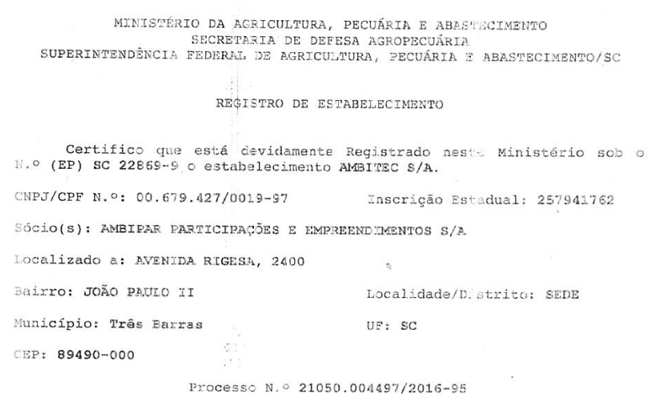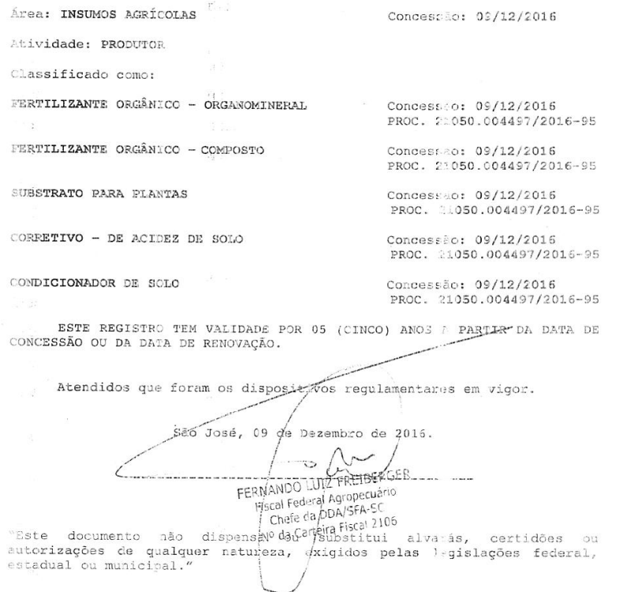

Product Registry of the compost, outcoming from the project activity composting, as soil conditioner class B is below in two pages. The first one details the association of the producer establishment with the licensed product.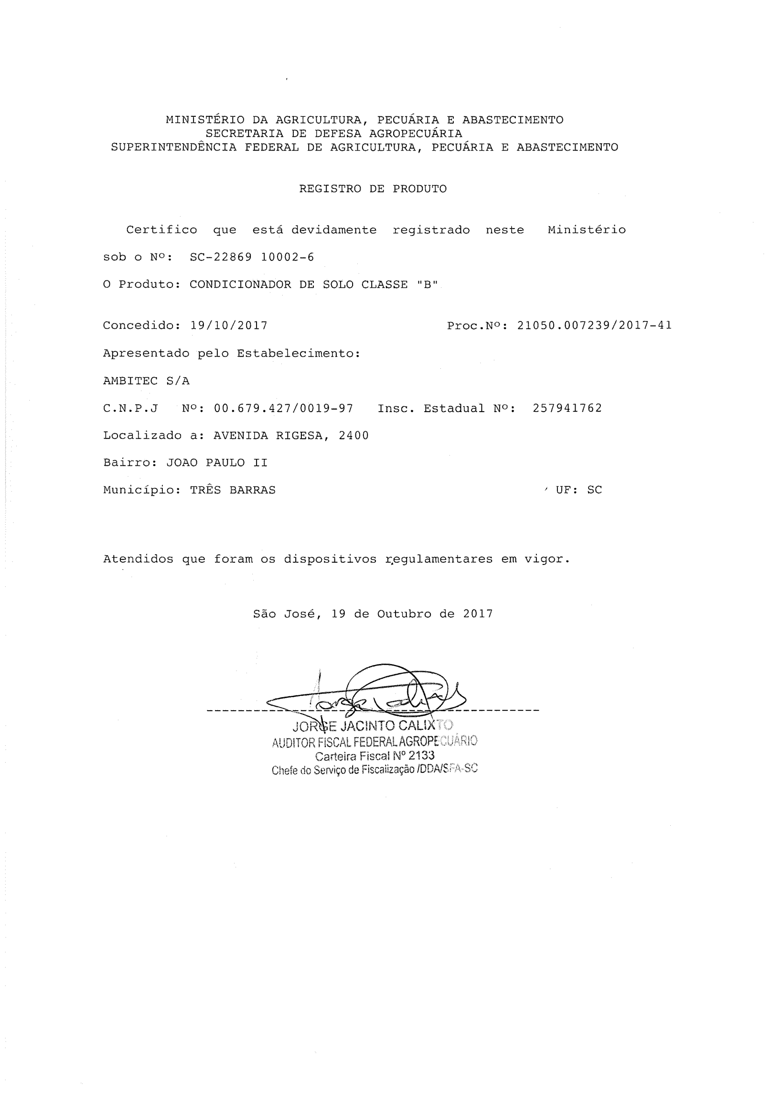

The second page of the product registry details the guarantees of the compost to be classified as soil conditioner: CEC – cation exchange capacity (CTC in Portuguese) and WRC – water retention capacity (CRA in Portuguese).

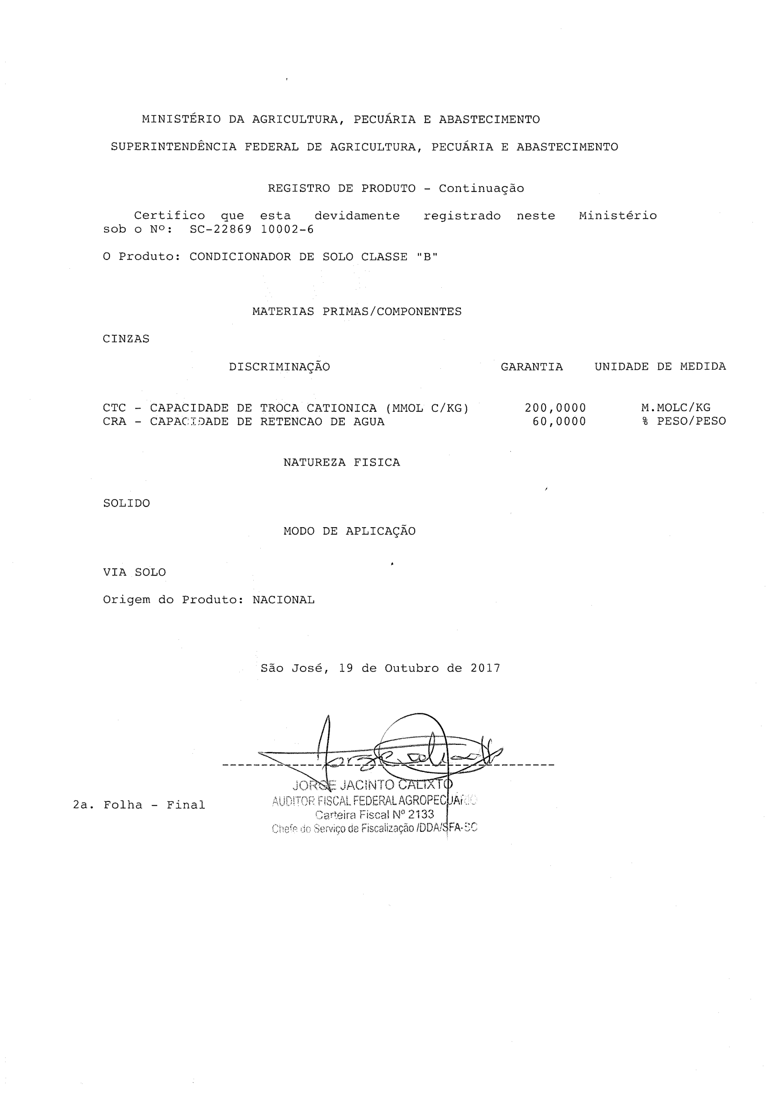

###### APPENDIX B

###### Benefits of the ECOSOLO application in agriculture reported by the technical development cooperation

